1. Introduction

1.1 Justification

Basketball is one of the most widely played sports all over the world. It consists of two teams competing with each other with 5 players in each team. Many basketball tournaments are held everywhere in which teams participate and the last standing team wins.

1.1 Problem Background

For basketball tournaments teams and players needs to be managed. The games or matches needs to be fixed on a certain date with two teams facing one another for which the team should be informed earlier. The winning team needs to be qualified for the next round while the losing team eliminated from the tournament. Thus, the last standing team finally wins the tournament.

1.2 Aim

The aim is to create an application capable of doing all the factors listed above for the basketball tournament and make a successful one.

1.3 Objective

The application needs to allow to create multiple admins and create multiple tournaments for each admin. Games needs to be fixed according to the entry of the team and progressed or qualified according to the score. Scores can be updated along with the player stats. The current progress and stats needs to be able to be viewed as well.

1.4 Overview of the Project

Therefore, the application needs to manage tournaments along with storing correct data for it. If this is done, then the project can be considered as a complete one,

2. Analysis

2..1 Introduction to Analysis

Analysis is one of the early stages of software development where requirements for it are determined and specified by following certain steps. It also helps to find or determine the feasibility of a project. The better the analysis, the better the software will be. So it is important to take time and think well while making analysis. The whole software or project depends on it.

Object Oriented Analysis is a model that consists of classes, diagrams etc. which helps us to view the system as a whole. This helps us to work with the system with ease and make proper analysis for the project or application.

There are advantages and hardships for everything. Therefore, problems arise during the development of the project like selection of the right data or classes which can make a big difference in terms of the quality of the application or project. The time needed to complete the project might be longer than the time the project is supposed to finished. However, the project can help in the future to hold basketball tournaments without problems and the time taken is reduced than the usual. This helps us to save effort and increase efficiency.

2.2 Requirements for Analysis

Functional

Functional requirements describe the desired end function of a system operating within normal parameters. It describes the main behaviors of the product that the user expects from the system.

|  |  |  |  |  |
| --- | --- | --- | --- | --- |
| **FID** | **Function** | **Data** | **Dependency** | **Remarks** |
| F01 | Login | Username and Password | None | It restricts unauthorized access |
| F02 | Team Registration | Team Name and Player Names | F01 | Teams that will be participating |
| F03 | Update Tournament Progress | Team Name and current progress | F01 | To keep record of the current progress |
| F04 | Check Player Stats | Team Name | None | Find the team name and their progress |
| F05 | Check Team Stats | Team Name | None | Check the team statistics |

Non-Functional

Nonfunctional requirements are important for software systems. It **defines how the system works.**

|  |  |  |  |  |
| --- | --- | --- | --- | --- |
| **NID** | **Functions** | **Purpose** | **Dependency** | **Remarks** |
| N01 | Reliable | For accurate outputs | N01 | Makes software trustworthy |
| N02 | Security | To prevent unauthorized access | N02, N01 | Makes the software safe |
| N03 | Performance | For software effectiveness | N03 | Satisfies the users |
| N04 | Maintainability | To fix errors and keep updating | N01, N02 | Updates the software to keep functioning |

**Software Requirements Specification**

Software Requirements

-Windows 7/8/10 or Windows XP

- SQL Server

-Visual Studio

Hardware Requirements

-Processer i5 or higher

- Memory with at least 4gb

-50 GB HDD space

**Moscow Prioritization**

Moscow Prioritization is used to help key stakeholders understand the significance of initiatives in a specific release. It can be used to understand and manage priorities of behavior of the system.

Must Have:

It is important and project cannot work without it

Should Have:

Project would still work without it but it still plays noticeable role which could Impact the quality

Could Have:

They are not important but still could be included. The project would work fine without it,

Won’t Have:

Those which could make the project worse rather than good fall into this category

|  |  |  |
| --- | --- | --- |
| **FID** | **Title** | **Priority** |
| F01 | Login | Must Have |
| F02 | Team Registration | Must Have |
| F03 | Update Team Progress | Must Have |
| F04 | Check Player Stats | Should Have |
| F05 | Check Team Stats | Should Have |

Moscow Table for Functional

|  |  |  |
| --- | --- | --- |
| **FID** | **Title** | **Priority** |
| F01 | Reliable | Should Have |
| F02 | Security | Must Have |
| F03 | Performance | Should Have |
| F04 | Maintainability | Should Have |

Moscow Table for Non-Functional

NLA

NLA stands for Natural Language Analysis. It is the process of filtering nouns, verbs and adjectives from a scenario which are related to the project. It helps us in creating class diagrams.

Scenario

Basketball tournaments are held everywhere in which there are limited number of teams who can participate. Each team usually must have an exact number of players. Basketball tournaments are held for the purpose of popularity and bonding with others. The winners are awarded with prizes.

Basketball tournaments have been held continuously throughout years. There have been basketball tournaments in different levels like tournaments for school level, high school level, international level etc. Different people from different places and schools have been organizing this sort of tournaments and taking part. These factors have increased the basketball’s popularity and encouraged people to organize more.

The project will allow user to organize basketball tournament with the names of the participant and keep an eye on the progress. The user will be able to register teams and players along with editing their names. The user can search team or player names and view their stats and current progress. This will remove any confusion and allow a smooth going.

|  |  |
| --- | --- |
| Nouns | Verbs |
| Team, Player, Tournament | Register, Edit, View, Search, Schedule, Update |

Initial Class Diagram

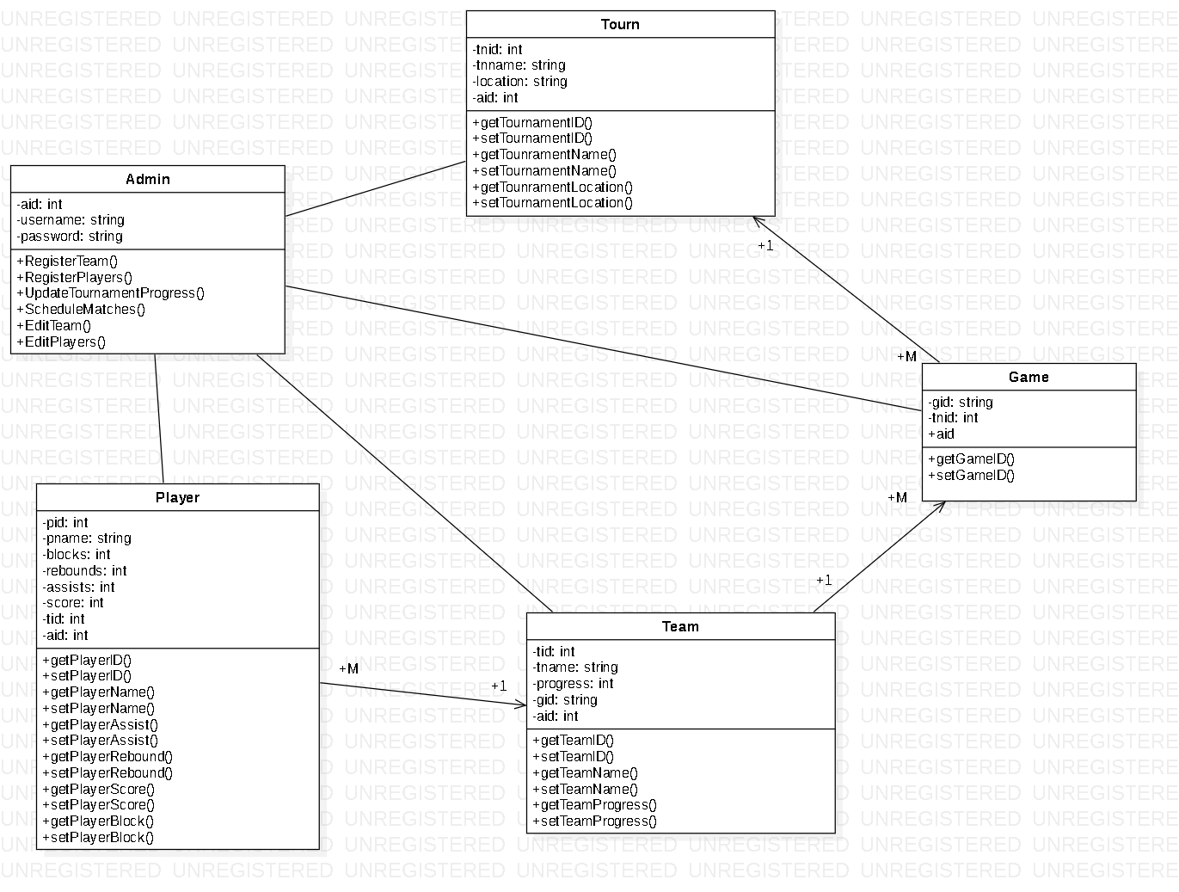

Figure: Class Diagram

Use Case

A UML Use Case is the smallest unit of activity that is meaningful to the user. A Use Case must be self-contained, and leave the business of the application in a consistent state

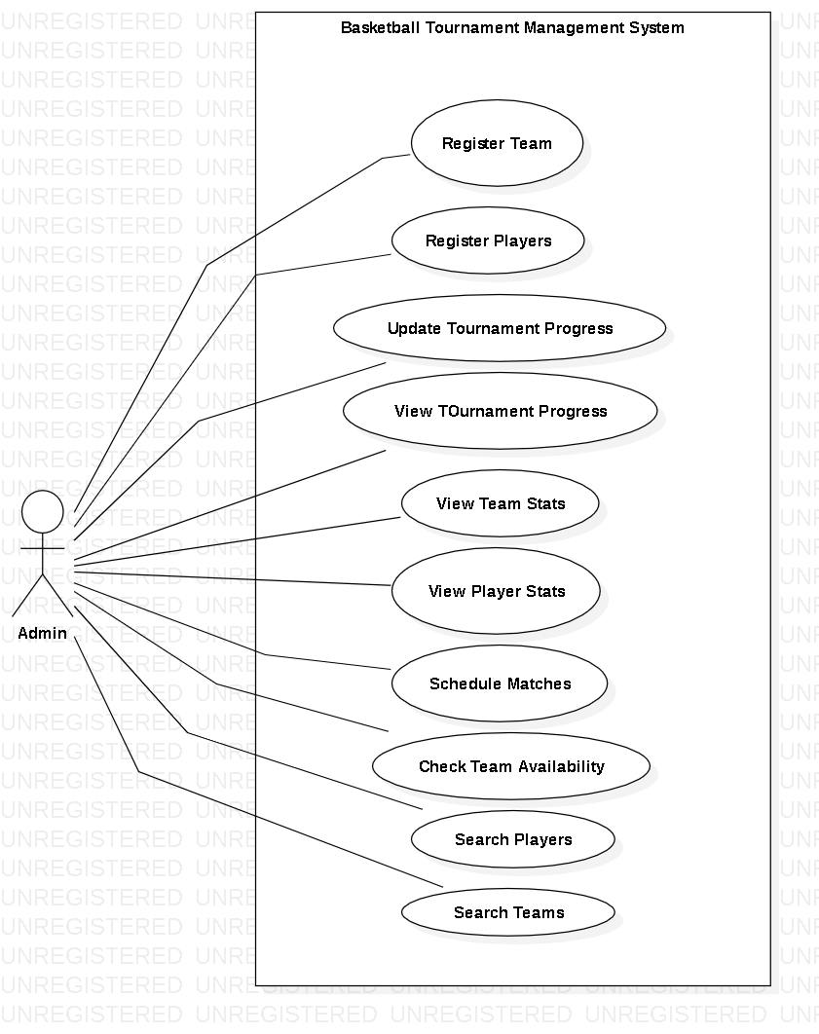

Figure: Use Case Diagram

3 Design

3.1 Justification

Design is the process of creating a model for a system which we have in our mind. It helps us in creating a depth view of the system we are about to create thus helping in the development of a system or software. The better the design, the better the software is going to be.

3.2 Dynamic Modelling

**Sequence Diagram**

A sequence diagram shows the interaction of objects in time sequence which helps to find which object performed more and which had least to do.

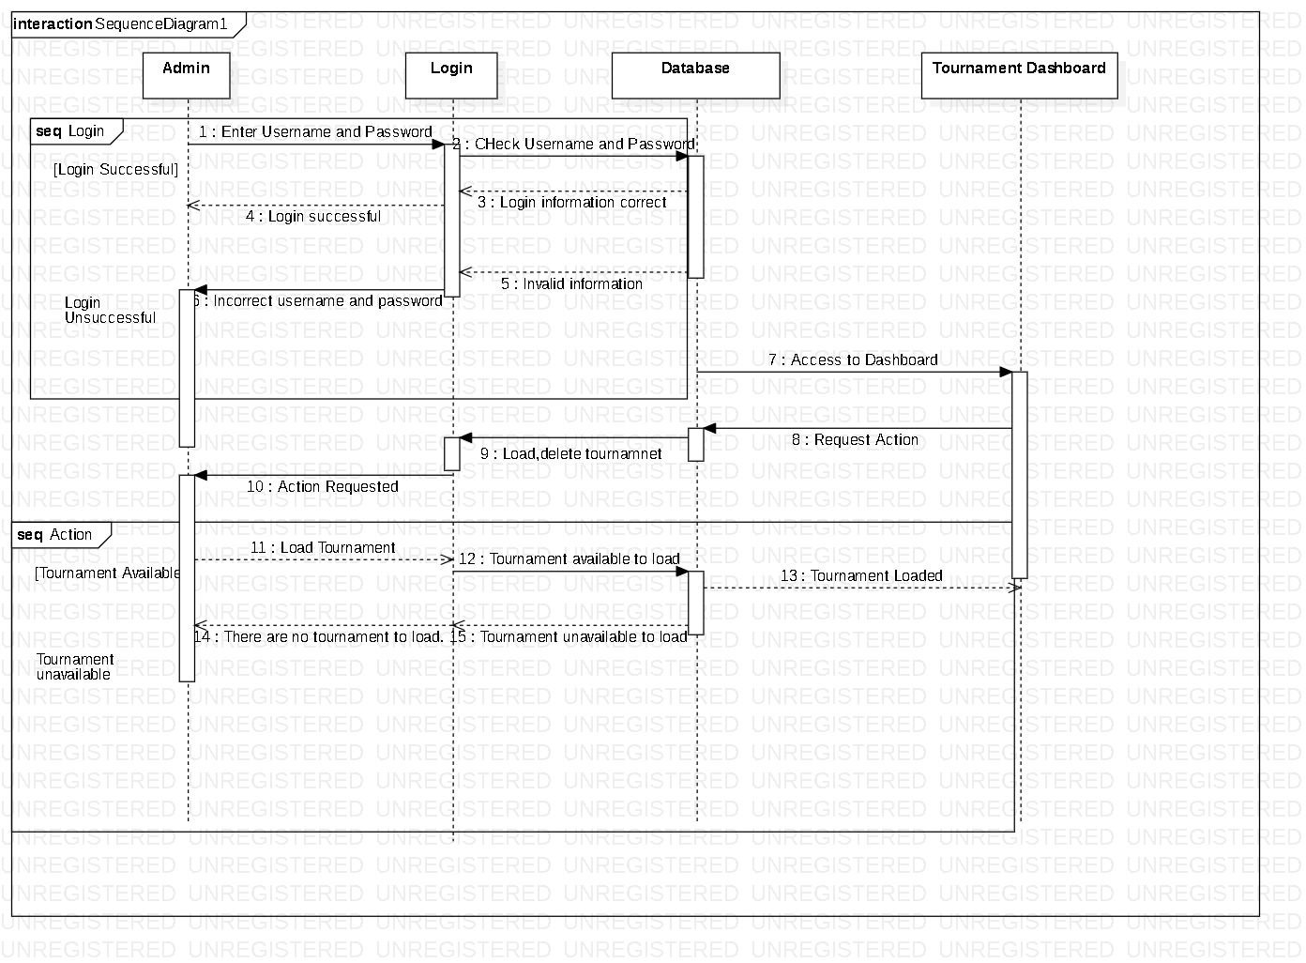

Figure: Sequence Diagram

I have created a sequence diagram which shows the actions performed by each object and their time period.

Notations Used

Lifeline: This shows the interaction and length of the operations.

Message: This shows the message sent.

Reply Message: This shows the reply received

Combined Fragment: It helps to act upon conditions.

Explanation

Admin login is required and the information are checked. If the login information is correct, the admin can proceed. However, if incorrect information is given error message is shown.

**Activity Diagram**

Activity diagram shows how the activities are carried and coordinated in a system. With the help of the activity diagram, we are able to see the flow of different operations.

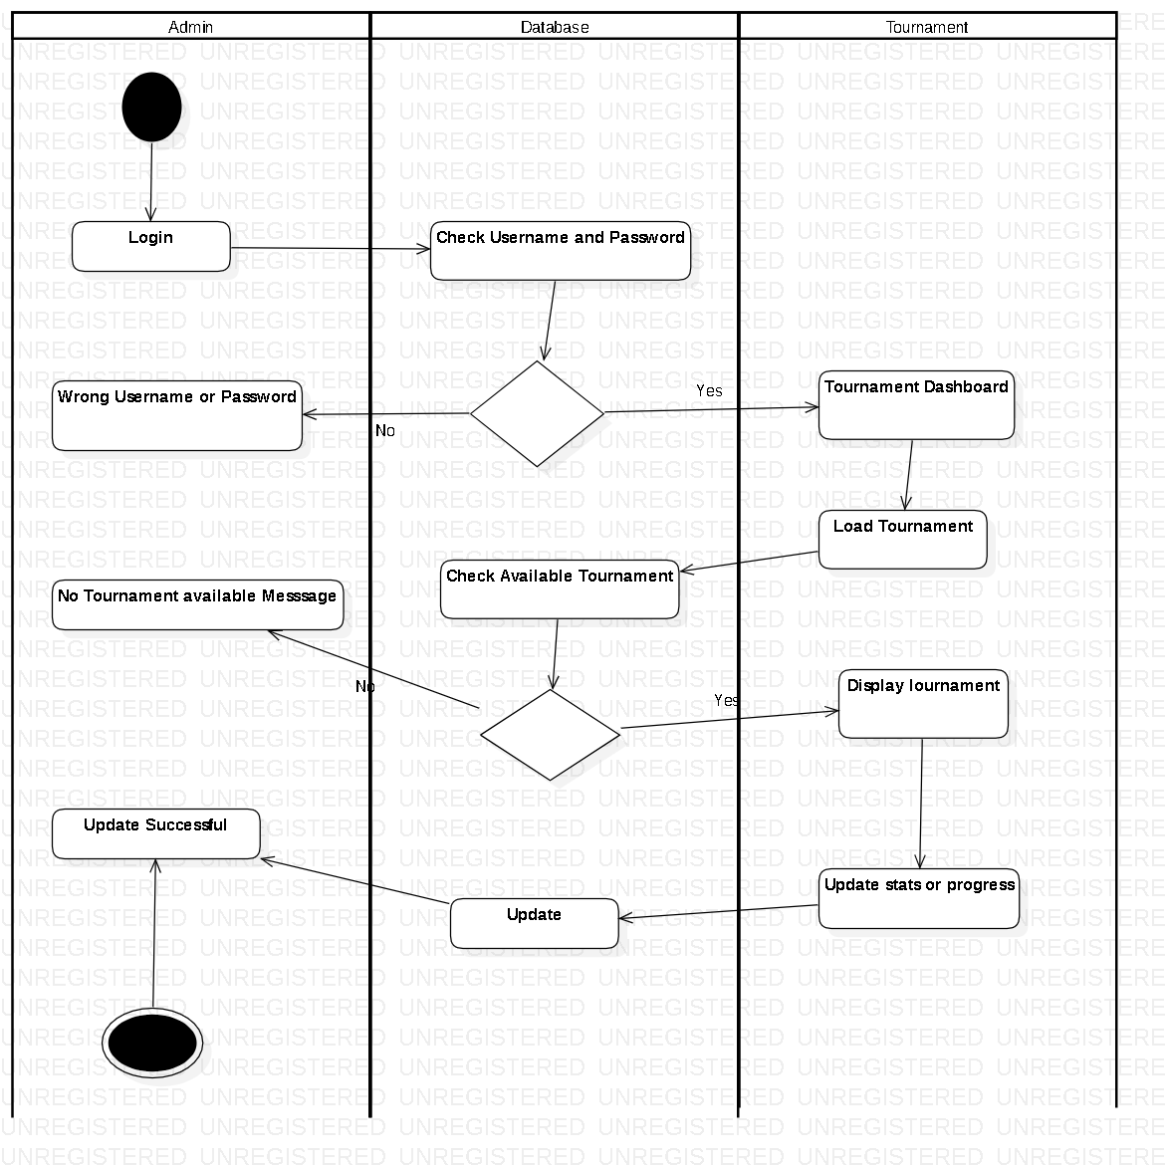

Figure: Activity Diagram

I have shown the activity diagram of the system which requires login for the administrative privileges or simply to proceed. Tournaments can be update and deleted which are shown in the diagram.

Notation used:

Action: It shows the action performed.

Swimlane: It separates and helps to identify objects.

Initial: This shows the beginning of the operation.

Final: This represents the end.

Decision: This helps when things could go either way and helps to choose.

Explanation

The Admin first logs in which is checked in the database if the login information matches and if it does then he/she is able to proceed and move to the next step of either deleting, loading or creating a tournament.

3.3 Structural Modelling

**Architecture level class diagram (Final Class Diagram)**

A class diagram defines the relationship between classes or can be view as a structural representation of a system. It helps us to observe a system properly.



Figure: Final Class Diagram

Justification and explanation

I have created or developed my class diagram with thorough examination and is able perform for the project.

My class diagram has 5 classes i.e. Admin, Players, Team, Game and Tournament.

Notations Used

Classes: Helps to separate objects and attributes

Association: Helps to view the relationships between entities

Attributes: Defines the class

Access Modifiers: Sets the protection level for different attributes and methods.

3.4 Flowchart

Flowchart is a step by step chart process which shows the functions along with outputs, inputs and decisions. It is a very simple chart used by many although it’s a quite old process.

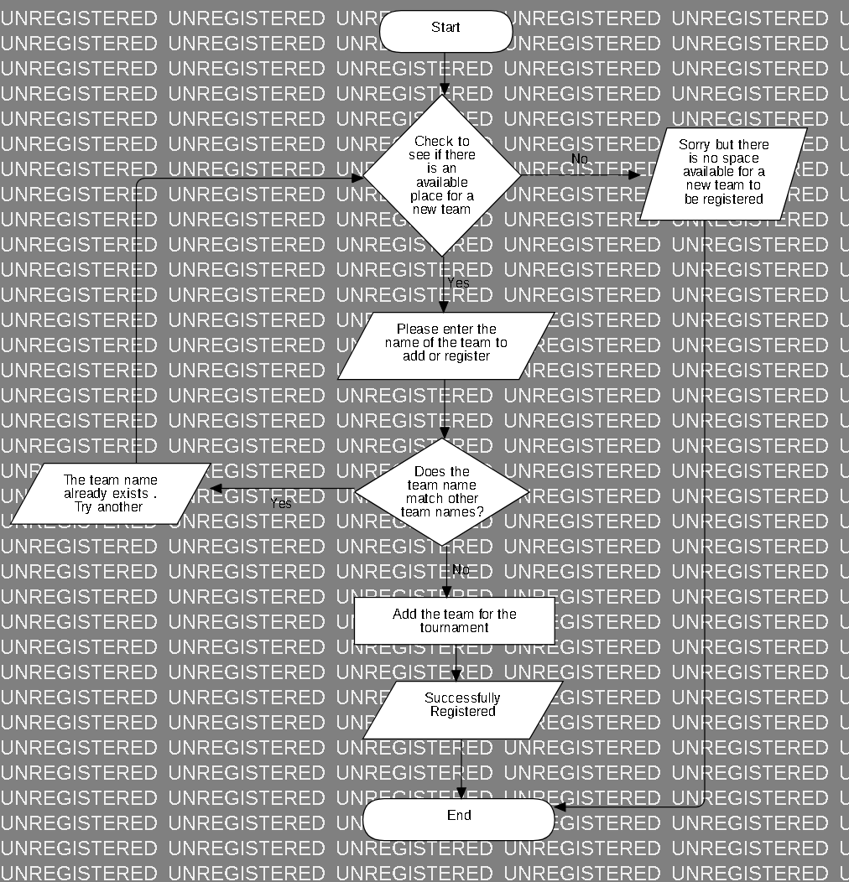

Figure: Adding teams for the tournament

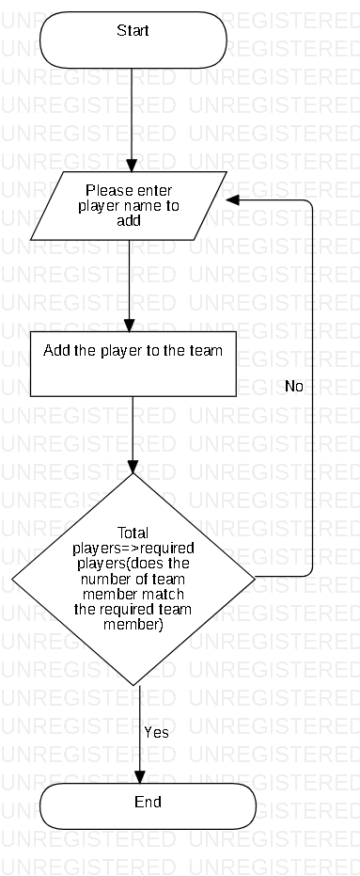

Figure: Adding players to a team

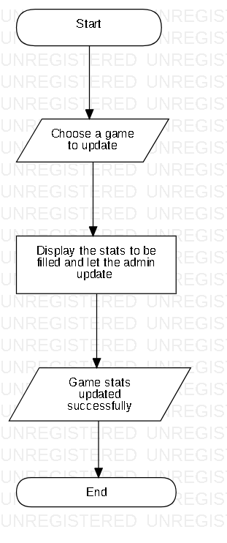

Figure: Updating Tournament Progress

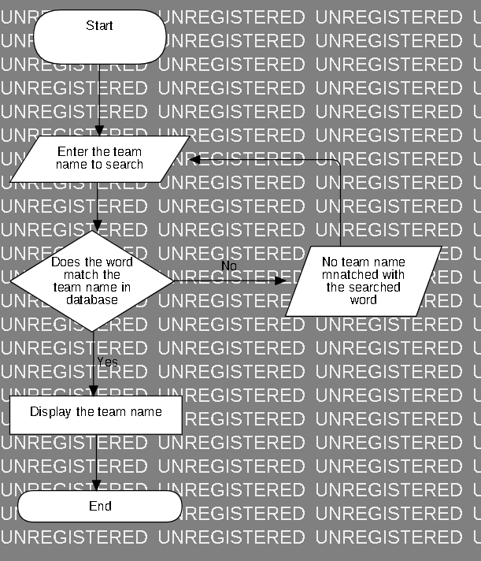

Figure: Search Team Names

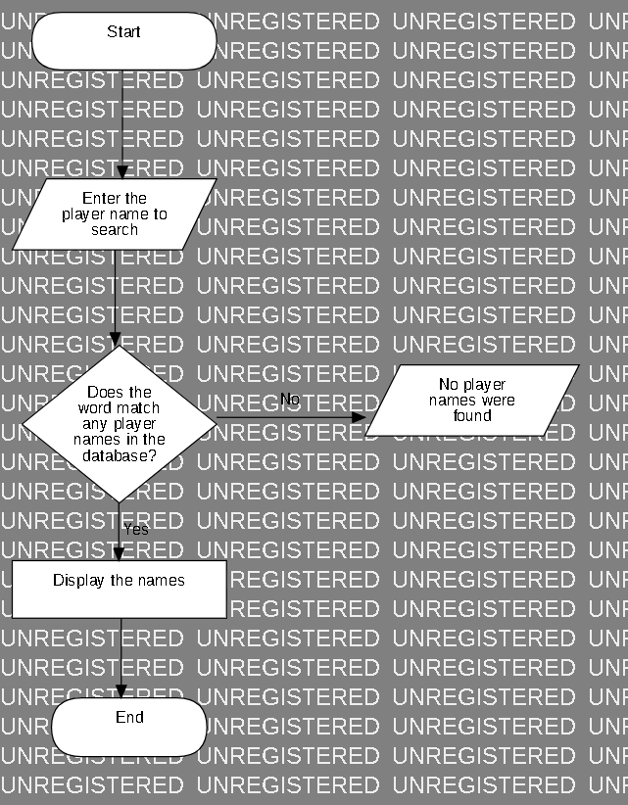

Figure: Search Player Names

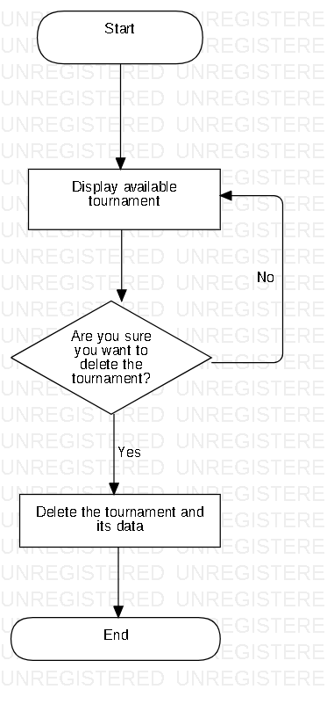

Figure: Deleting a tournament

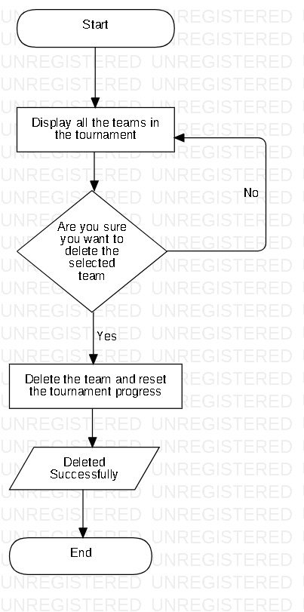

Figure: Deleting a team from a tournament

Explanation

Here, I have shown the process or tasks carried out by the admin in flowcharts which shows the steps clearly and decisions which cannot be carried itself. It consists of the admin deleting tournaments, loading saved tournaments, updating tournament progress etc.

Notations Used

Flow: It lets process continue to next step

Terminator: It starts and ends the flowchart

Process: It consists of process that is carried by the system

Decisions: It helps to act according to conditions

3.5 Database Modelling

**ER**

ER stands for Entity Relationship which shows relation between entities as the name suggests. It helps us to study on how things work or which entity depends on whom. It can be defined as a graphical representation of an information system.

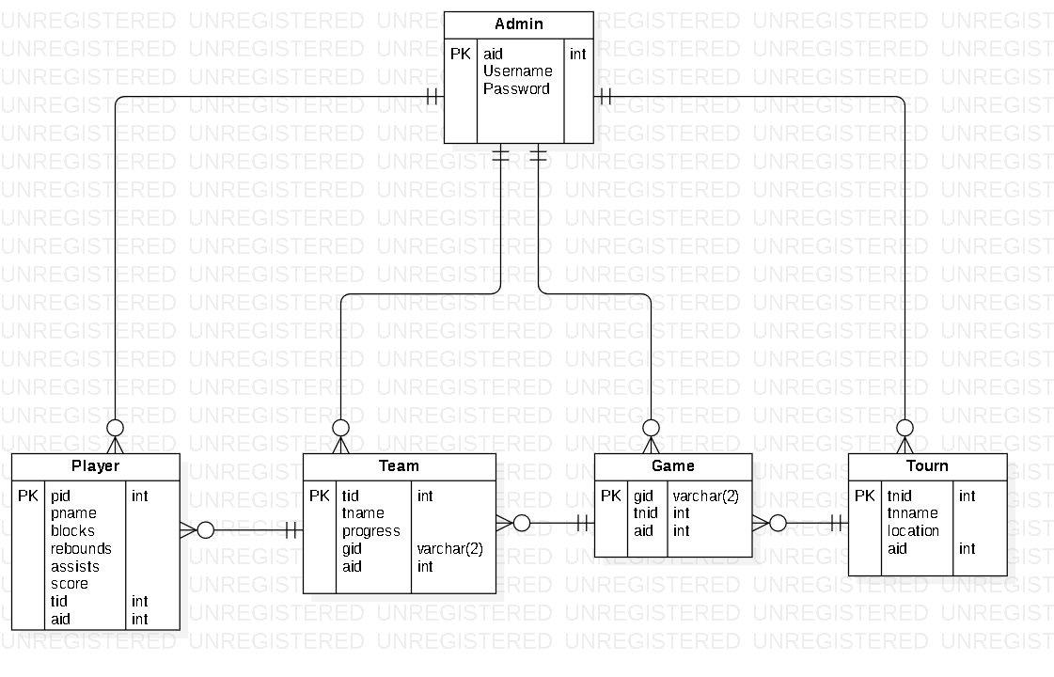

Figure: ER Diagram

Here, I have shown the relationship between each entities in the diagram which helps us in the understanding of how things work. The entities I have used are admin, player, team, game and tourn (Tournament).

Notations Used

Entity: Stores attributes and their data types

Relationships: Helps to identify relation between entities

Attributes: Helps to define the entities

Data Types: Lets certain and suitable data only to be inserted to certain attributes

**Data Dictionary**

Data Dictionary is that which consists of information able to define the structure and format of a database. It can also show relationships between elements

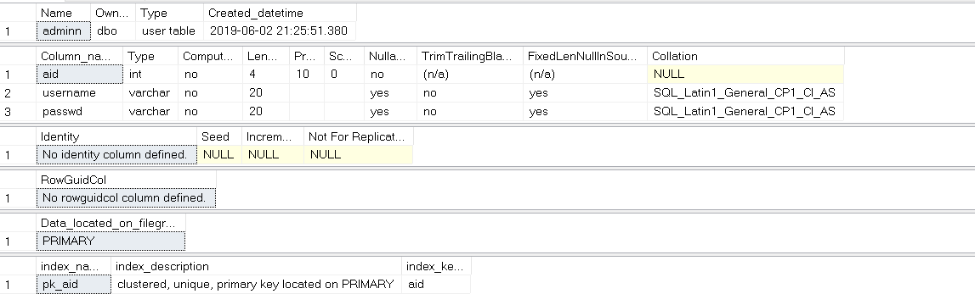

Figure: Data Dictionary of Admin

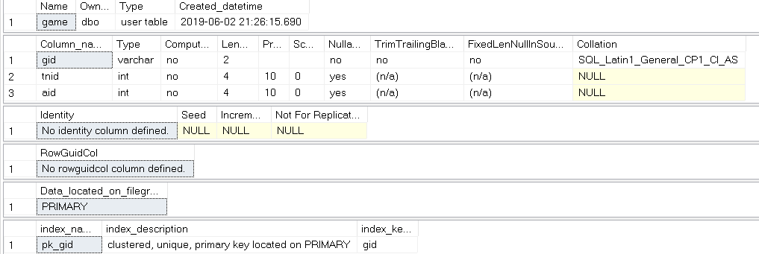

Figure: Data Dictionary of Game

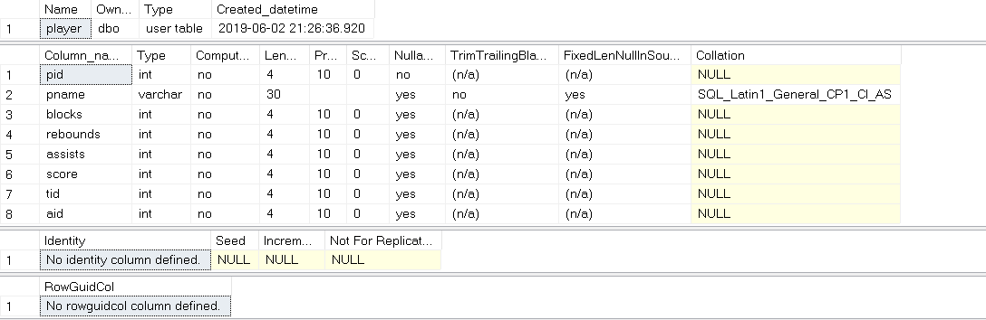

Figure: Data Dictionary of Player

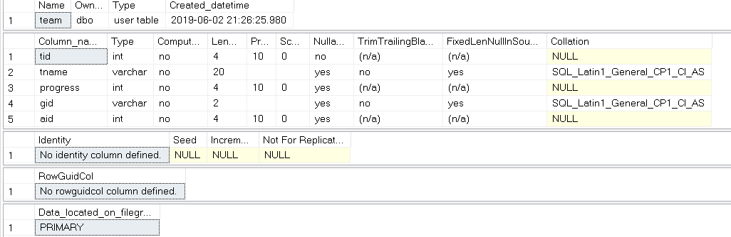

Figure: Data Dictionary of Team

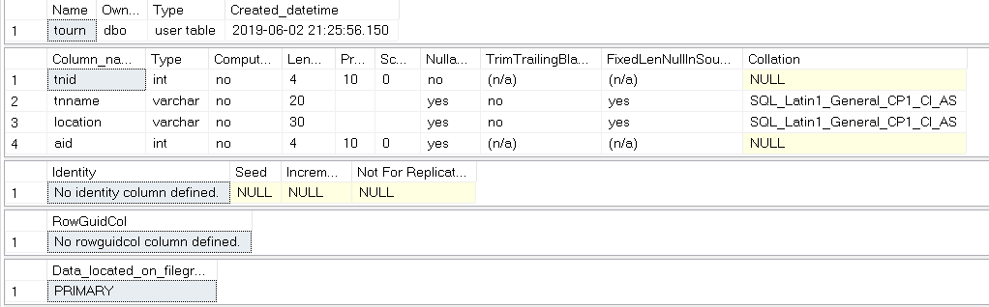

Figure: Data Dictionary of Tournament

I have shown data dictionary for all 5 entities or tables which shows data types of attributes and other information. Proper data types are given to each attributes.

Notations Used

Attributes: It defines the table or entity

Data types: It sets the attribute type

Row: It lets data exist in row wise

Column: It lets data exist in column wise

3.6 Prototype

Prototyping is the process gone before actually implementing or starting the actual project to get proper results and avoid confusions.

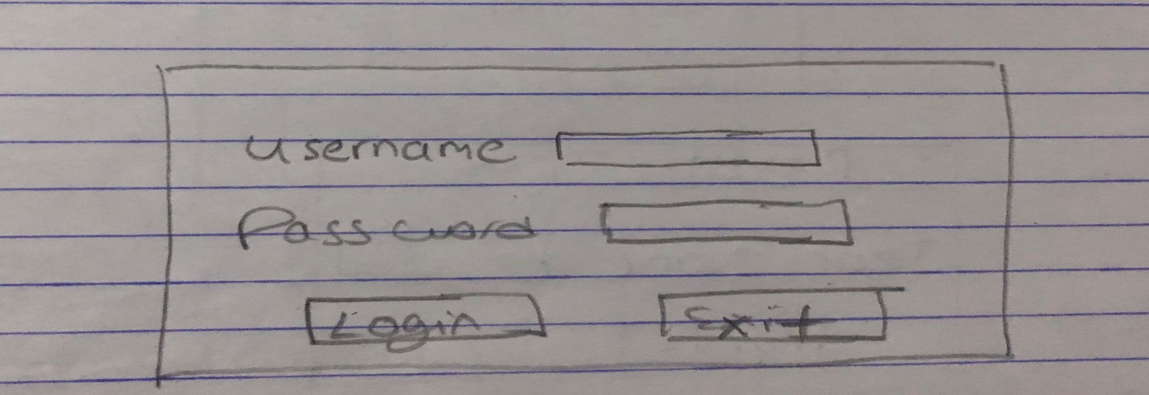

Figure: Admin Login

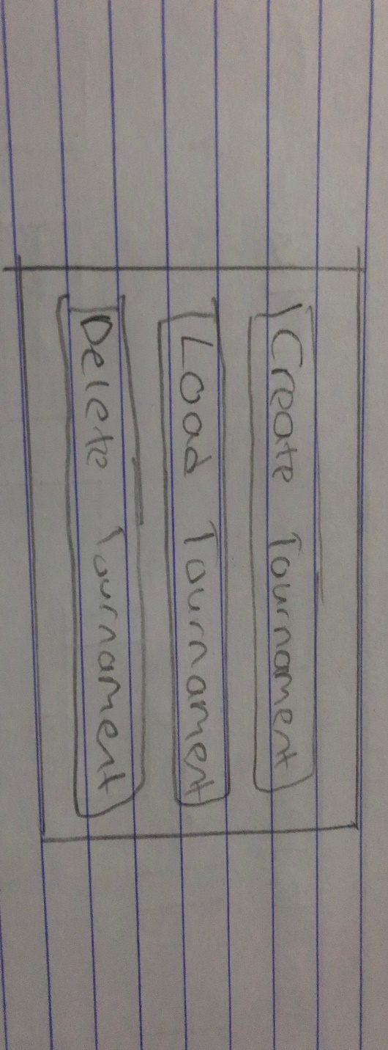

Figure: Tournament menu

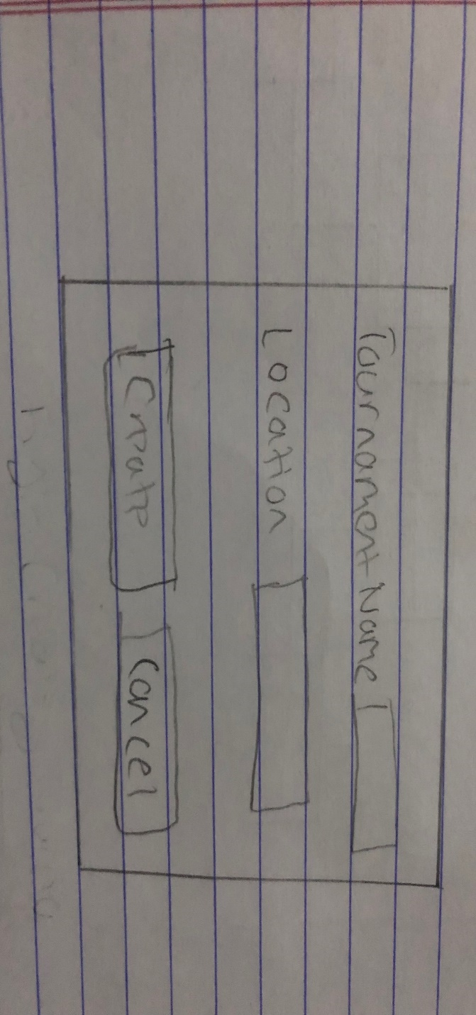

Figure: Create Tournament

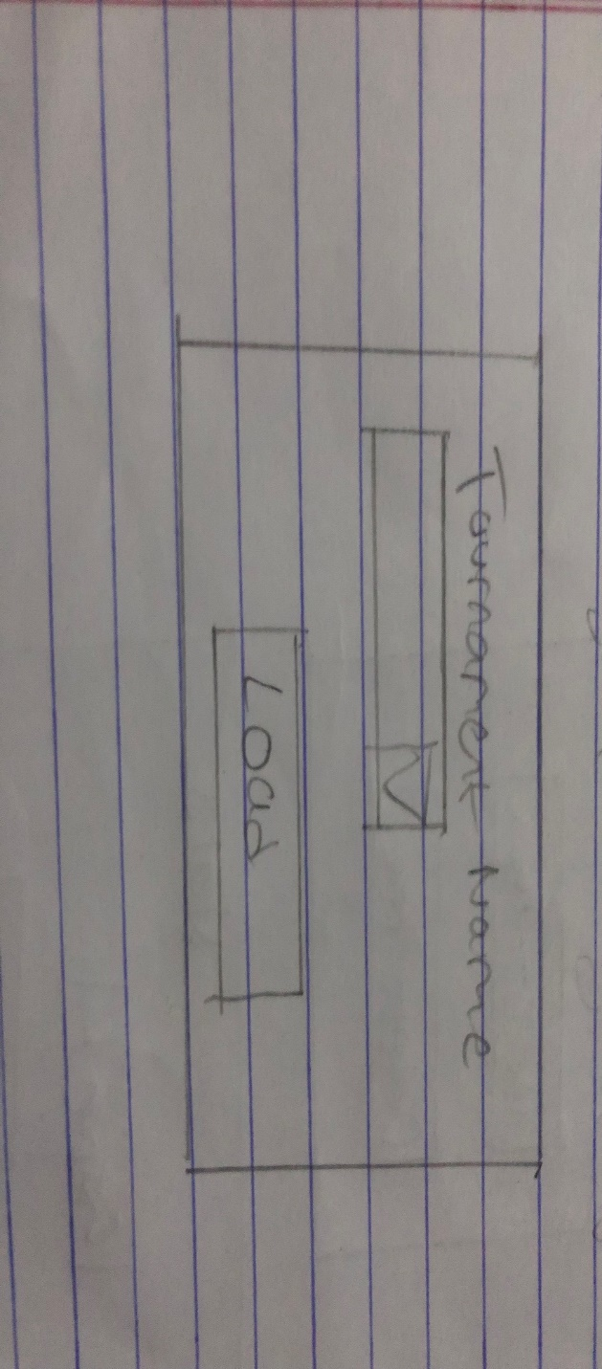

Figure: Load Tournament

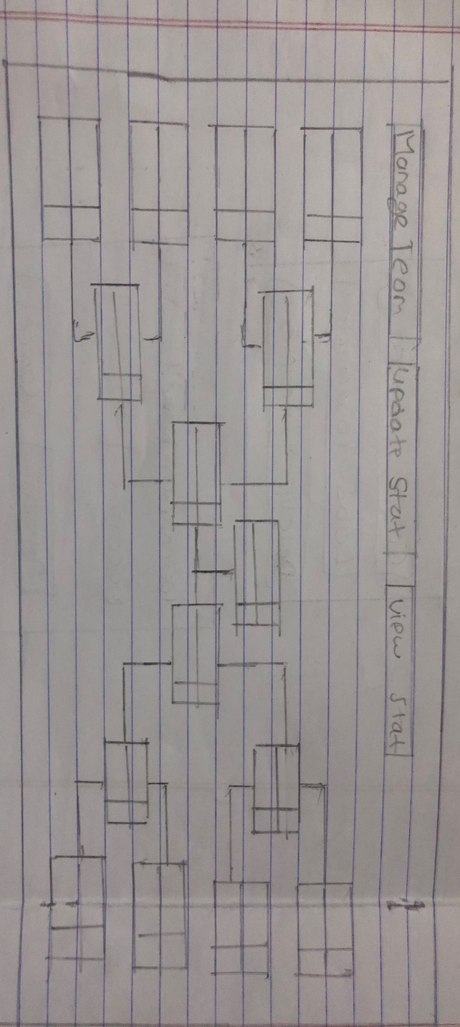

Figure: Tournament Progress

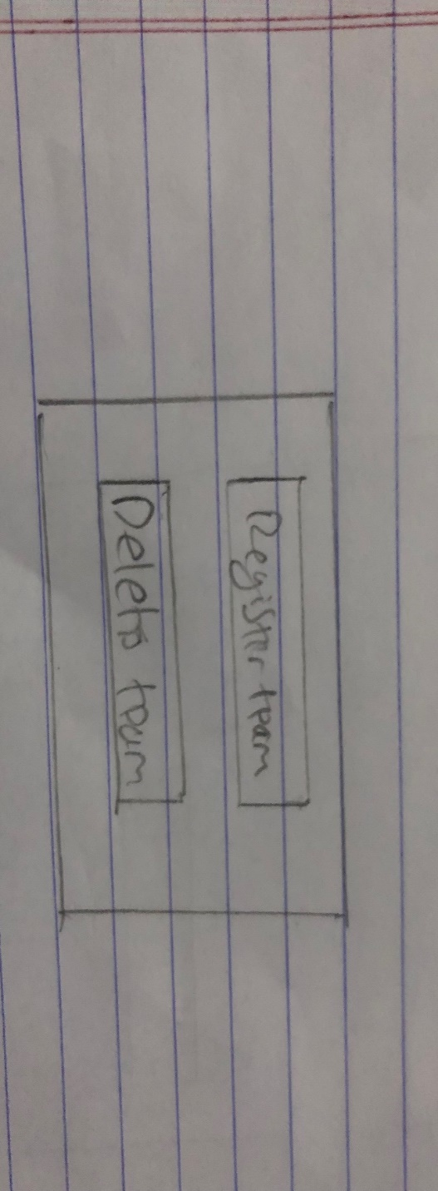

Figure: Manage Team

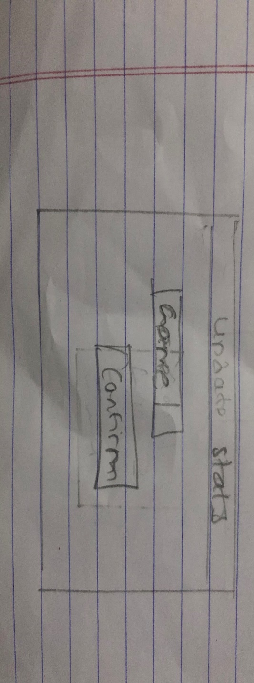

Figure: Select Game to Update Stats

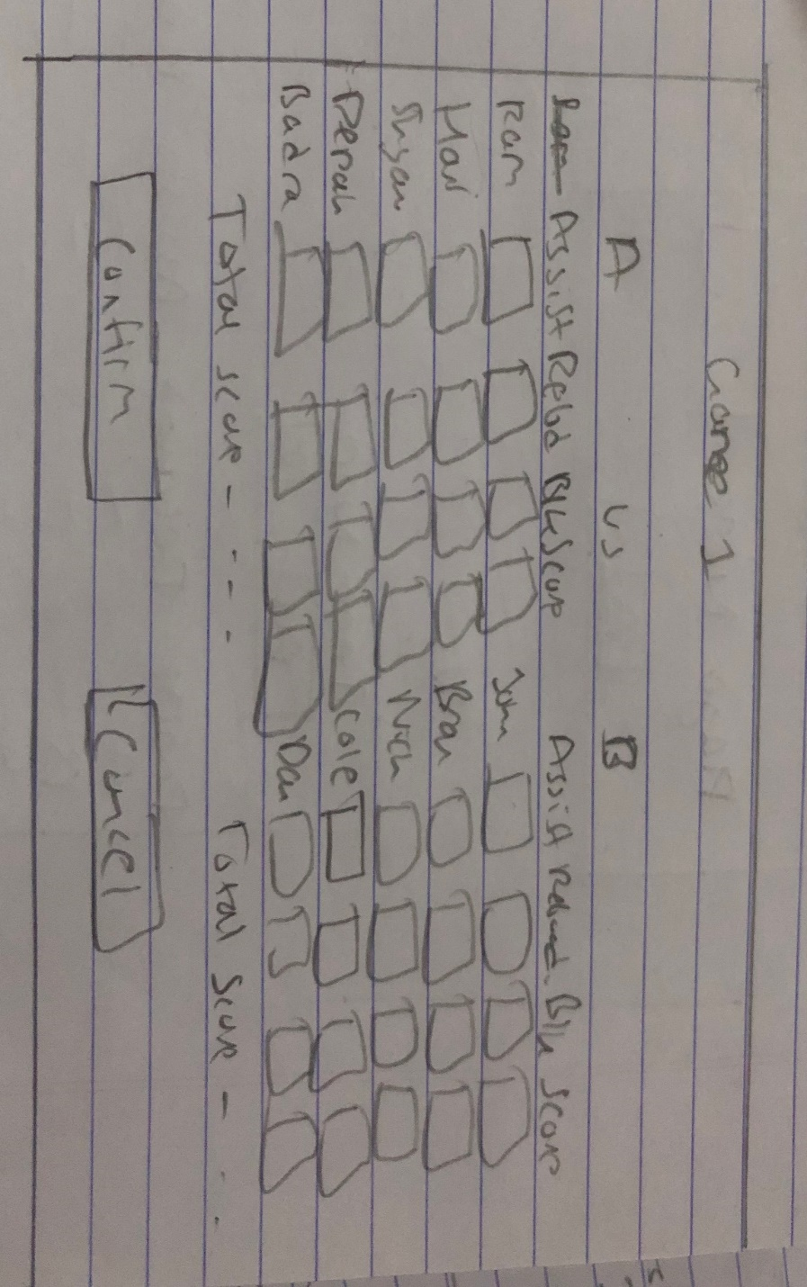

Figure: Update Stats

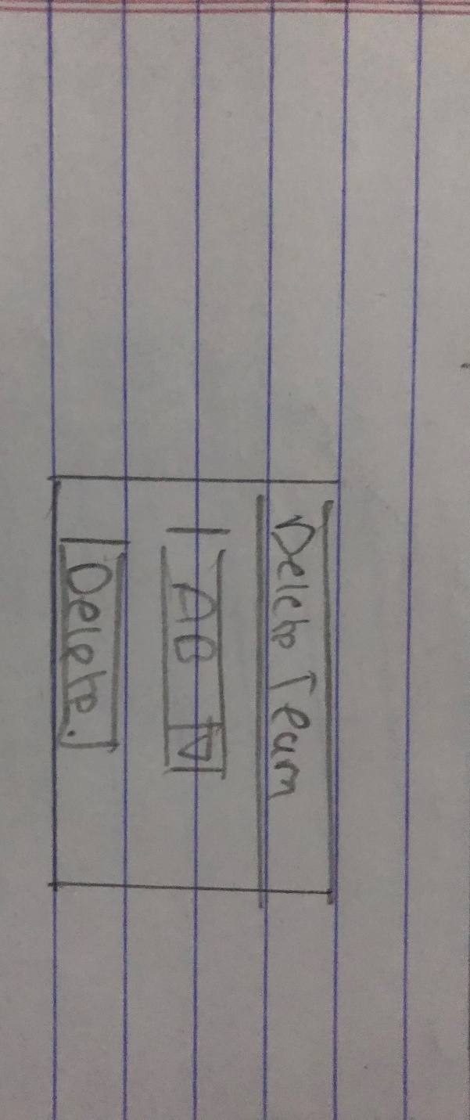

Figure: Deleting Teams

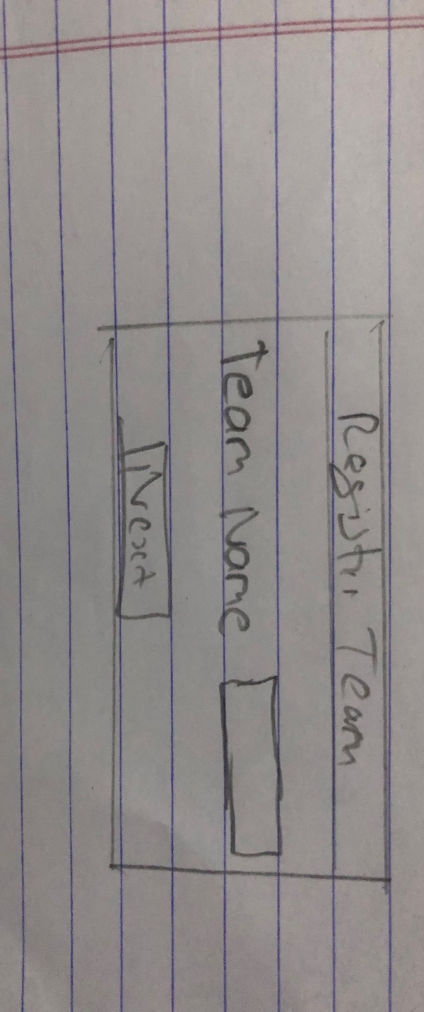

Figure: Register New Team

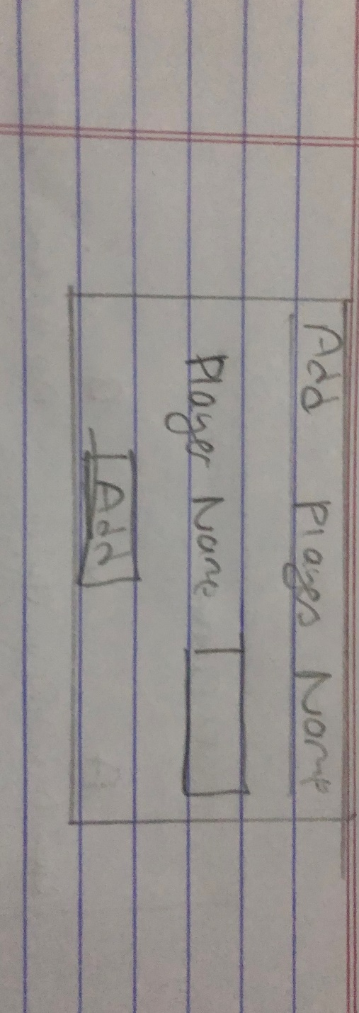

Figure: Registering Players for a Team

Justification and explanation

Here, I have shown rough diagrams which are required for the project to work. It consists of admin login, different options for tournament and the ability to update and view the progress.

Notations Used

Windows Form Box: For inserting objects

Button: To perform actions

Textbox: To insert information

4 Implementation

Language: C#

Framework: .Net

C# has been used to develop the application for easy use and access which is one of the most used programming language used to develop application in the world. It is more suitable for my project and thus, I used C# to develop my application.

**UI**

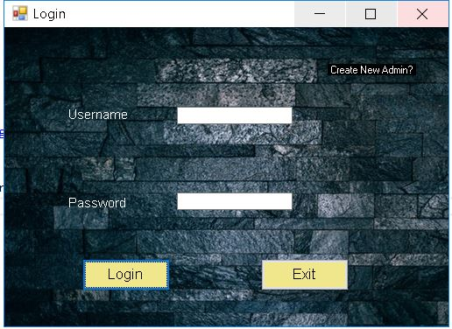

Figure: UI of Login

**Code**

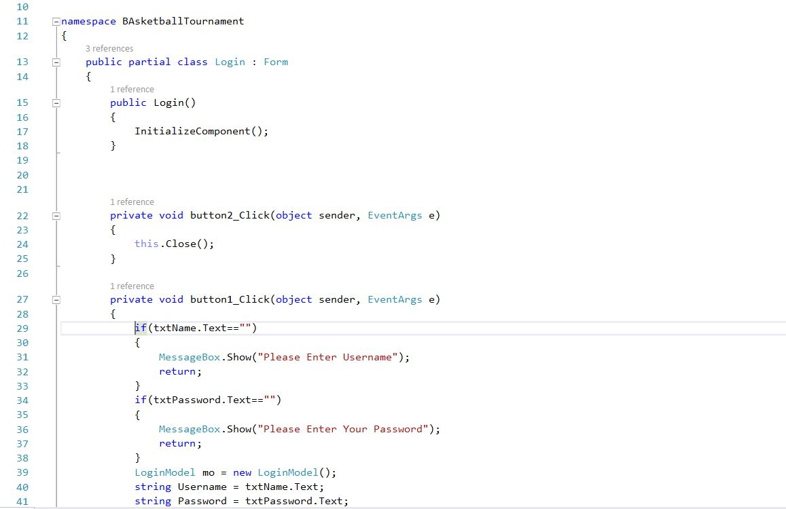

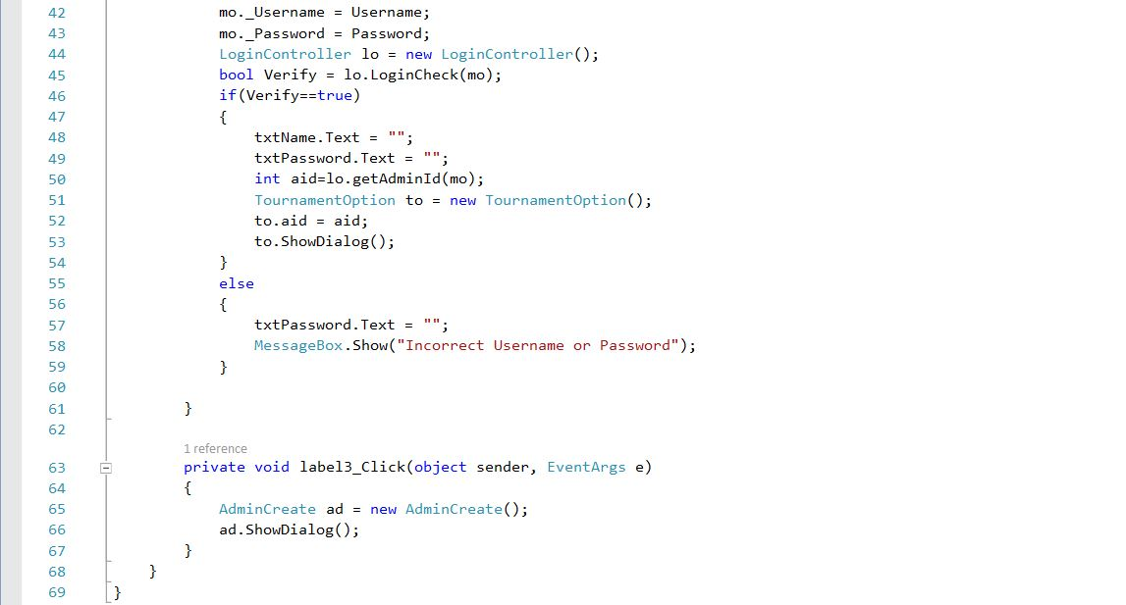

Figure: View of Login

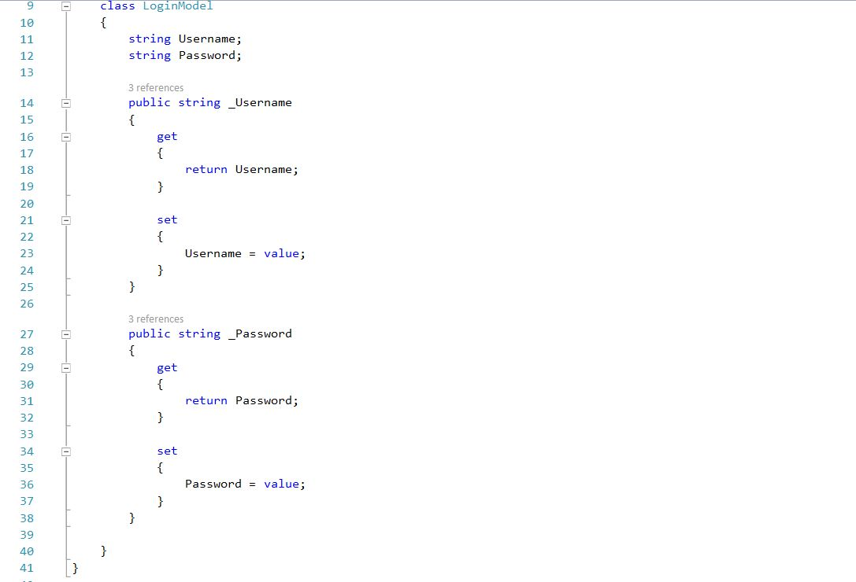

Figure: Model of Login

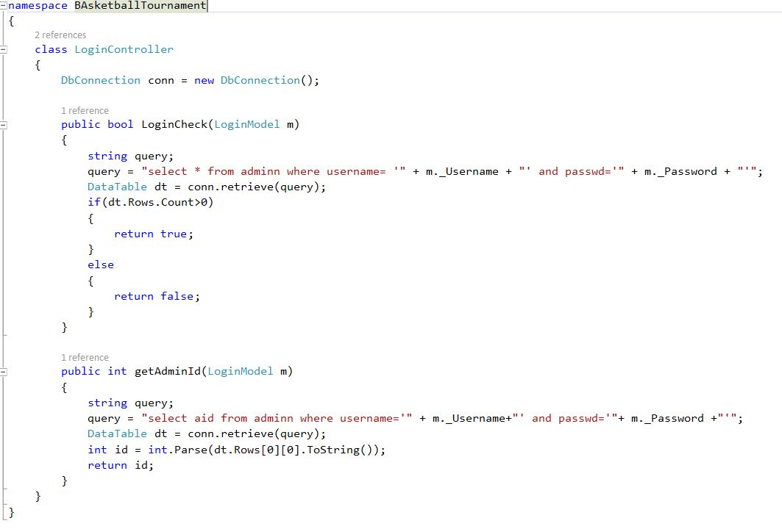

Figure: Controller of Login

**UI**

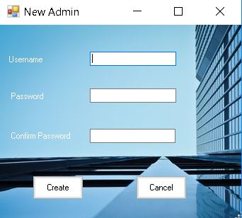

Figure: UI of Creating an Admin

**Code**

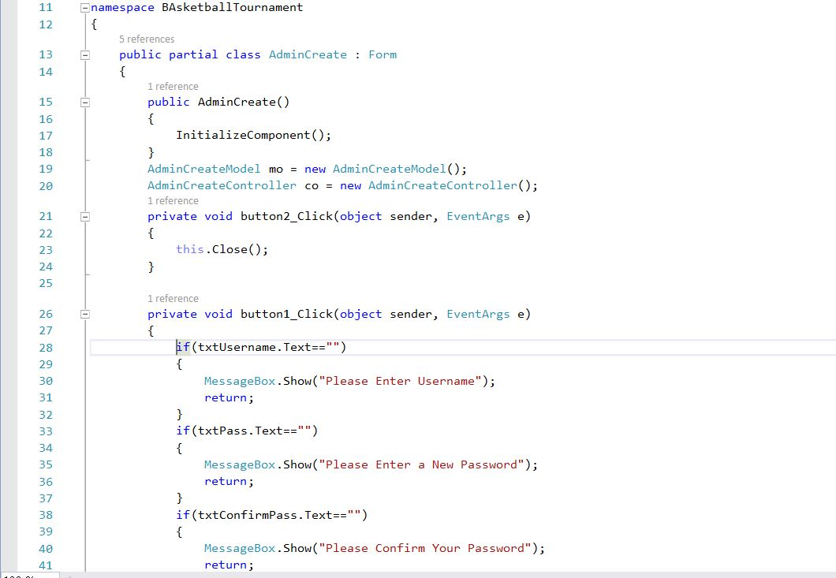

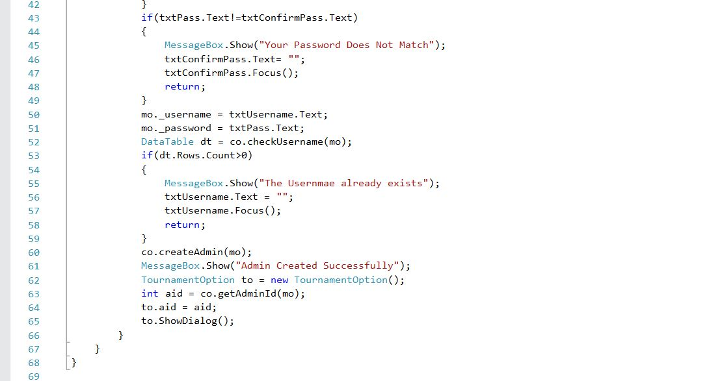

Figure: View of Creating an Admin

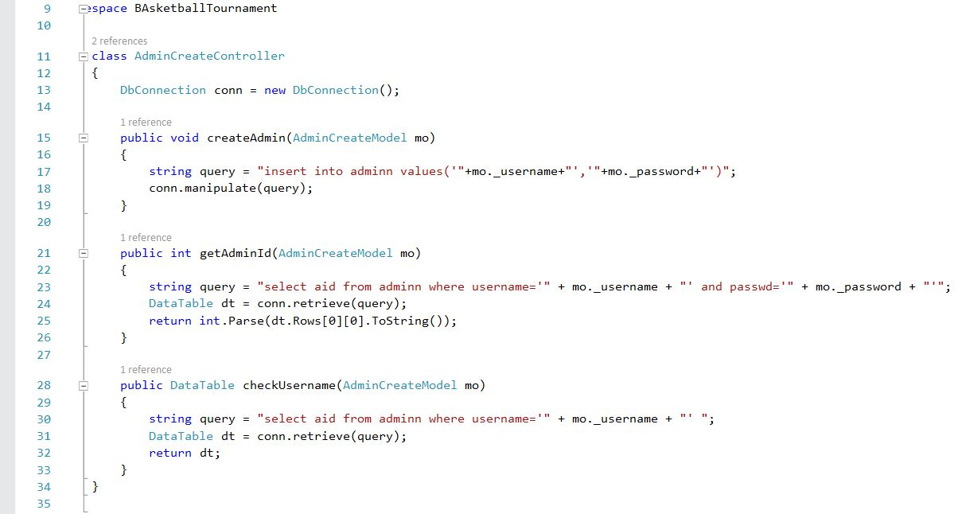

Figure: Controller of Creating an Admin

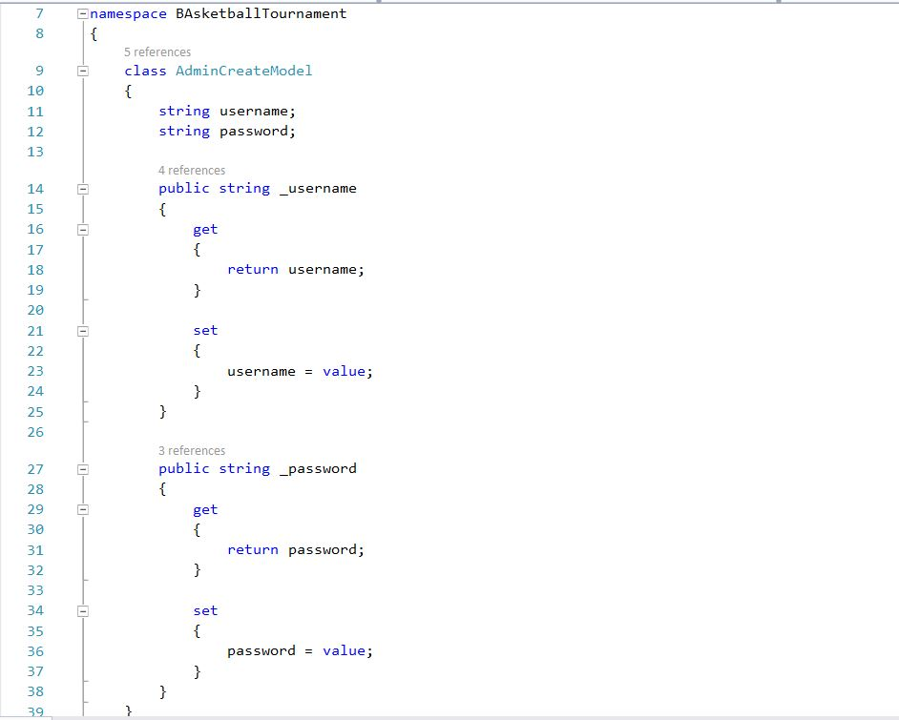

Figure: Model of Creating an Admin

**UI**

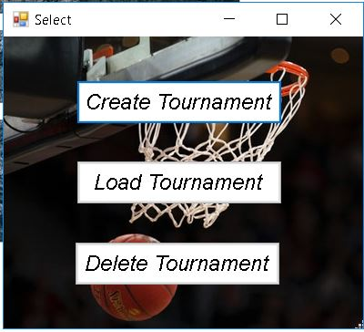

Figure: UI of Tournament Options

**Code**

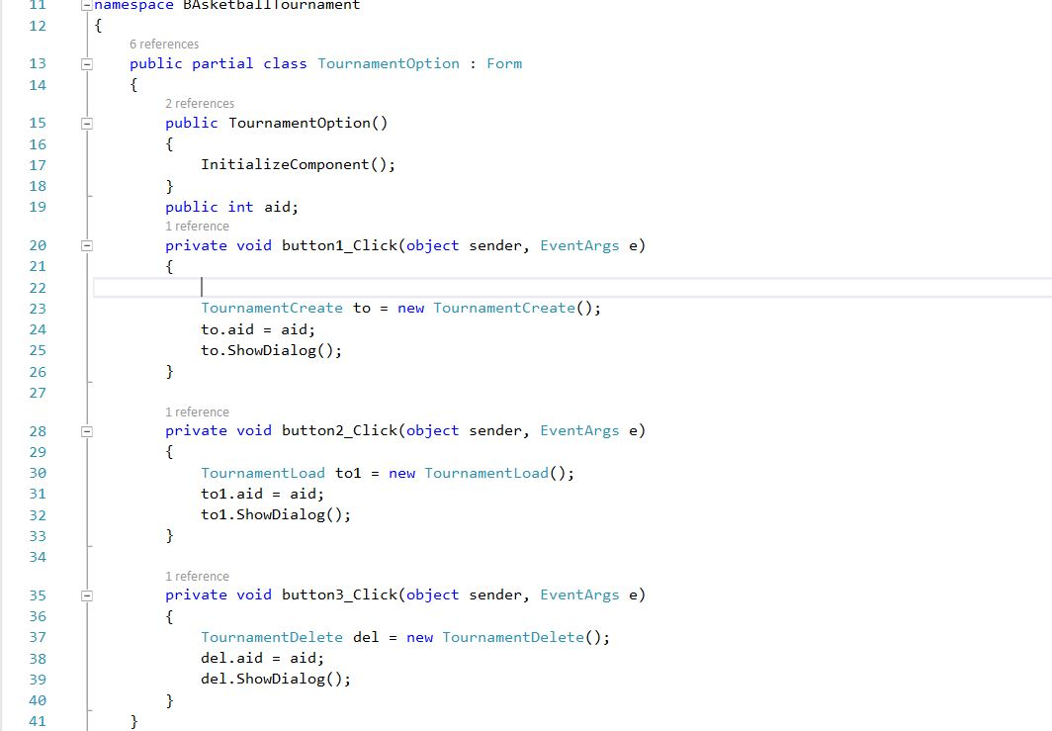

Figure: Code of Tournament Option

**UI**

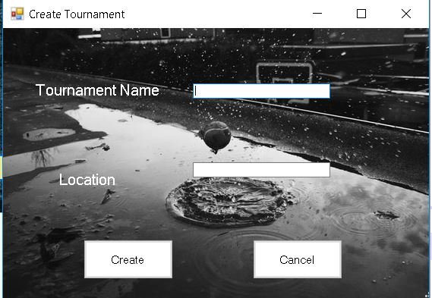

Figure: UI of Creating a Tournament

**Code**

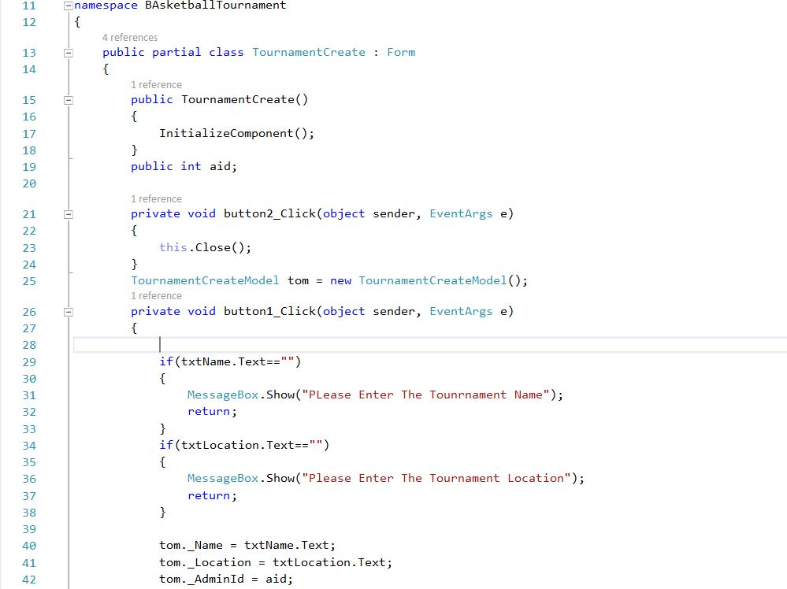

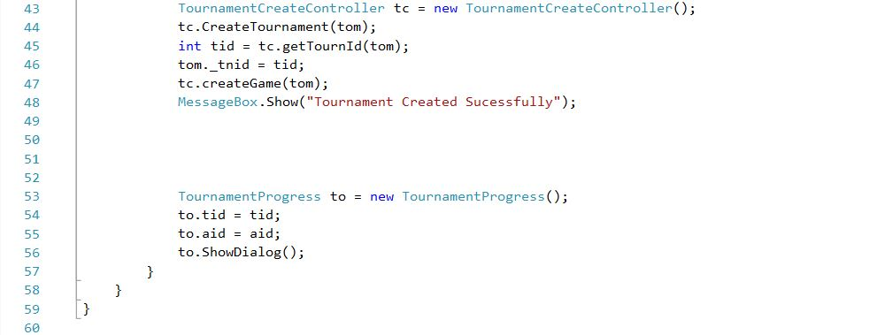

Figure: View of Creating a Tournament

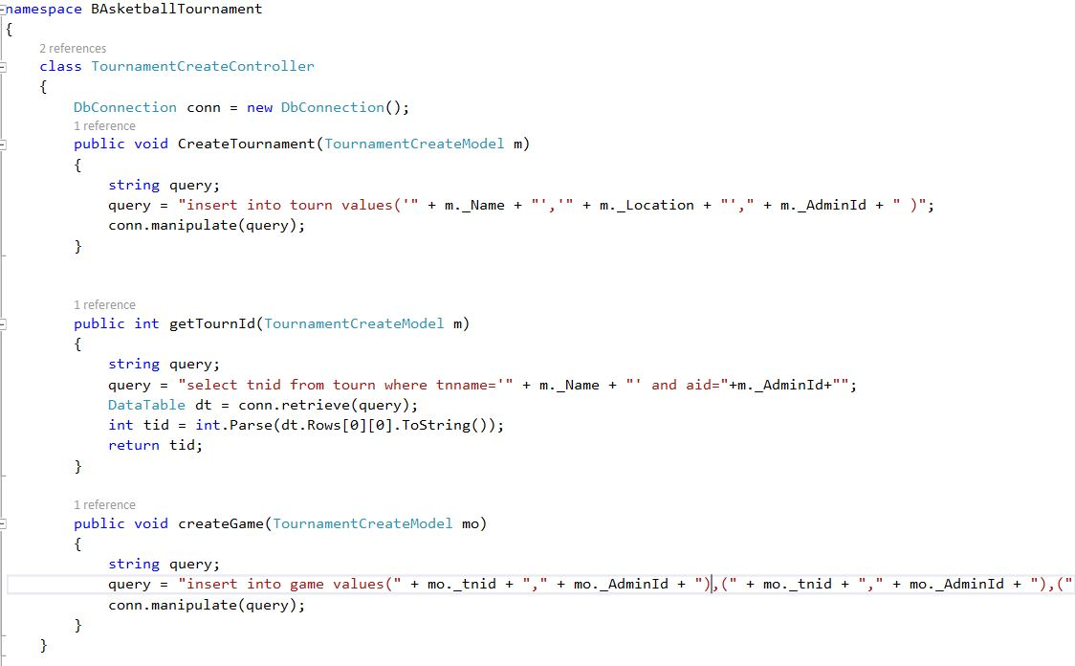

Figure: Controller of Creating a Tournament

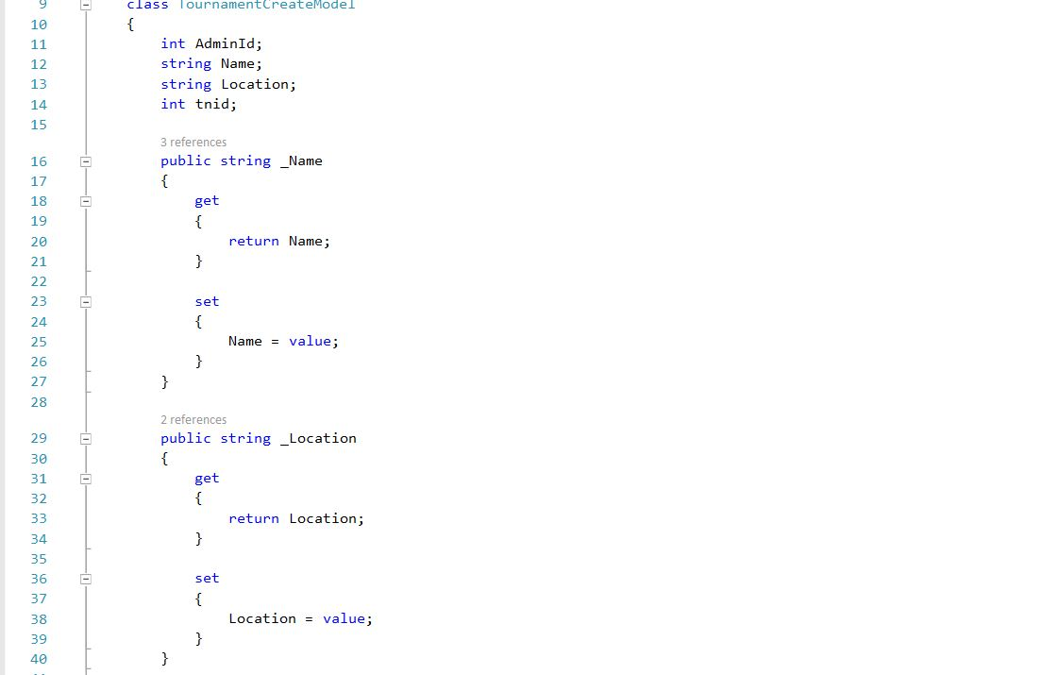

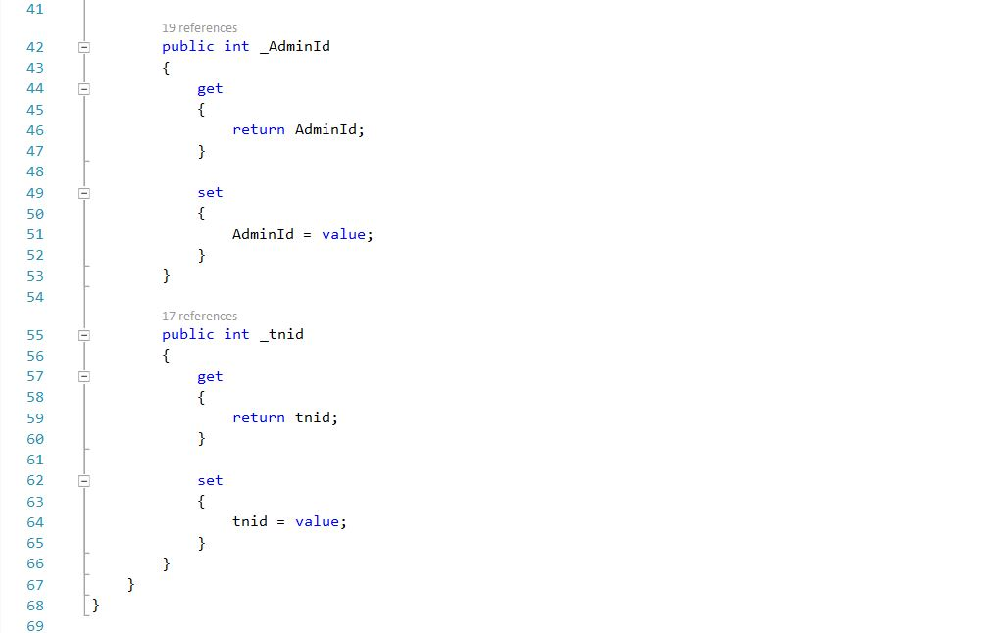

Figure: Model of Creating a Tournament

**UI**

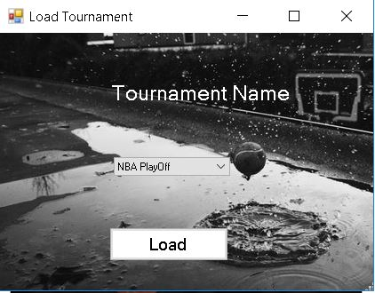

Figure: UI of Loading a Tournament

**Code**

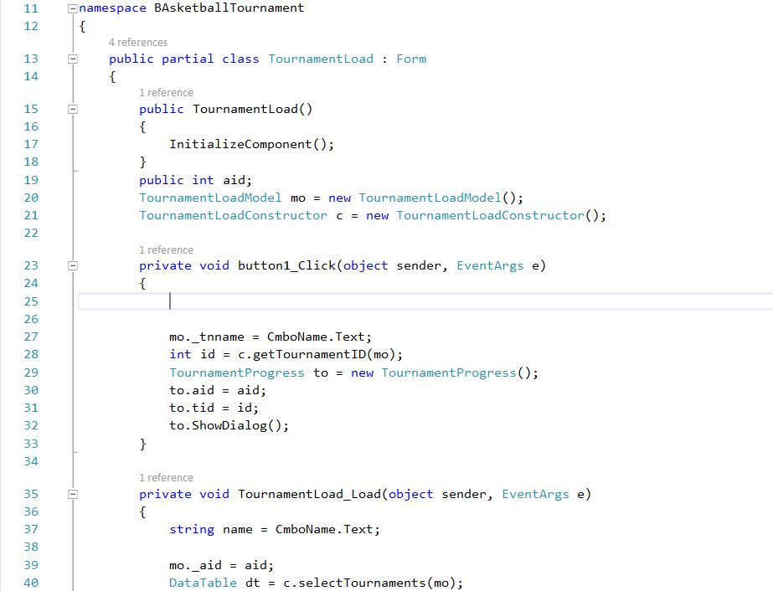

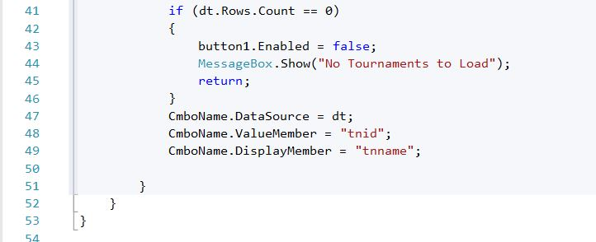

Figure: View of Loading a Tournament

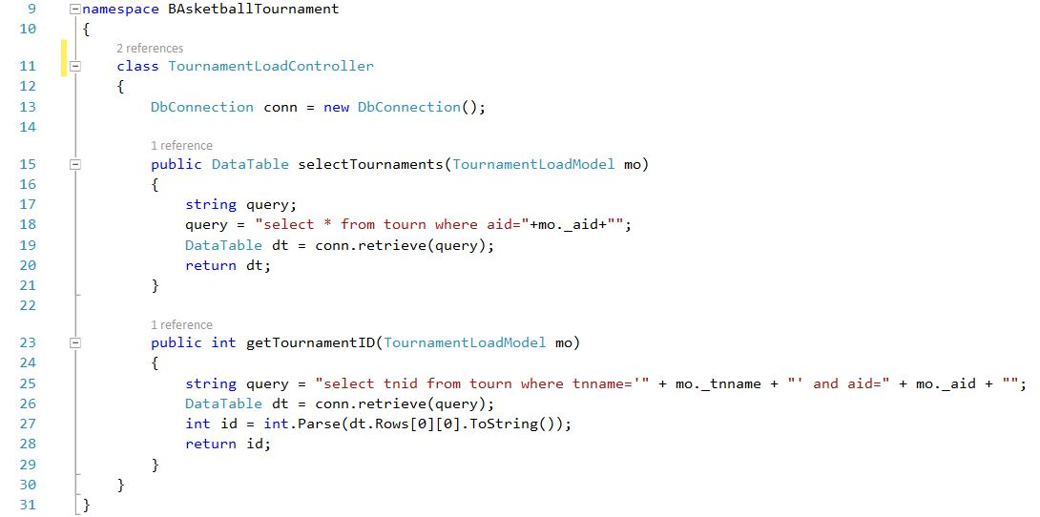

Figure: Controller of Loading a Tournament

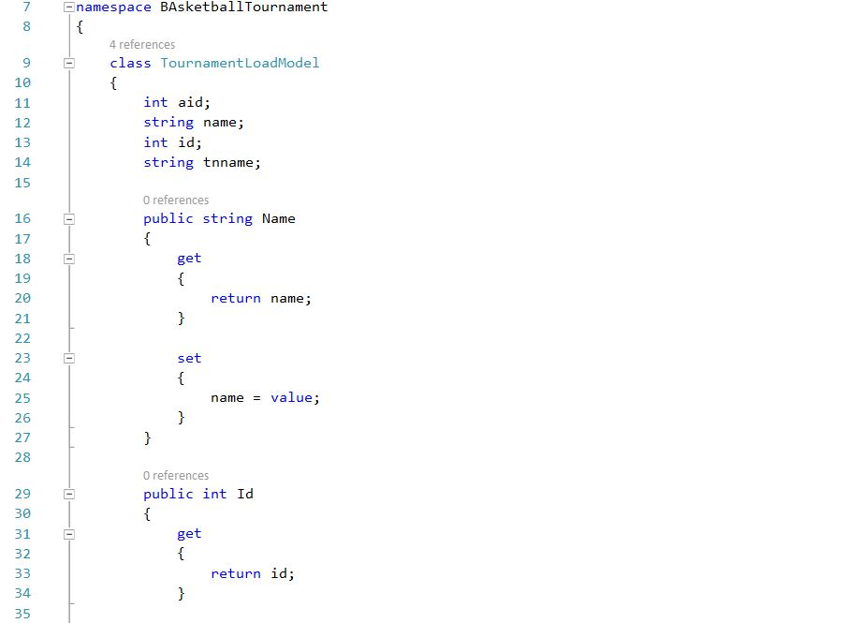

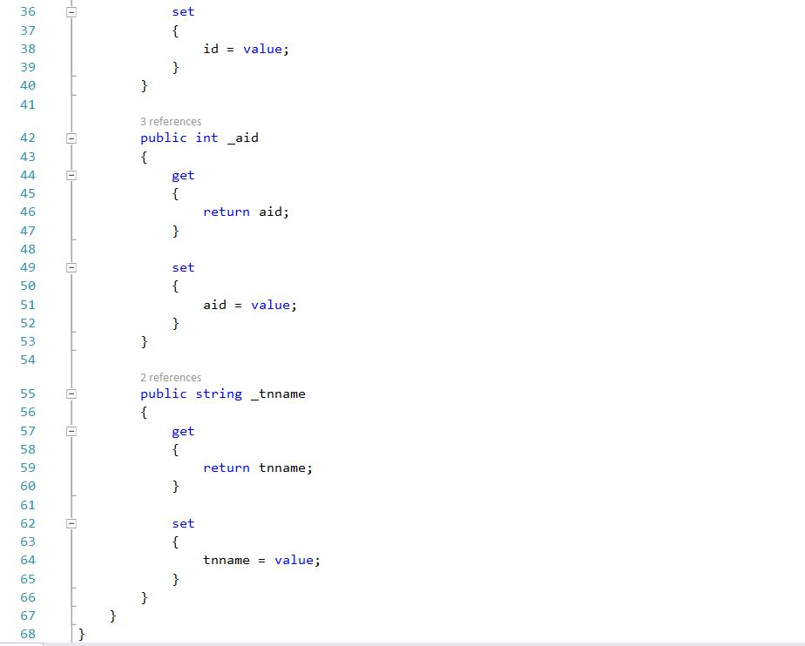

Figure: Model of Loading a Tournament

**UI**

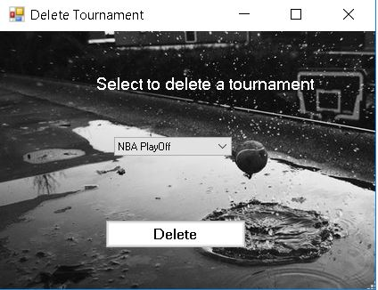

Figure: UI of Deleting a Tournament

**Code**

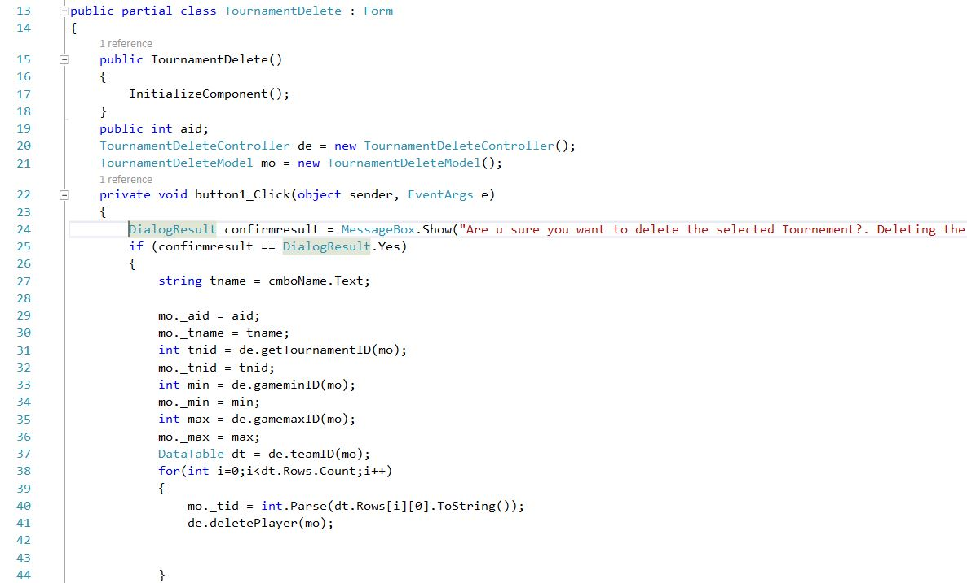

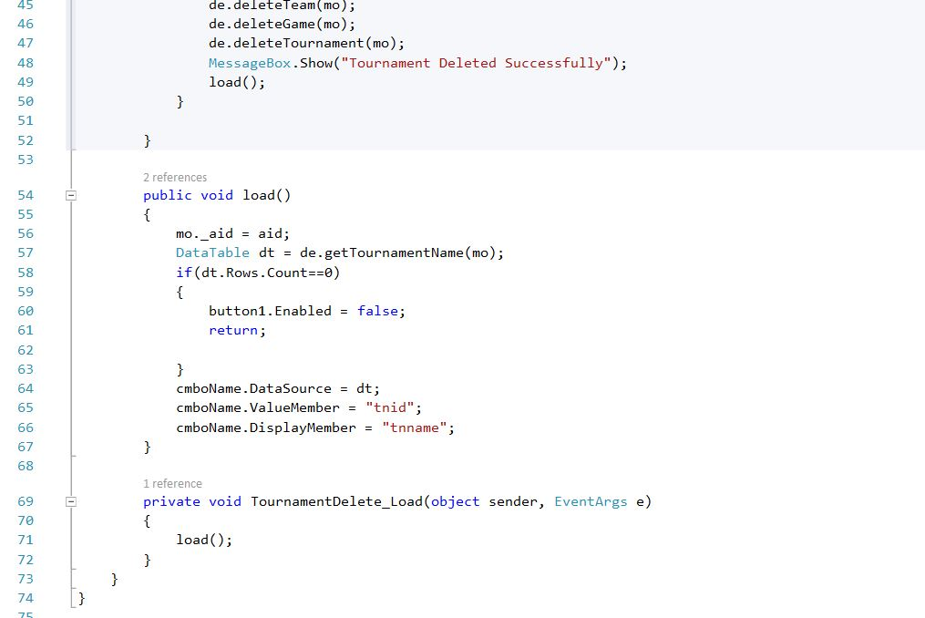

Figure: View of Deleting a Tournament

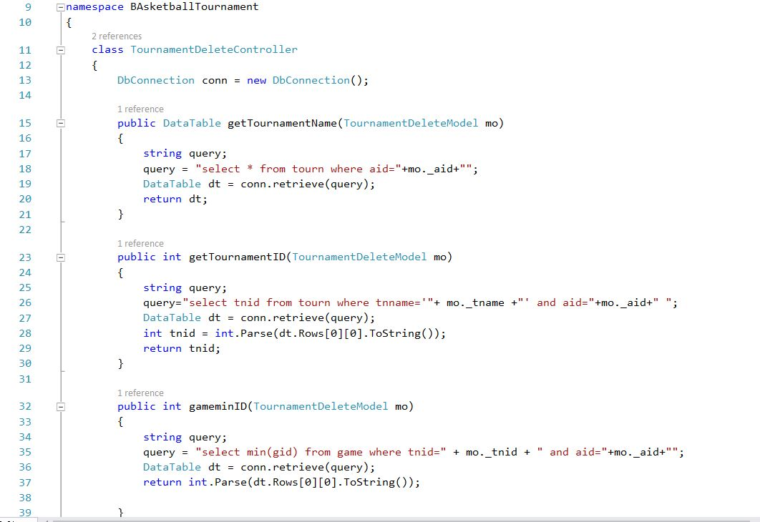

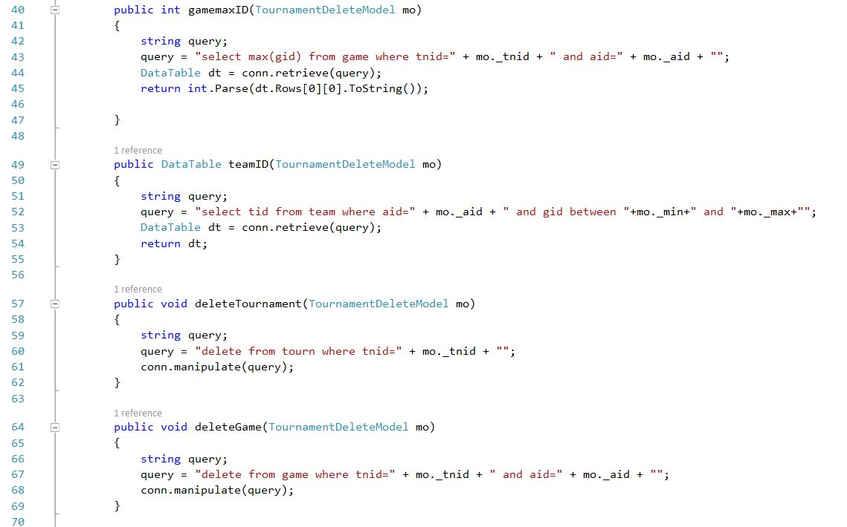

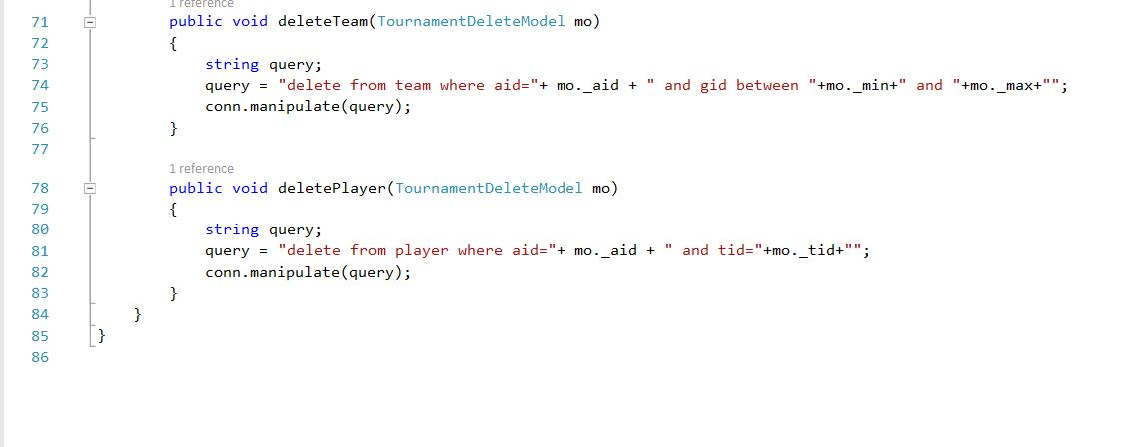

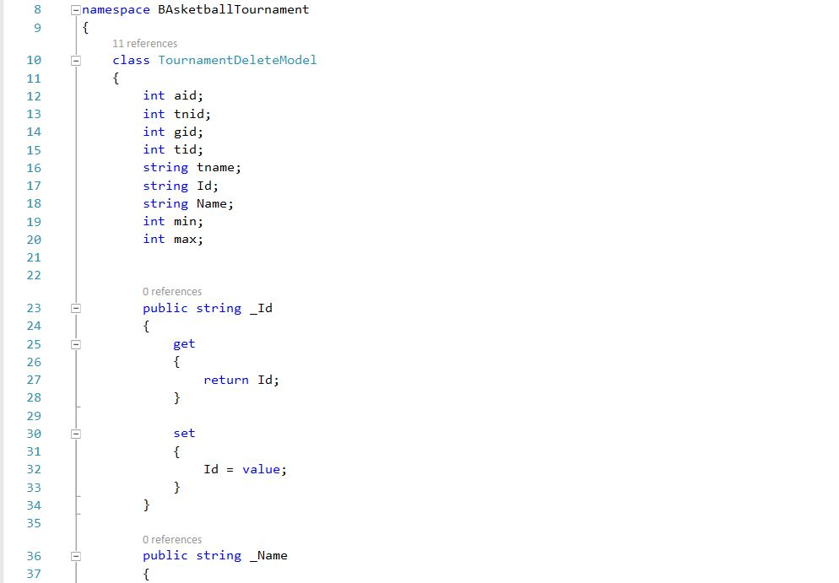

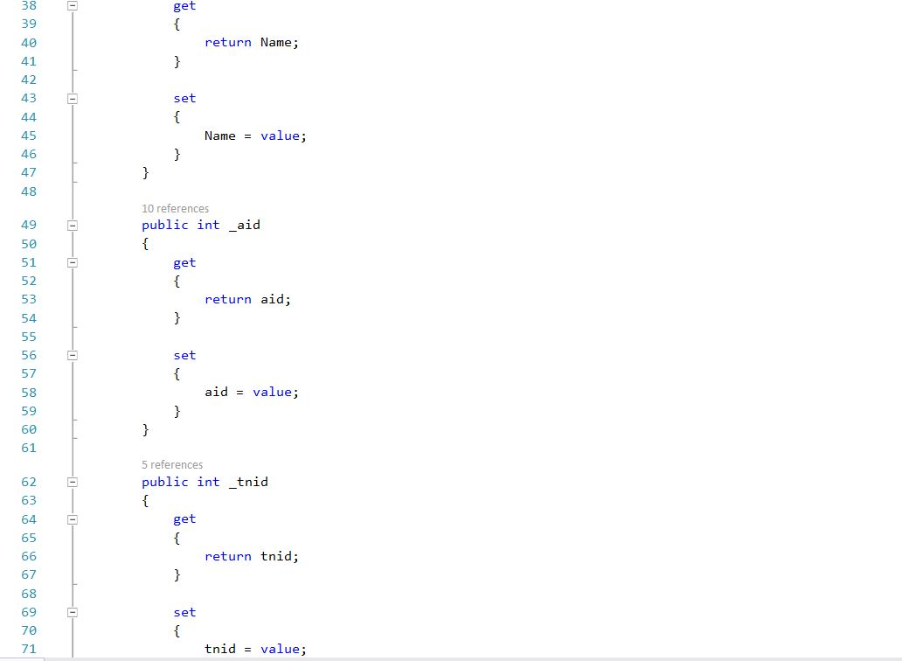

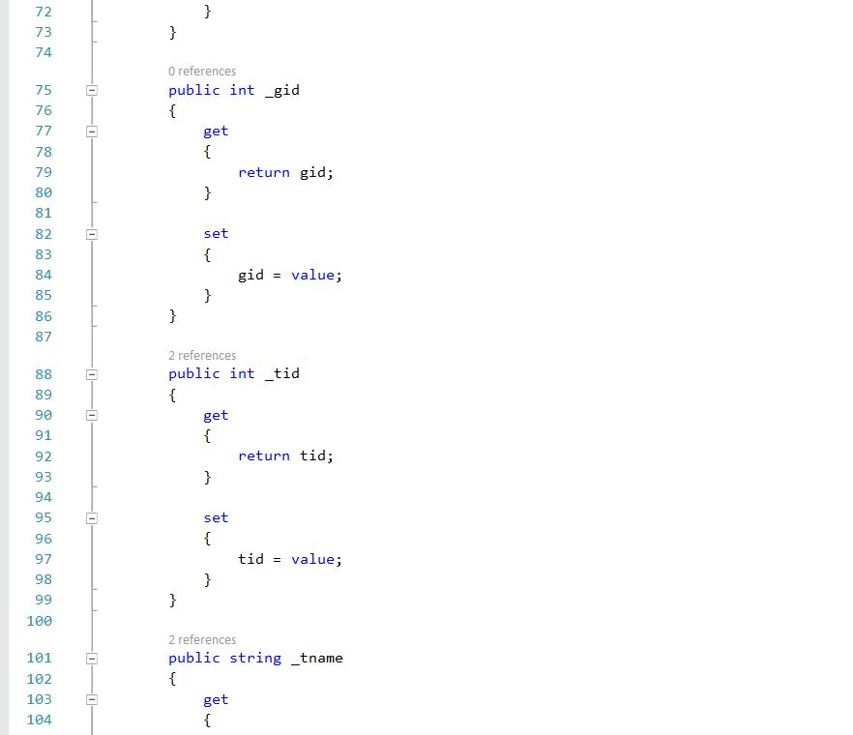

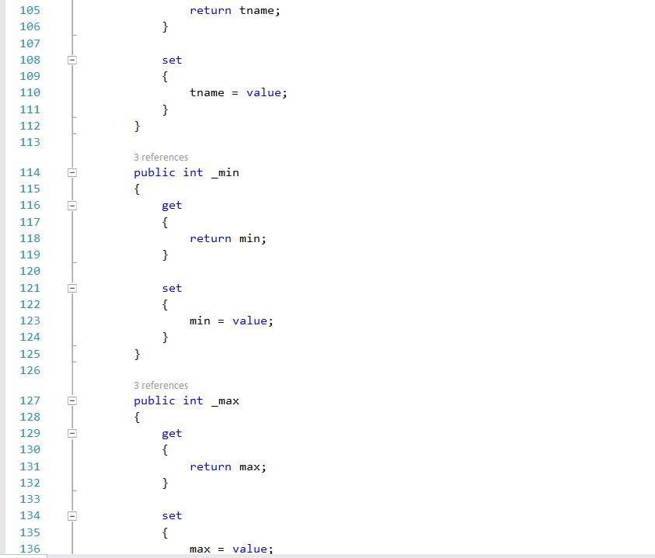

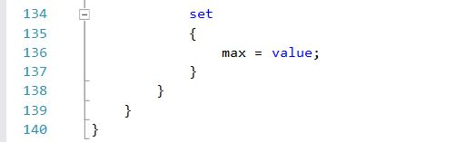

Figure: Model of Deleting a Tournament

**UI**

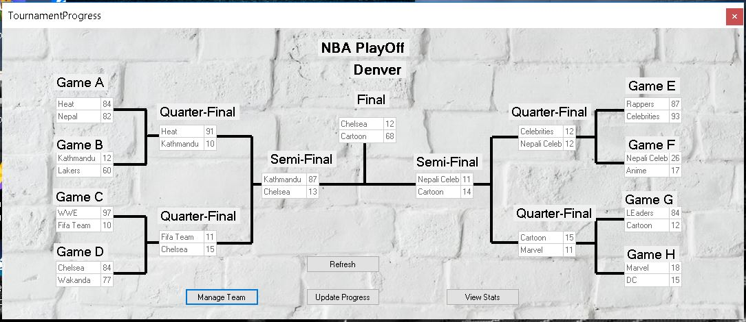

Figure: UI of Tournament Progress

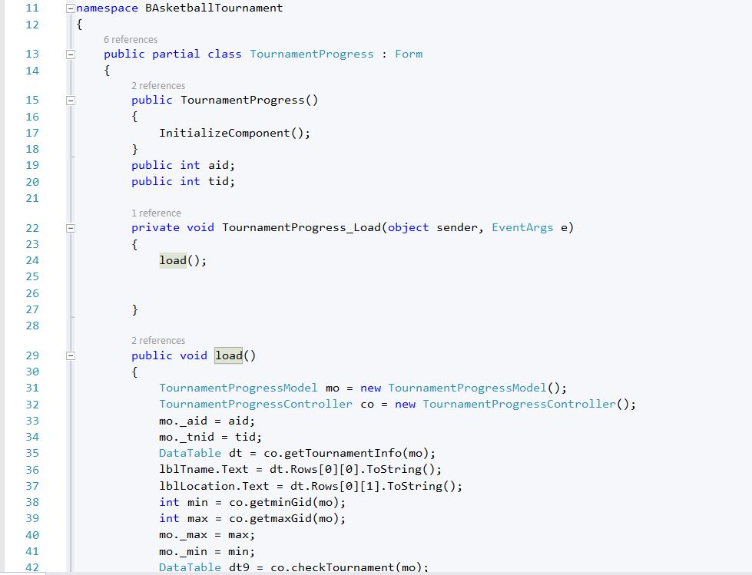

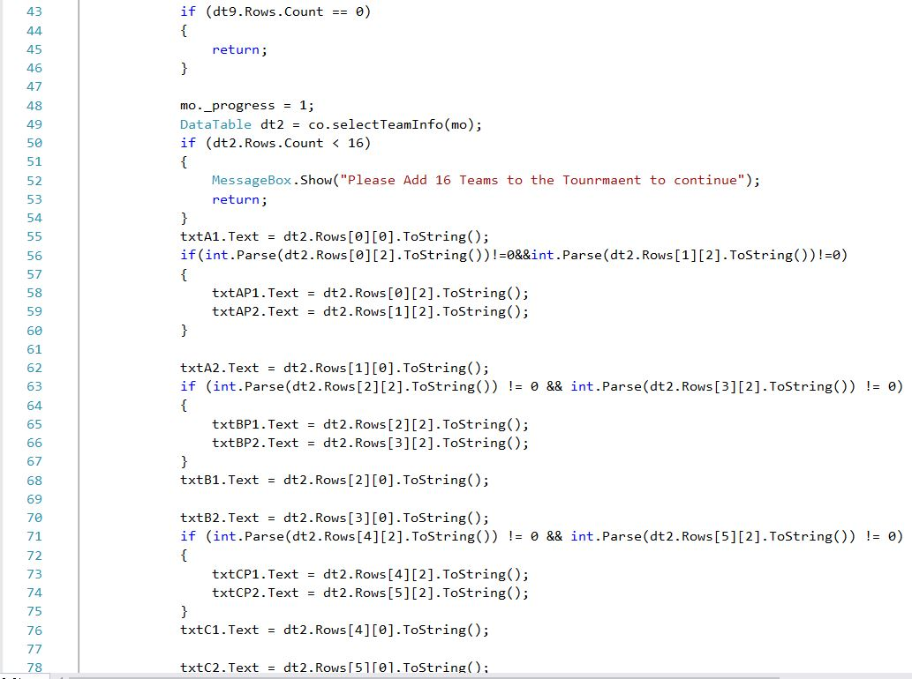

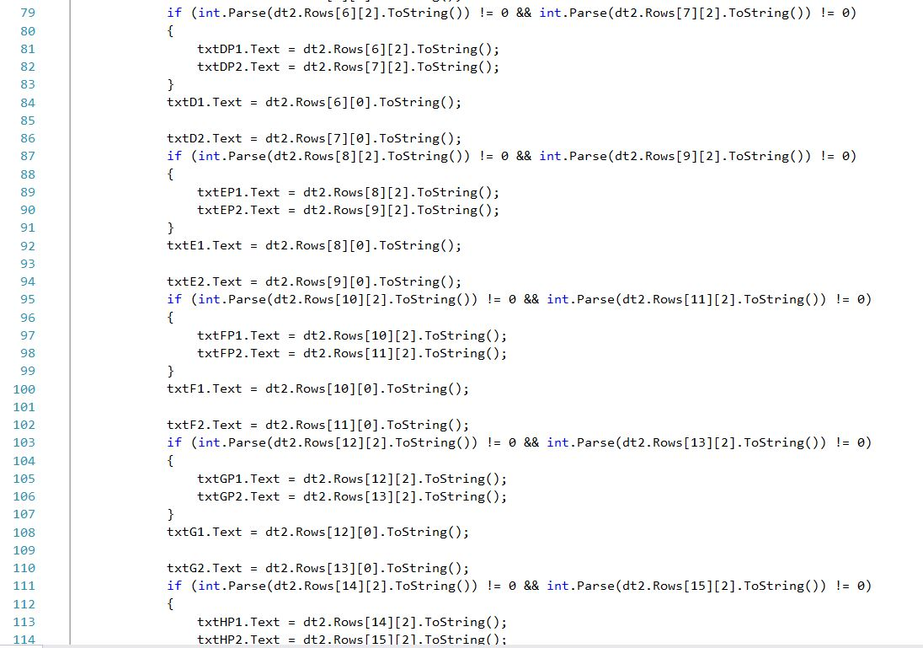

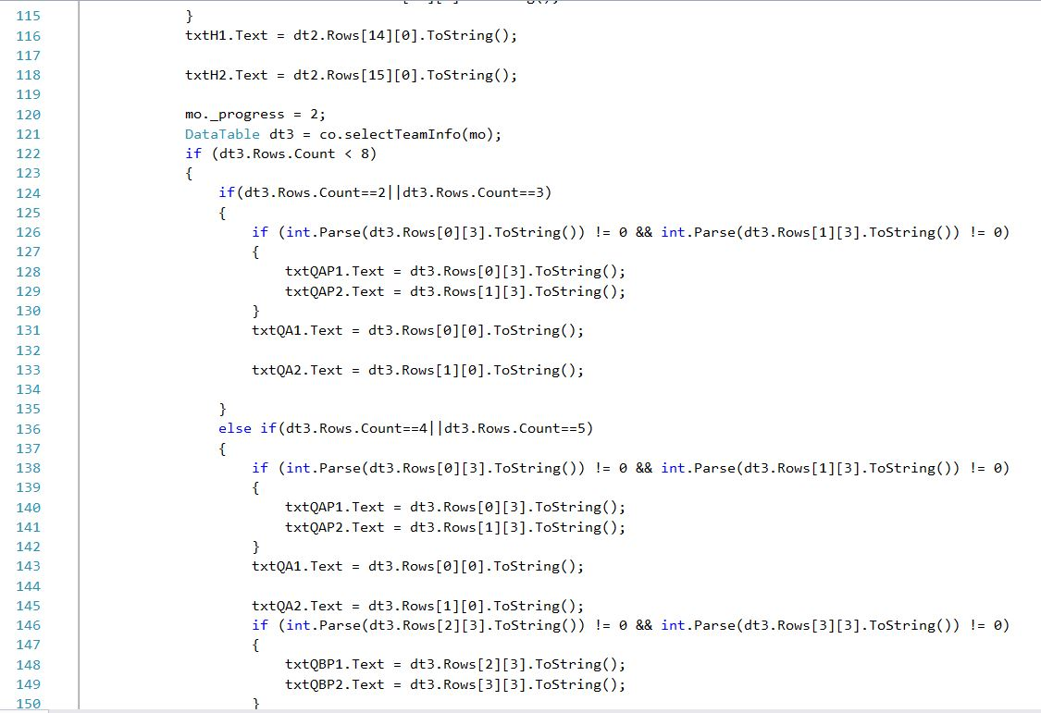

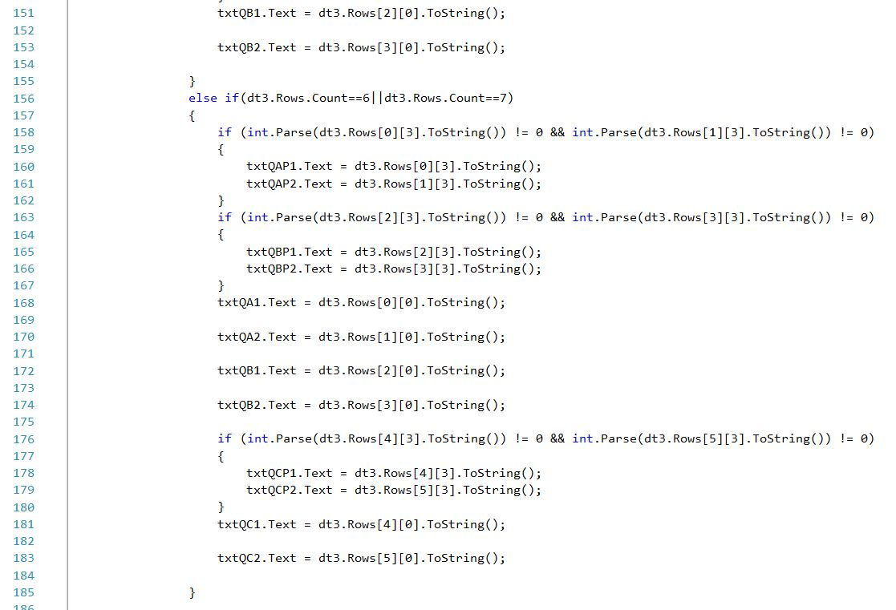

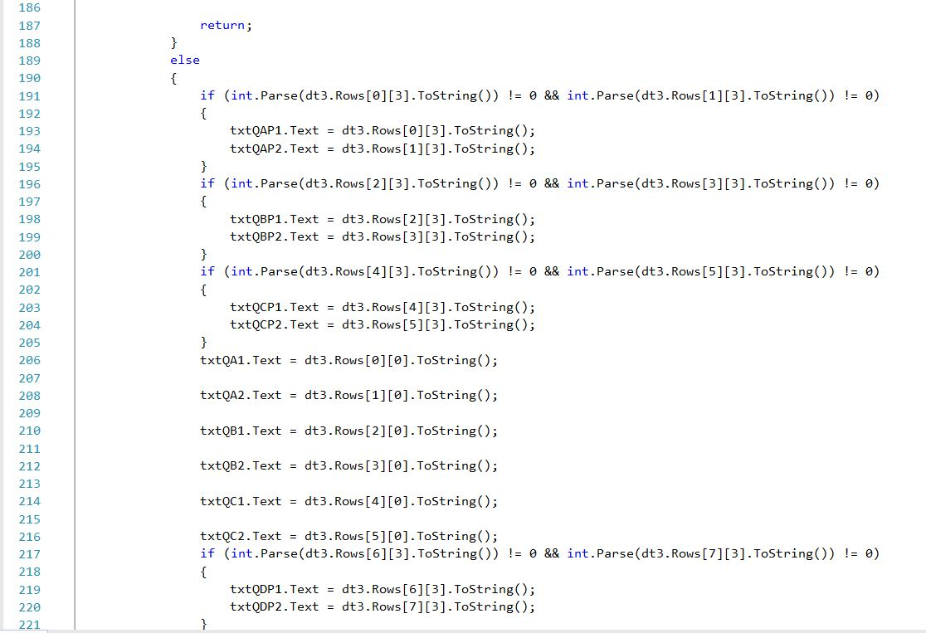

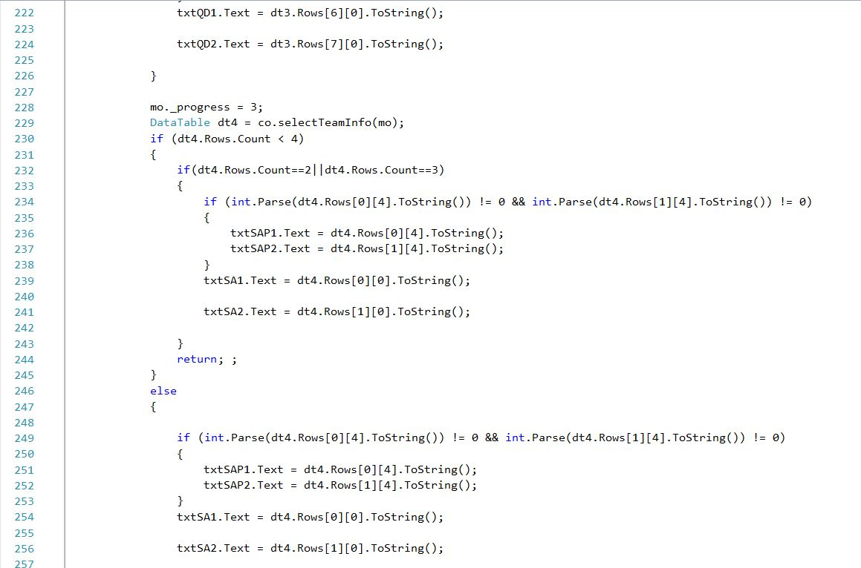

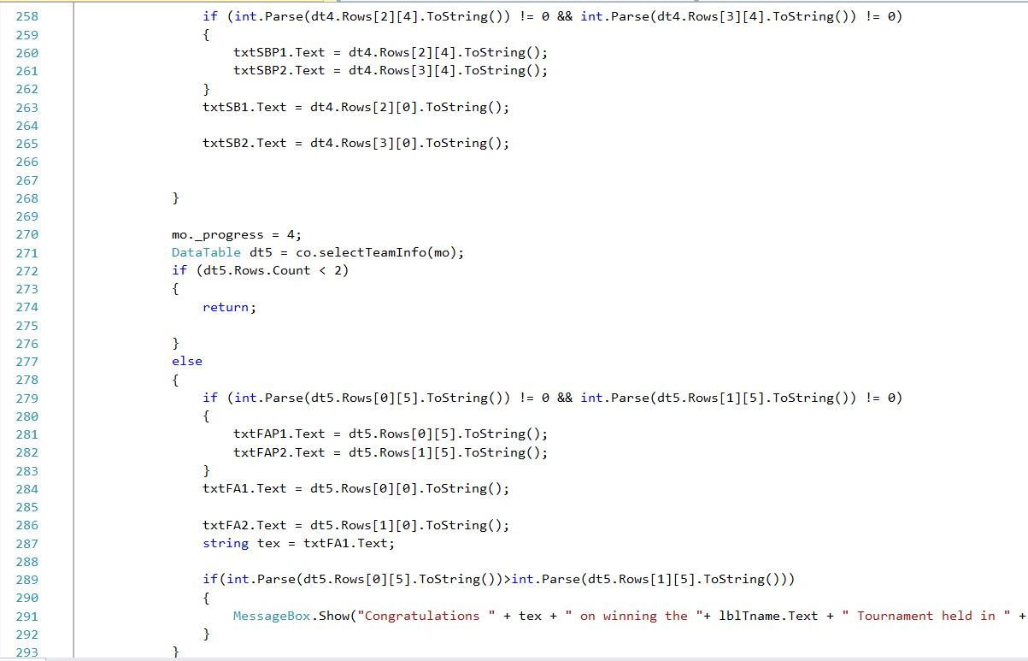

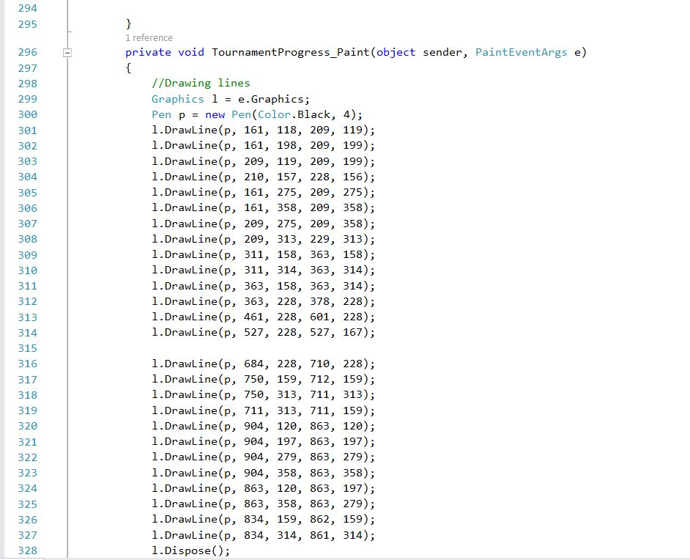

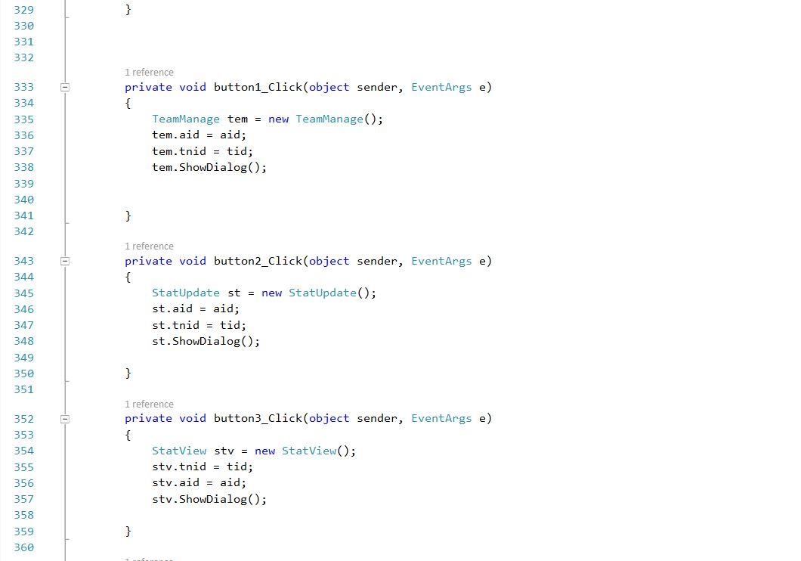

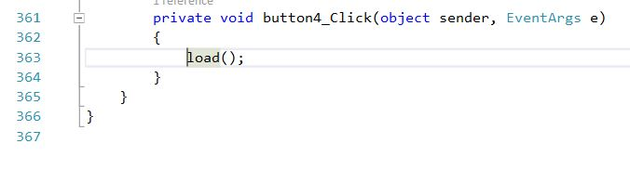

Figure: View of Tournament Progress

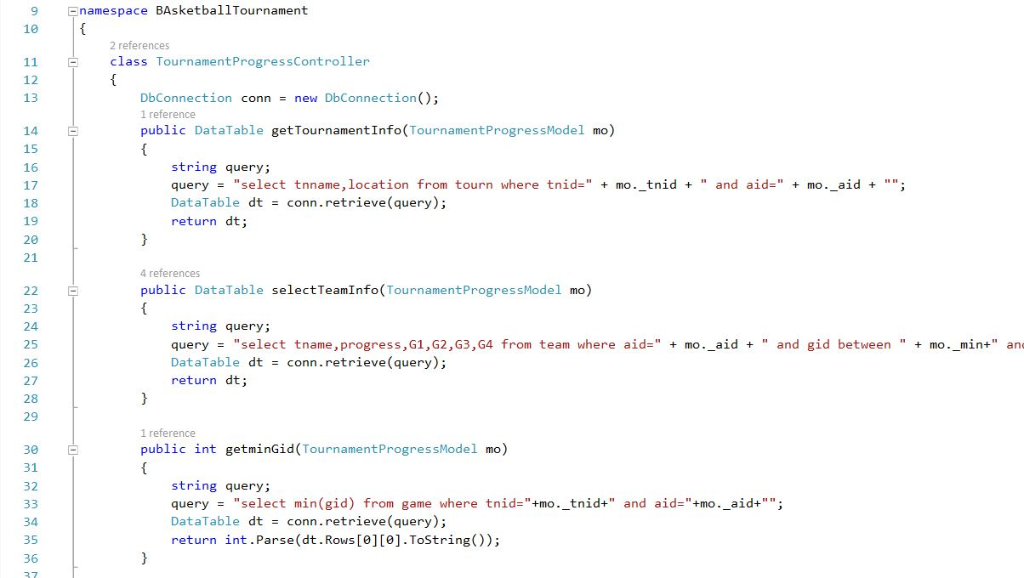

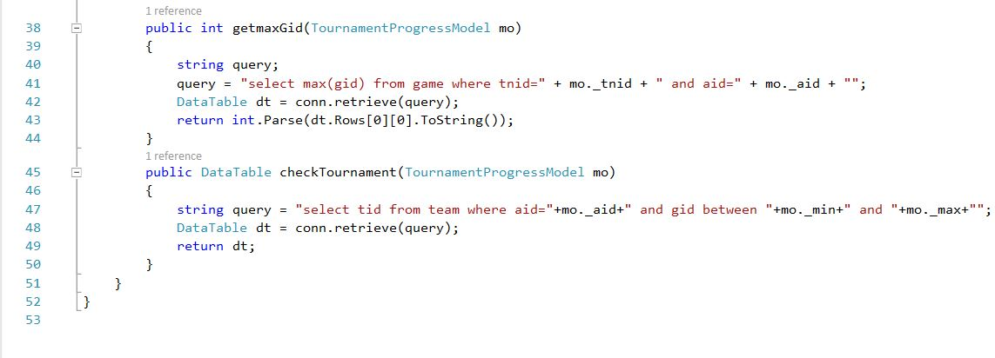

Figure: Controller of Tournament Progress

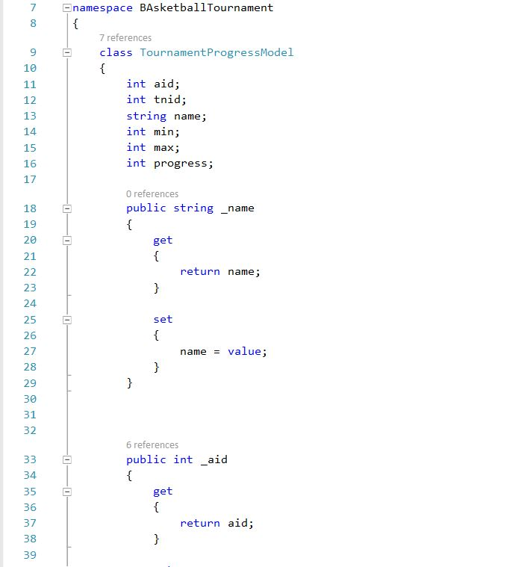

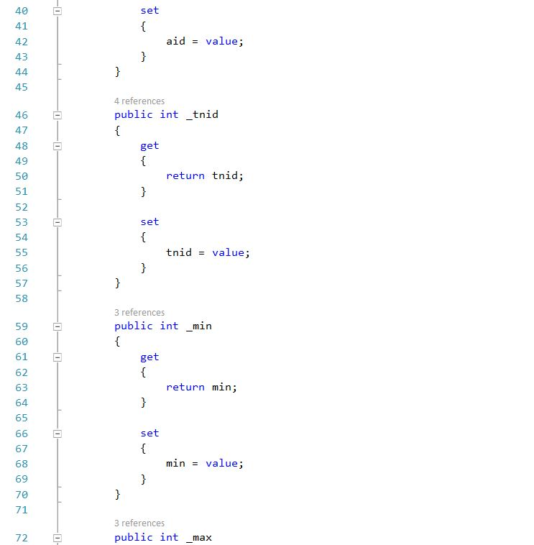

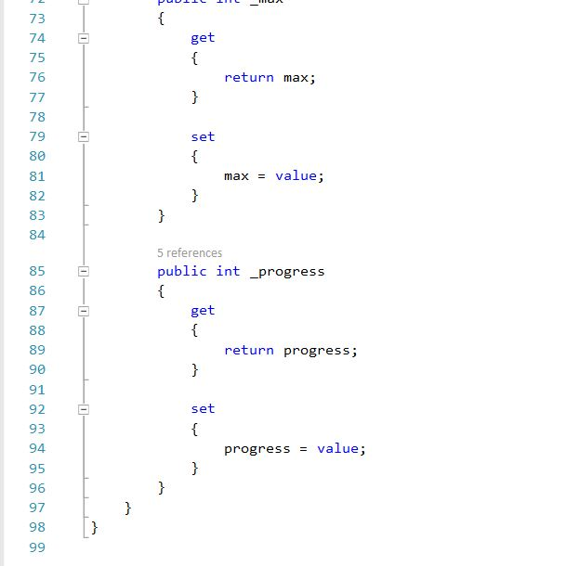

Figure: Model of Tournament Progress

**UI**

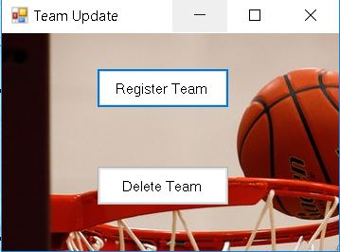

Figure: UI of Team Update Option

**Code**

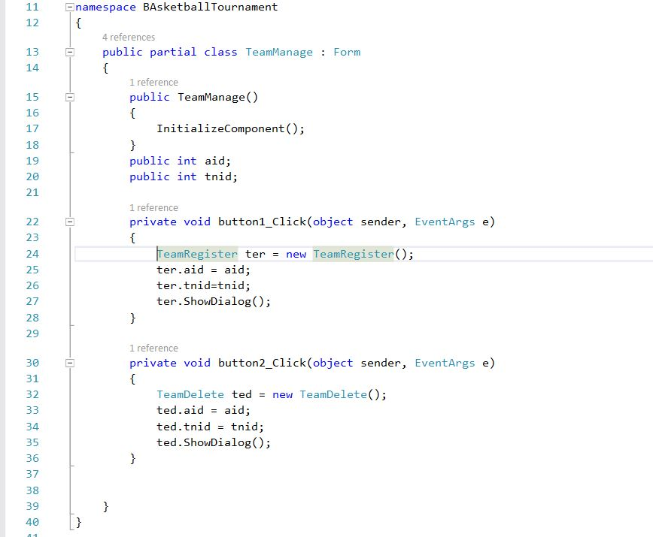

Figure: Code of Team Update Option

**UI**

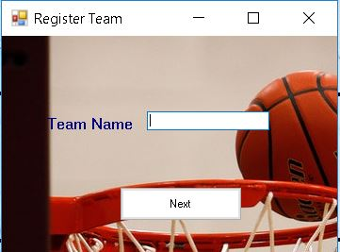

Figure: UI of registering a team

**Code**

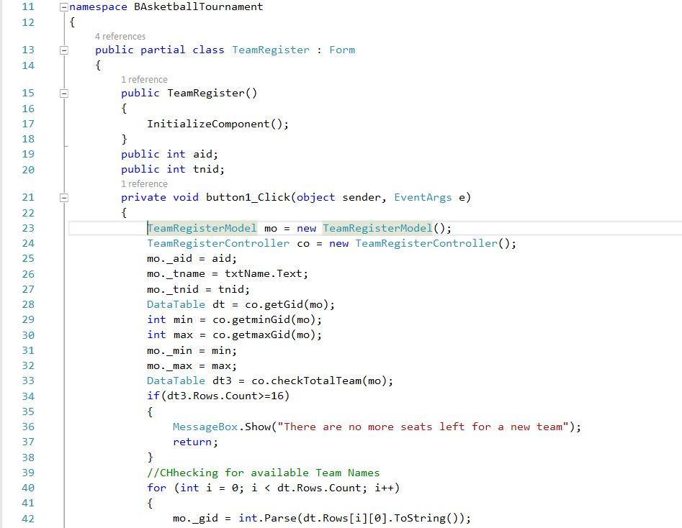

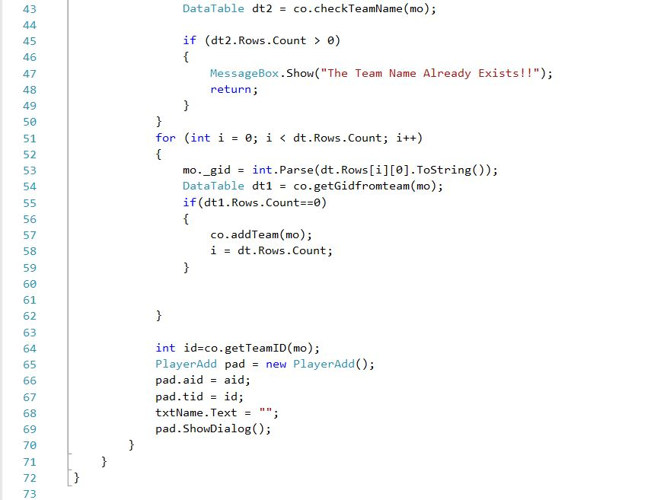

Figure: View of Registering a Team

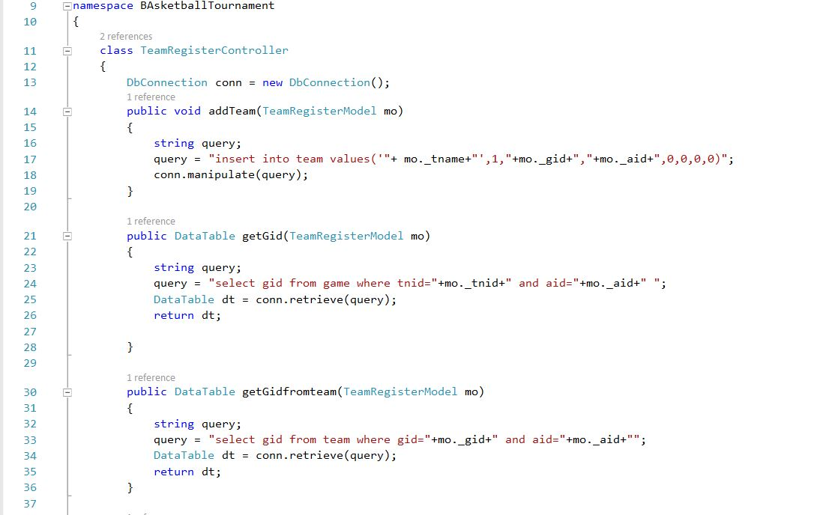

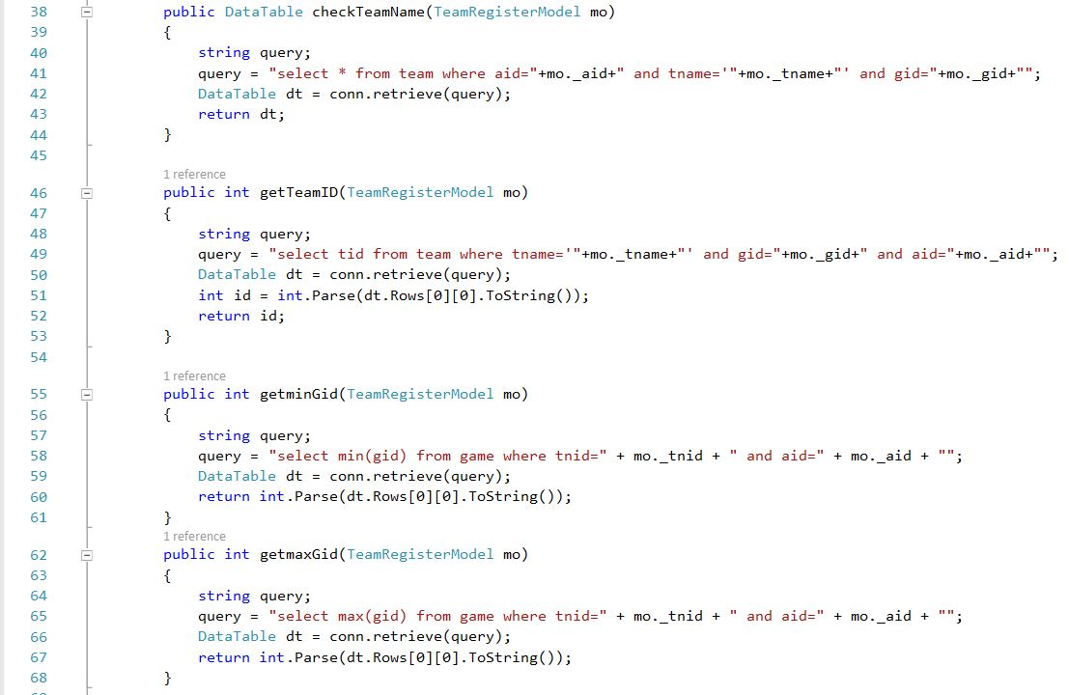

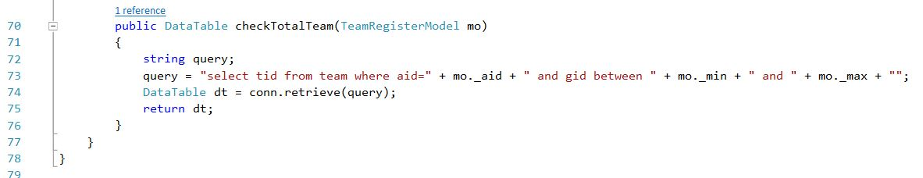

Figure: Controller of Registering a Team

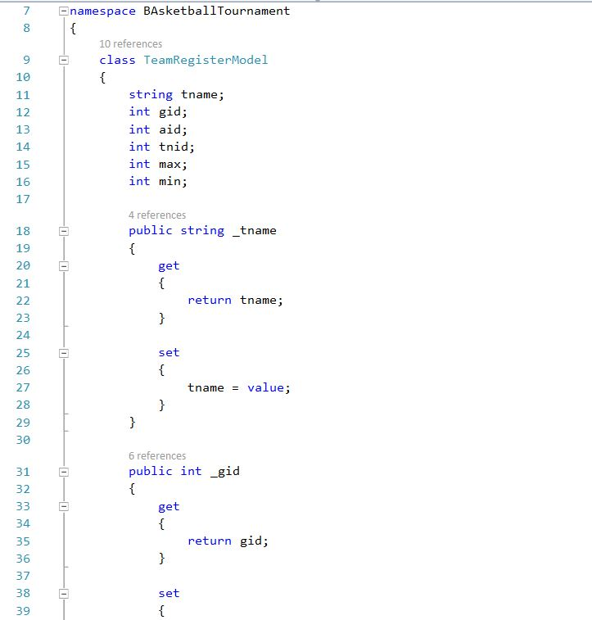

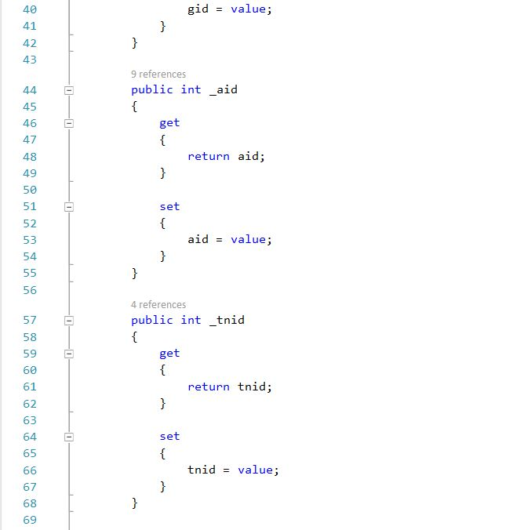

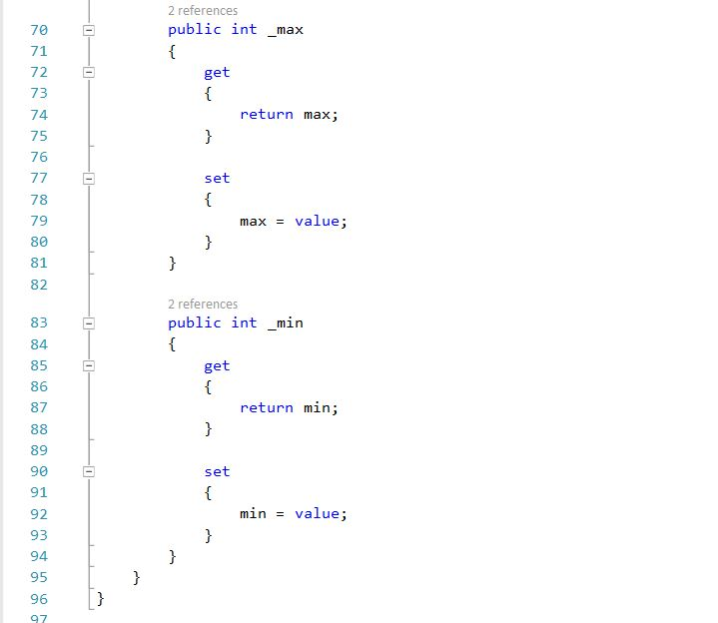

Figure: Model of Registering a Model

**UI**

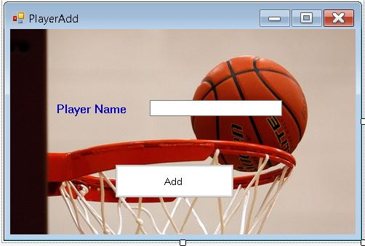

Figure: UI of Adding Players

**Code**

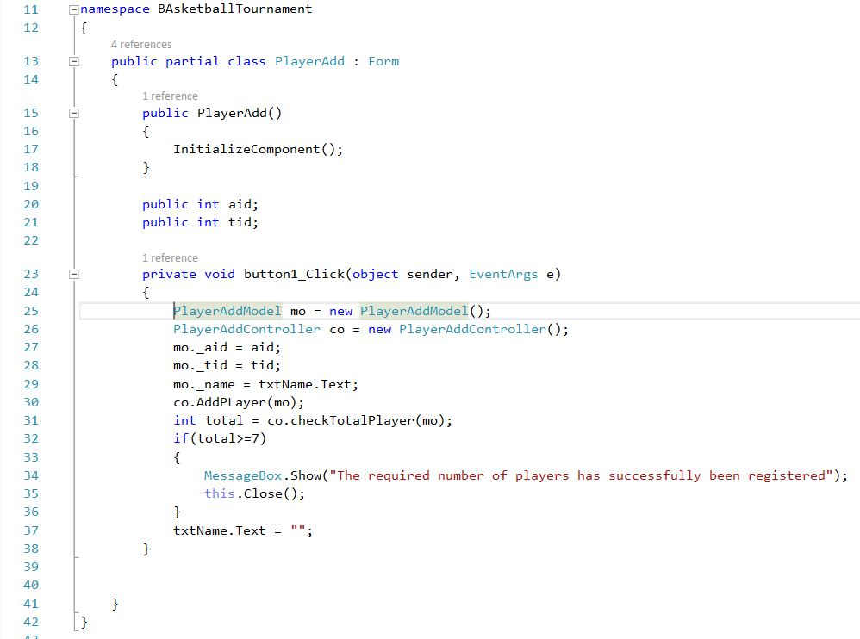

Figure: View of Adding Players

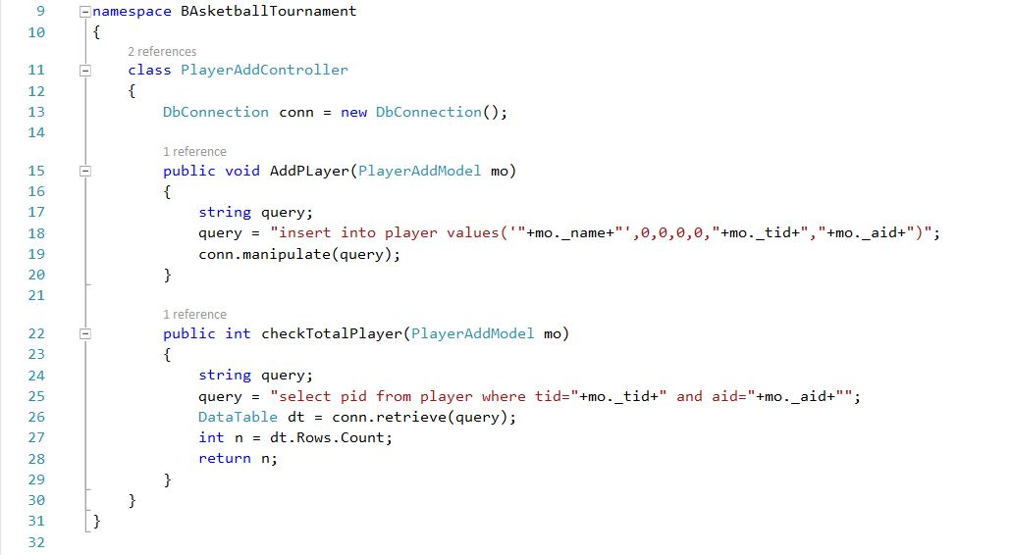

Figure: Controller of Adding Players

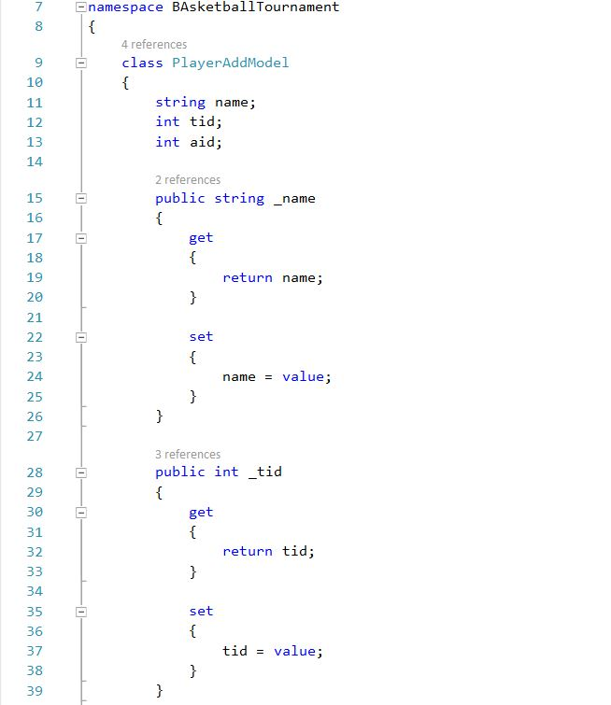

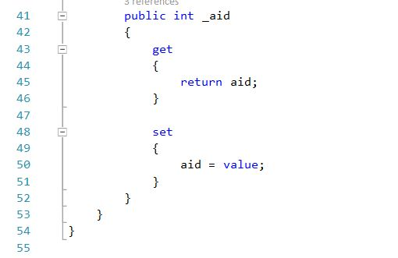

Figure: Model of Adding Players

**UI**

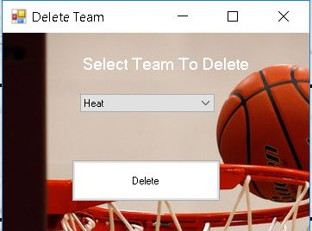

Figure: UI of Deleting a Team

**Code**

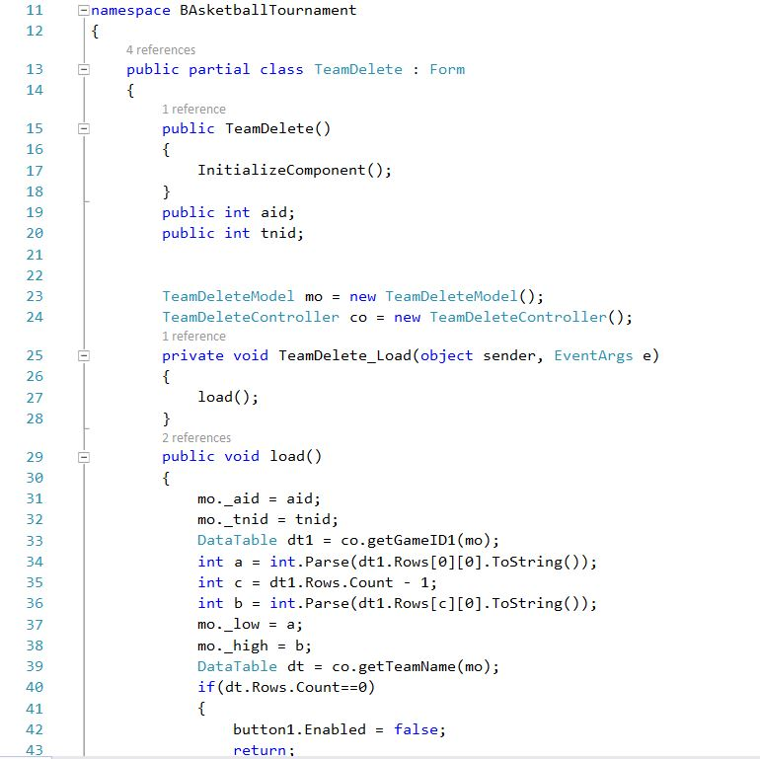

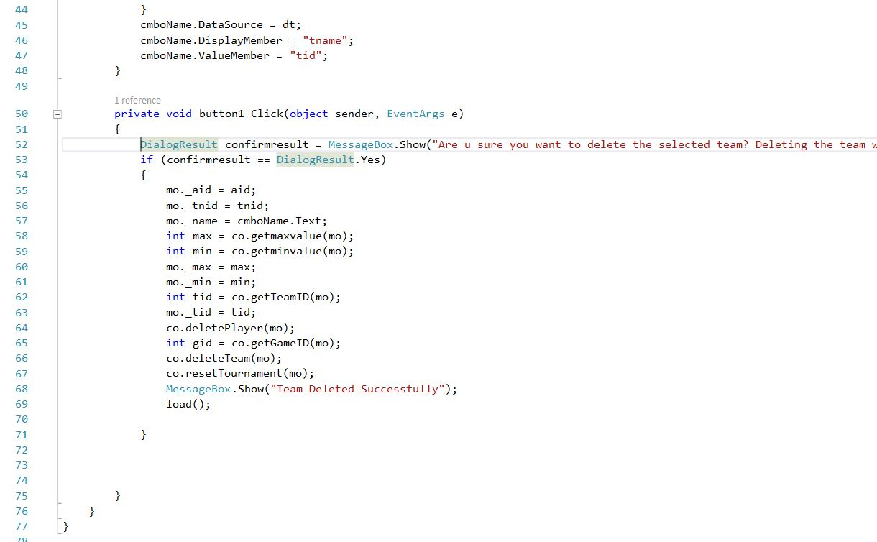

Figure: View of Deleting a Team

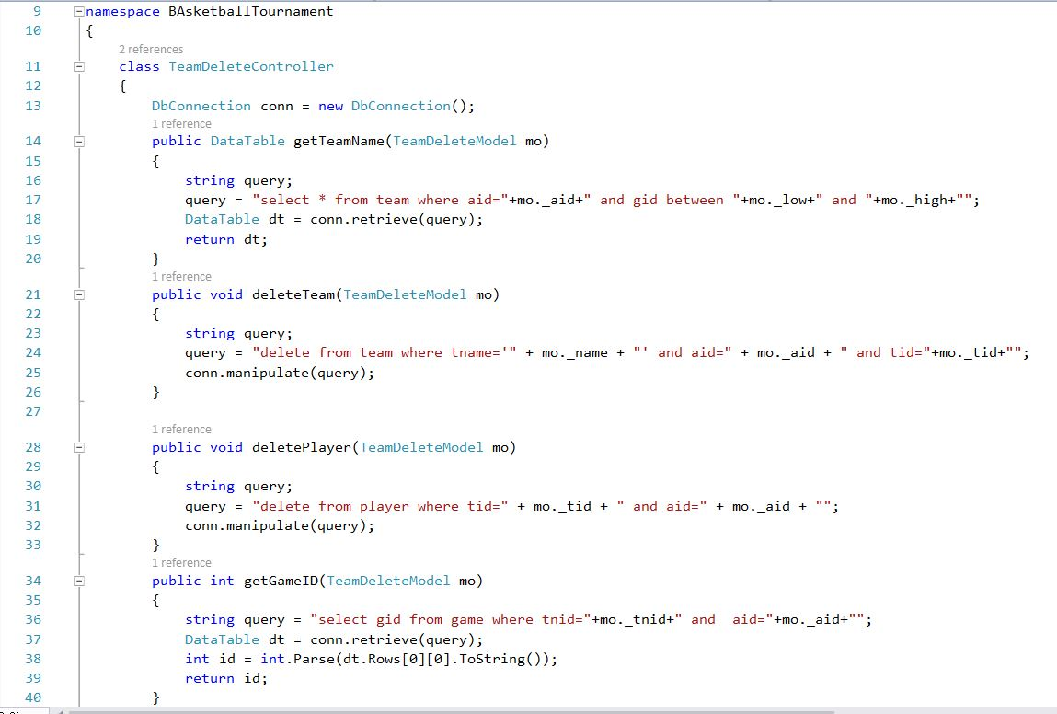

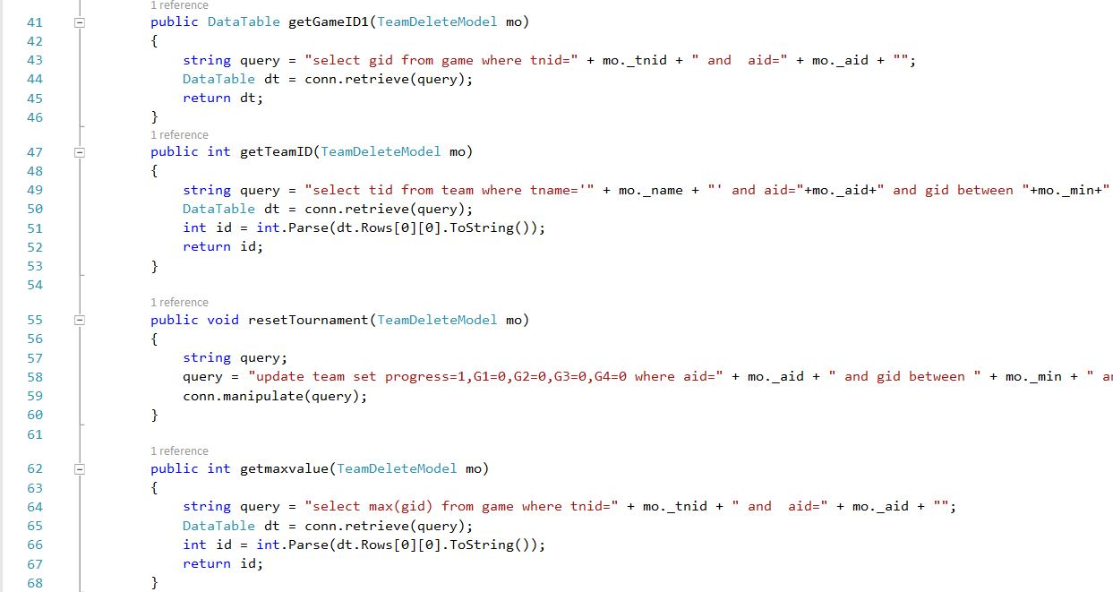

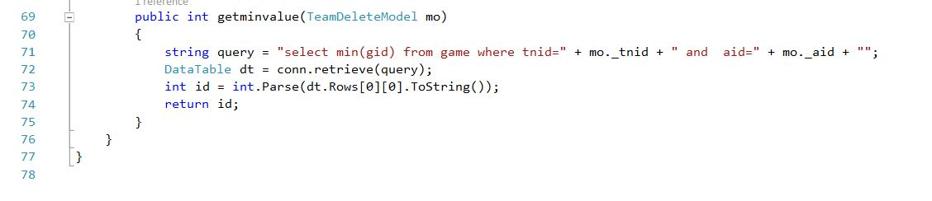

Figure: Controller of Deleting a Team

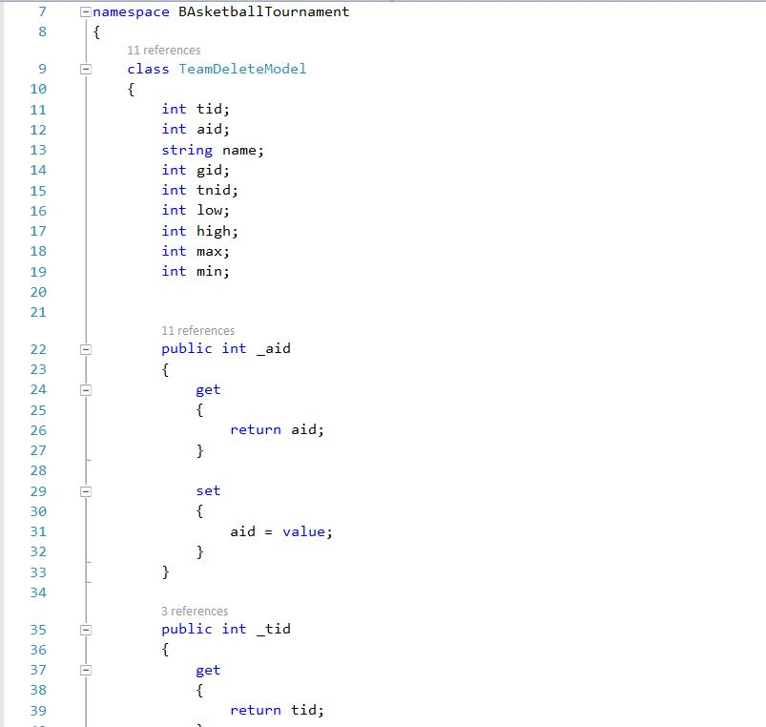

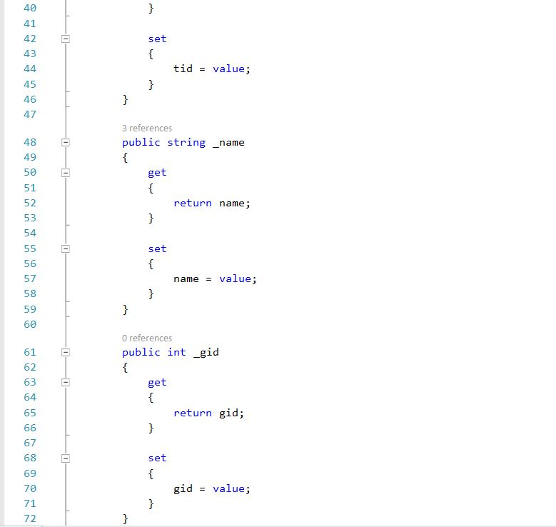

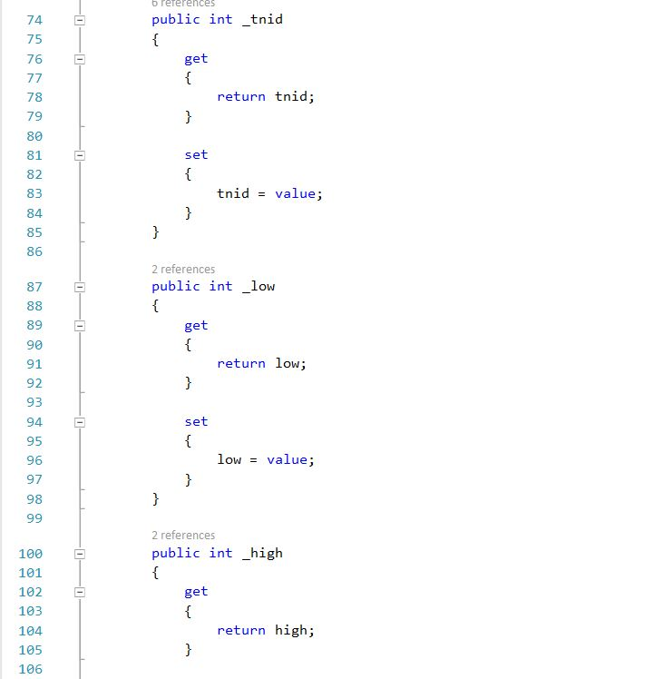

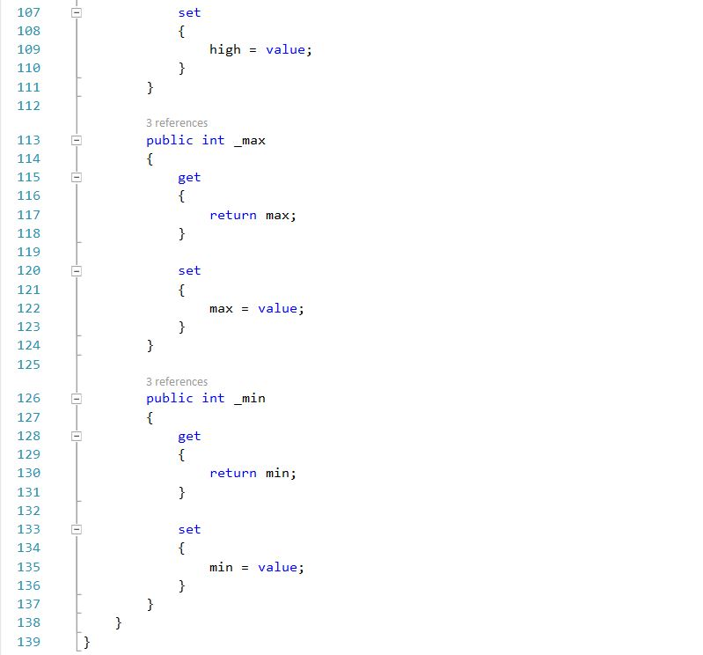

Figure: Model of Deleting a Team

**UI**

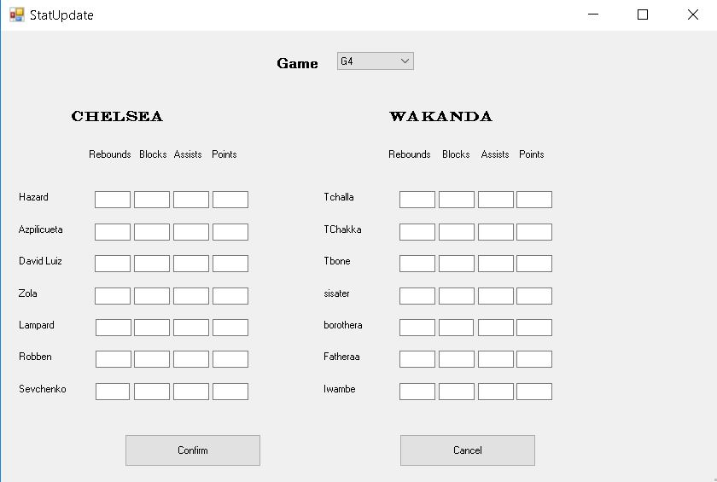

Figure: UI of Stat Update

**Code**

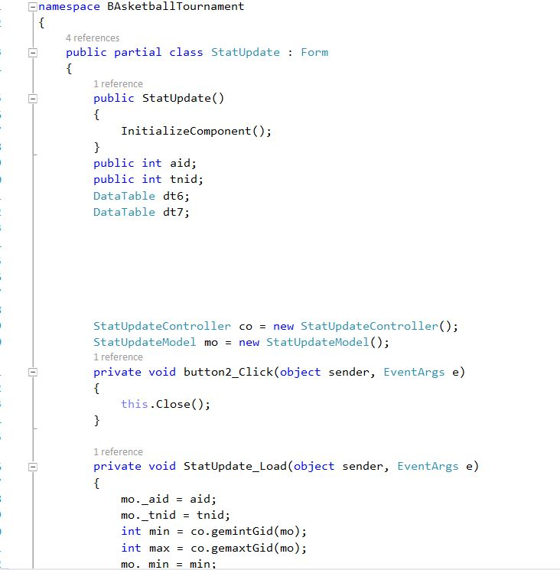

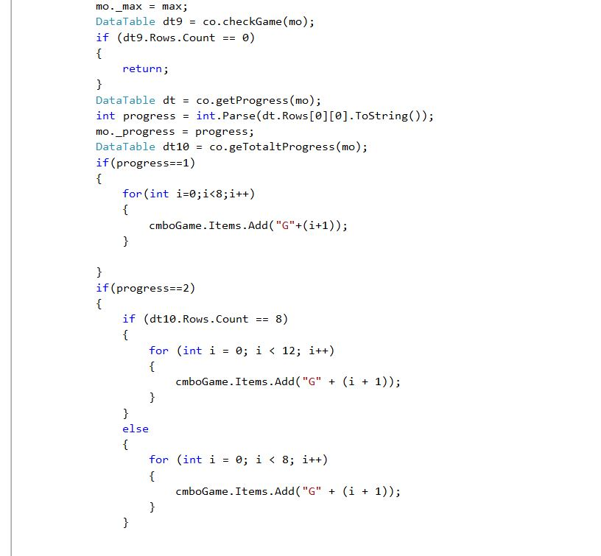

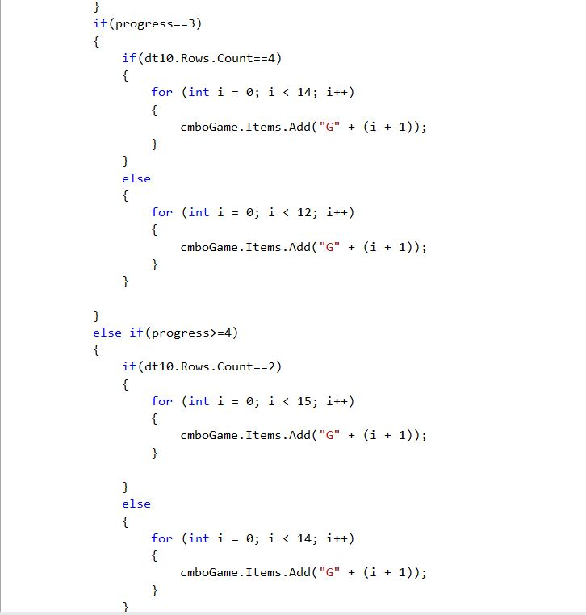

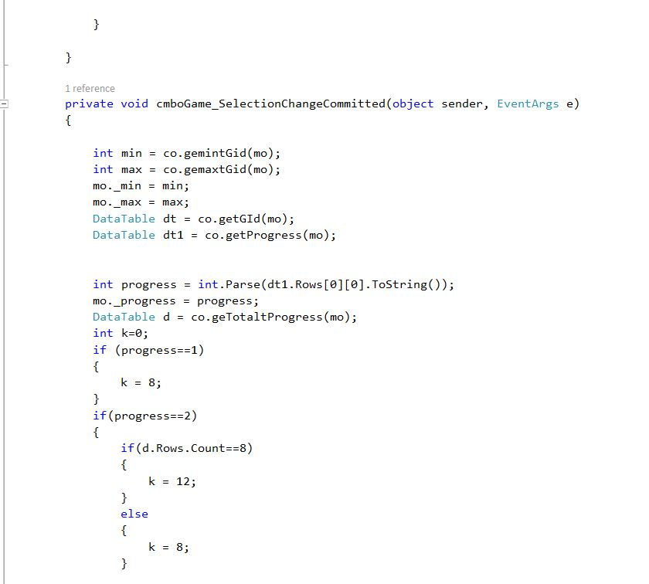

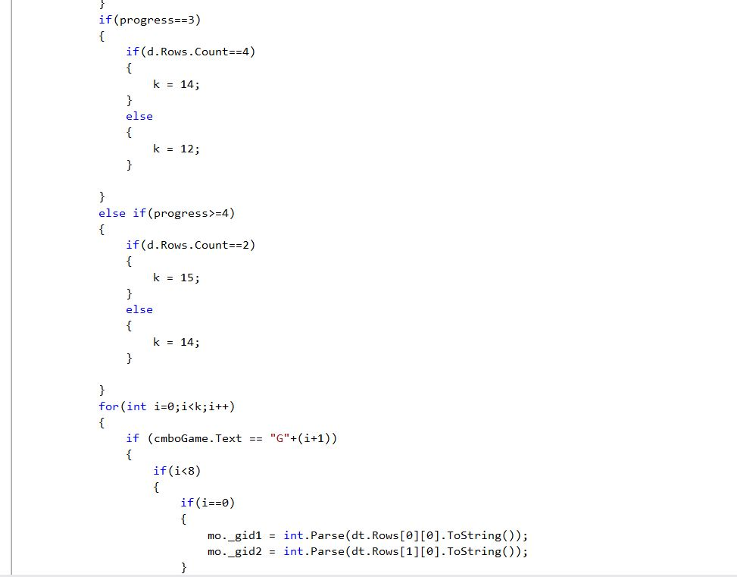

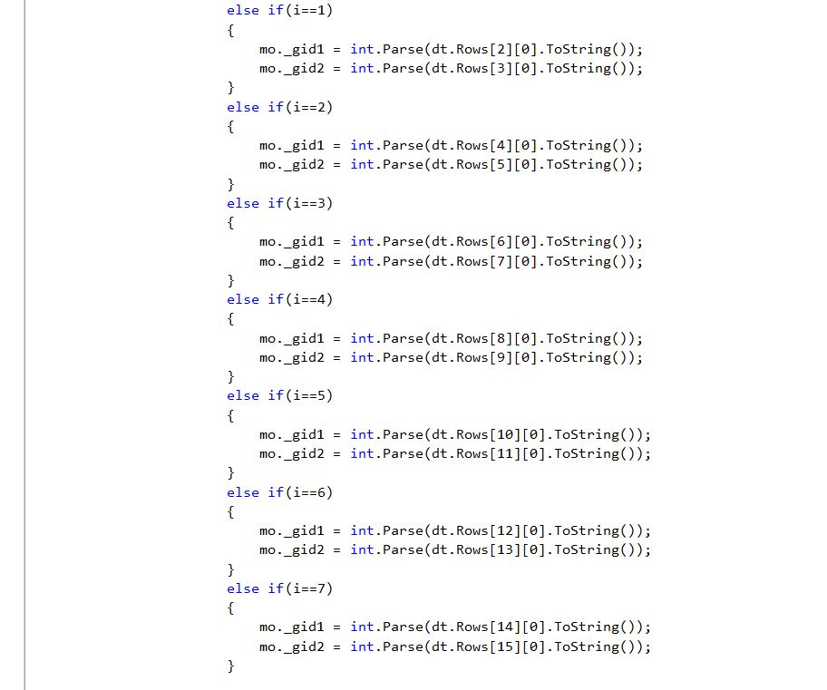

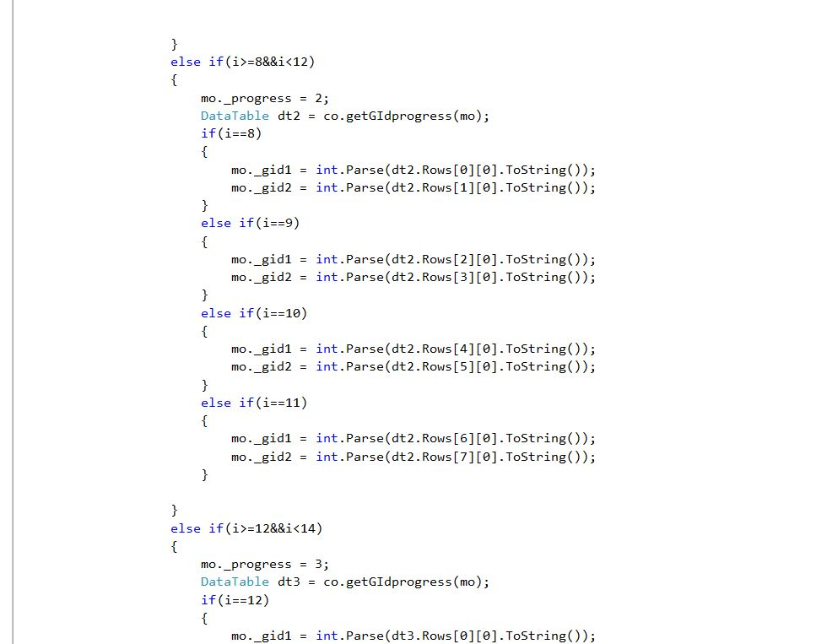

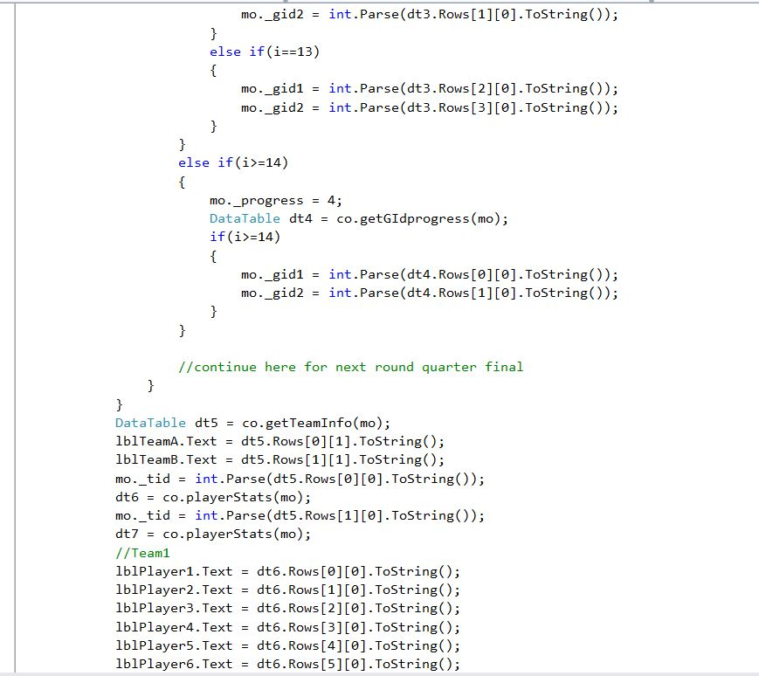

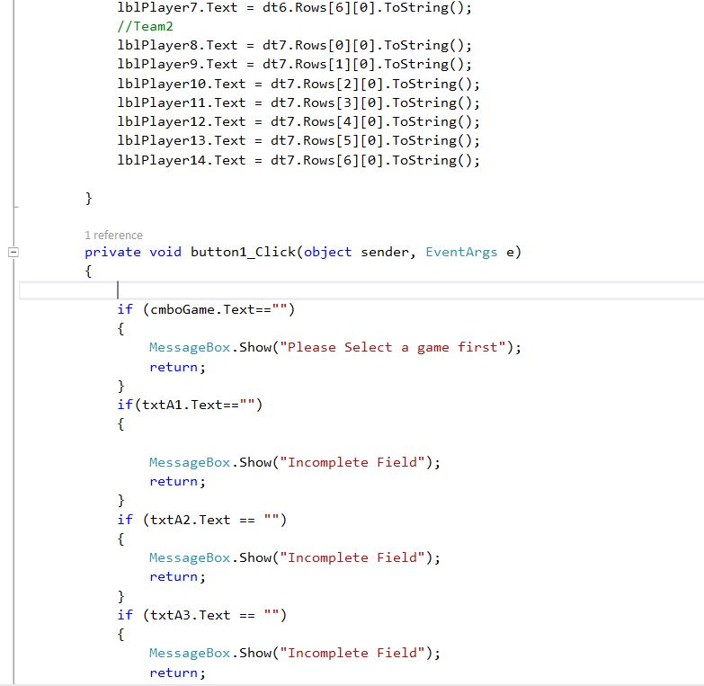

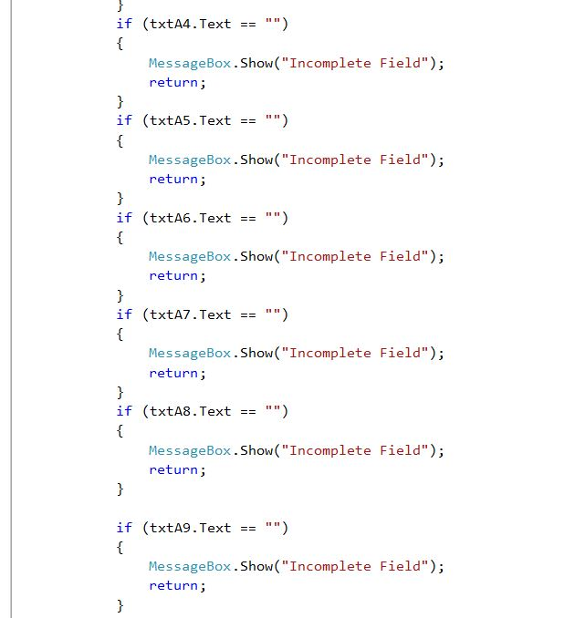

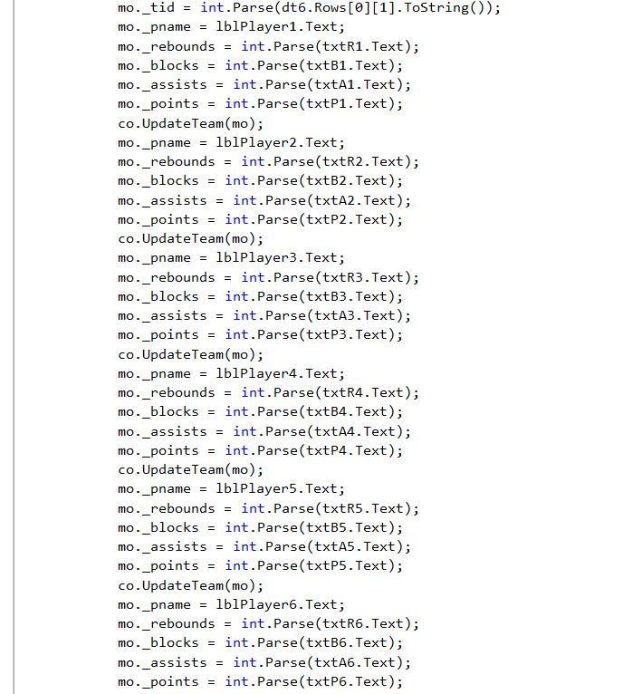

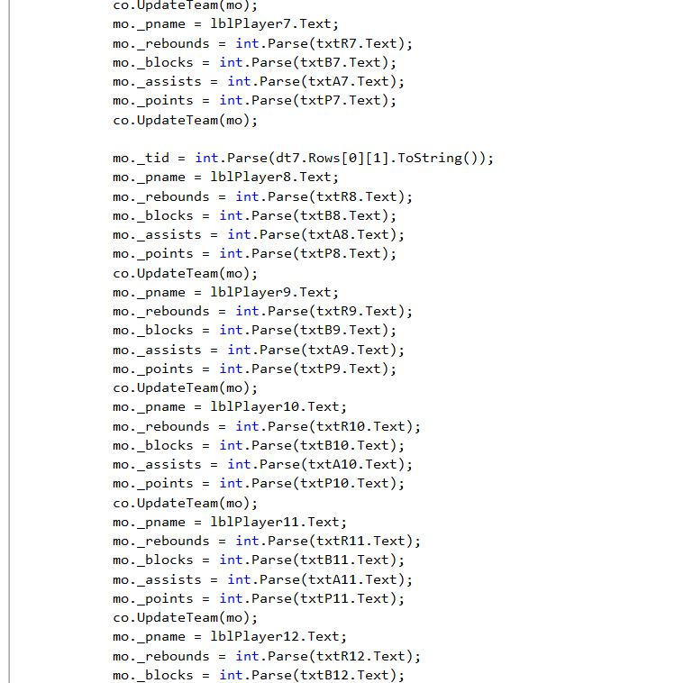

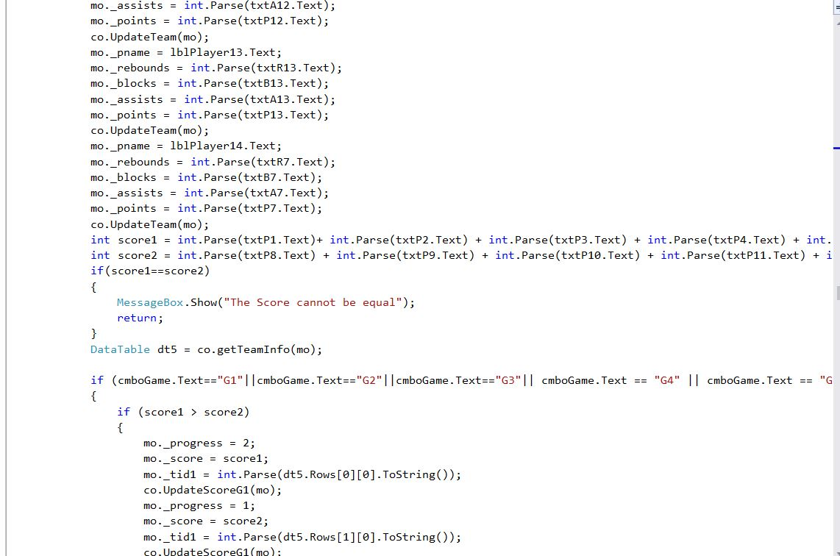

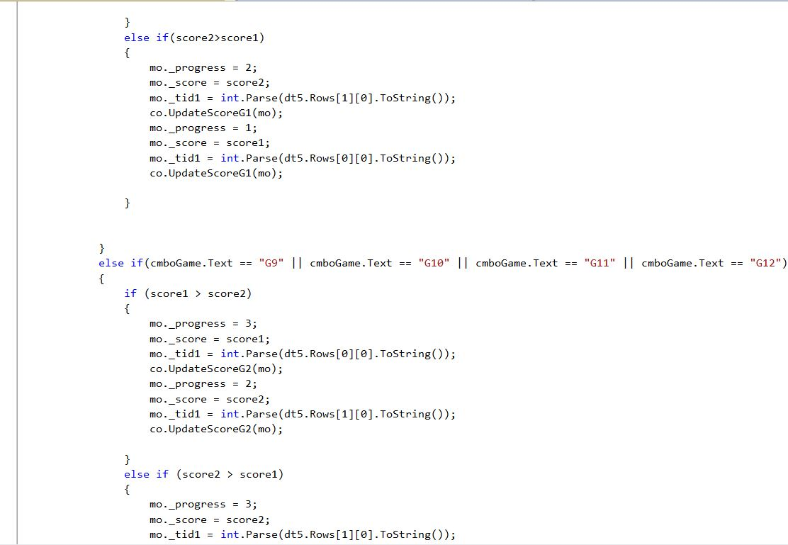

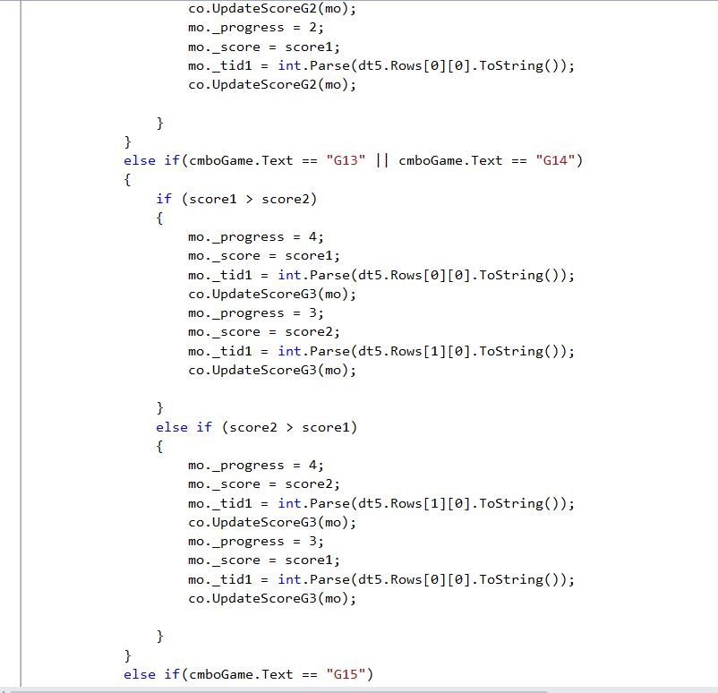

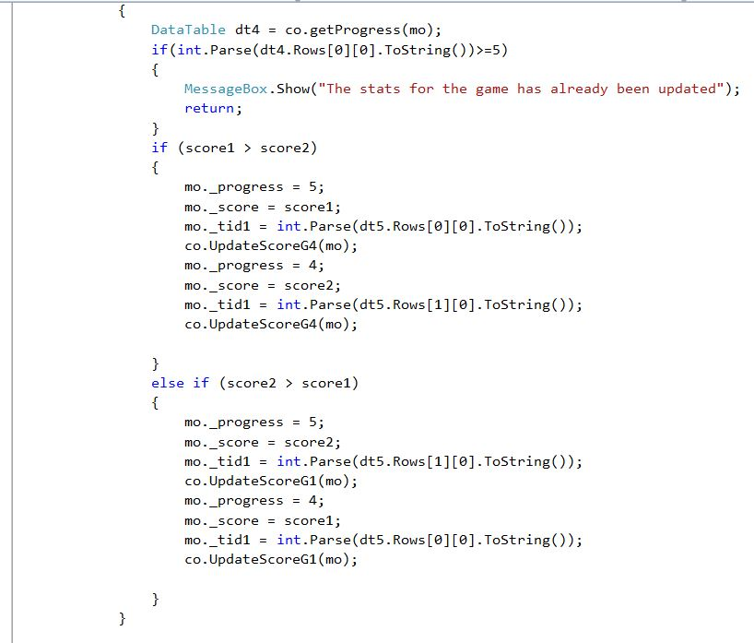

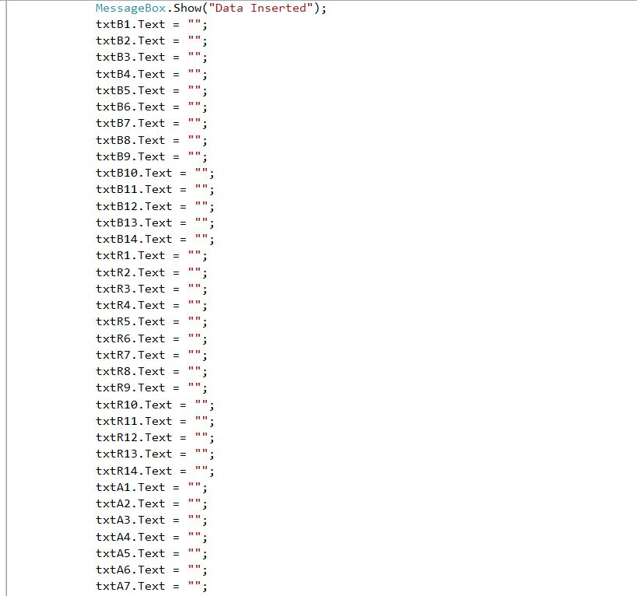

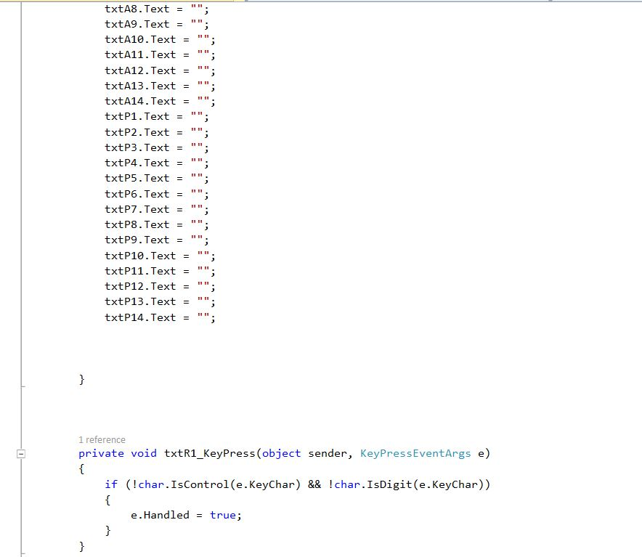

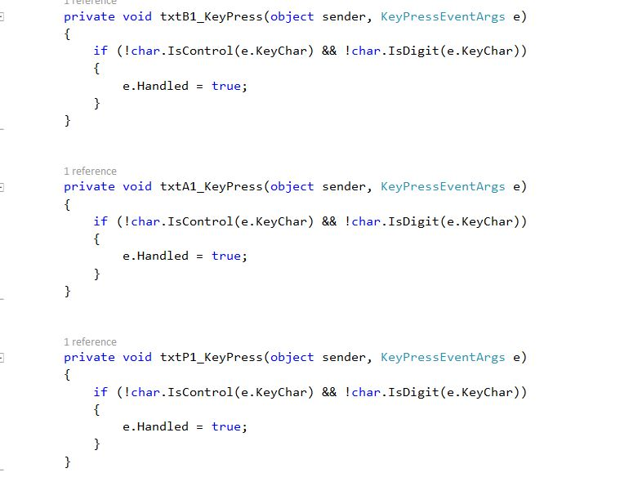

Figure: View of Stat Update

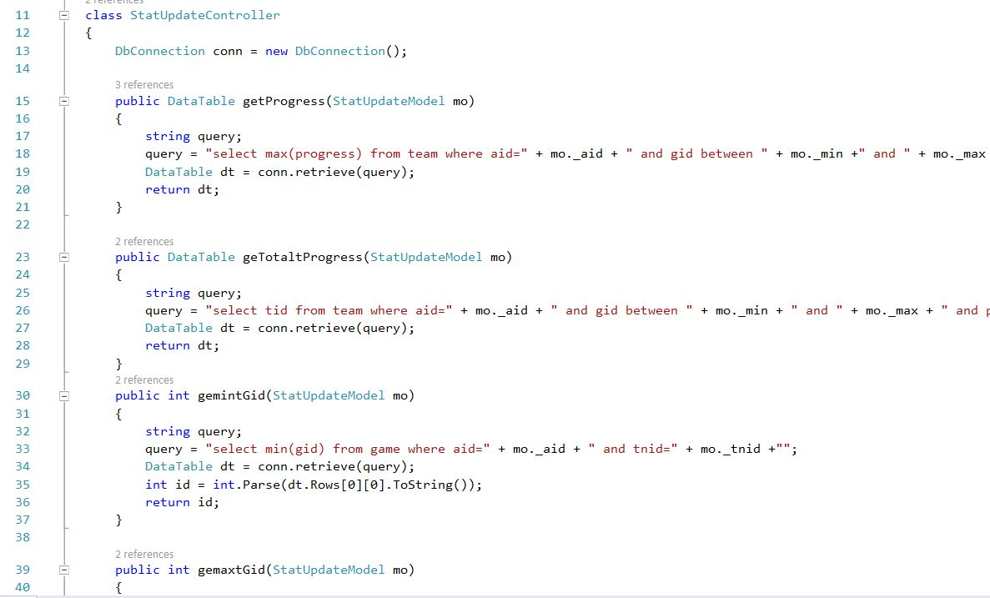

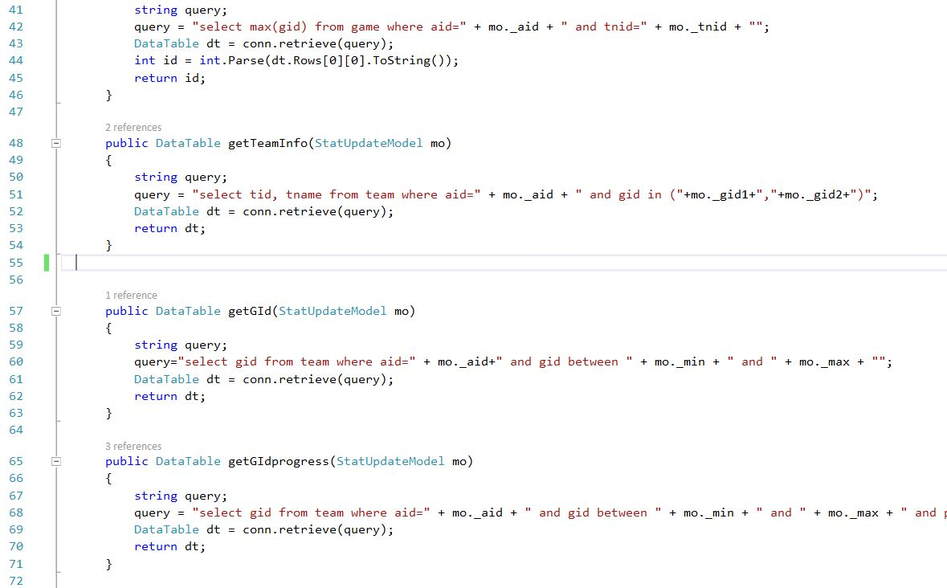

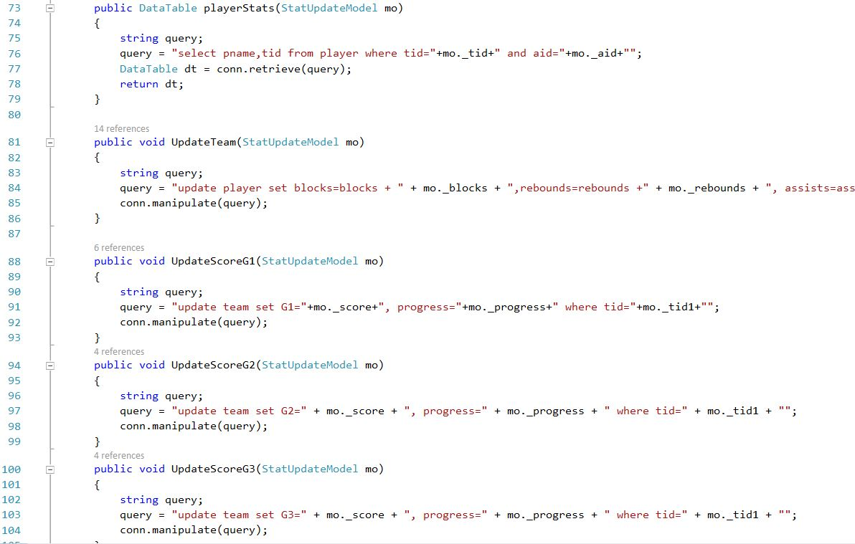

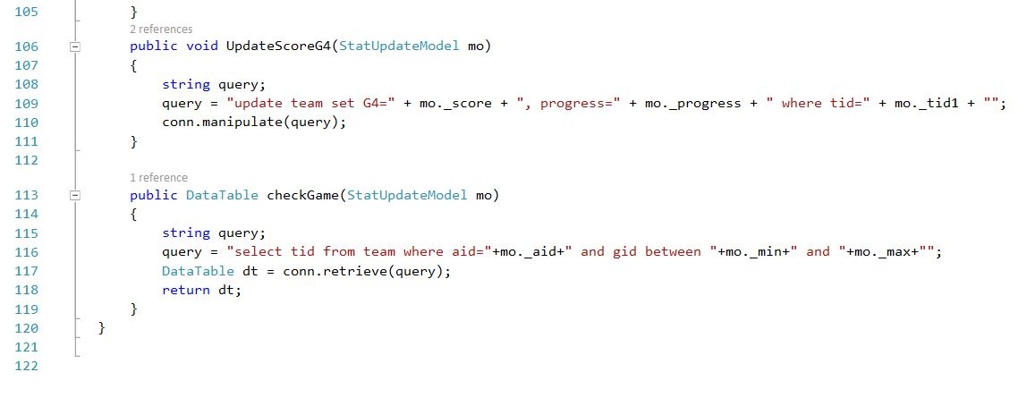

Figure: Controller of Stat Update

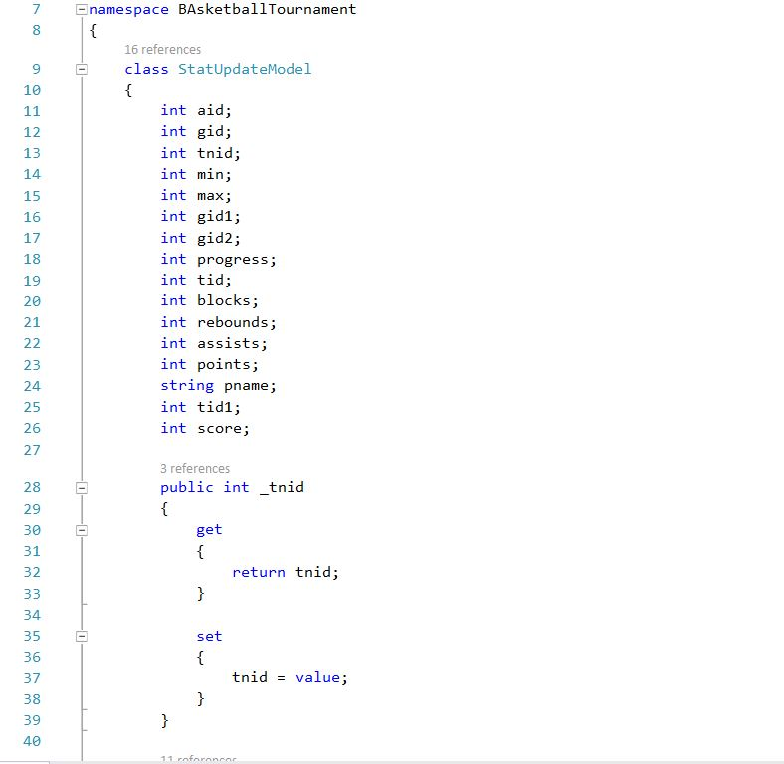

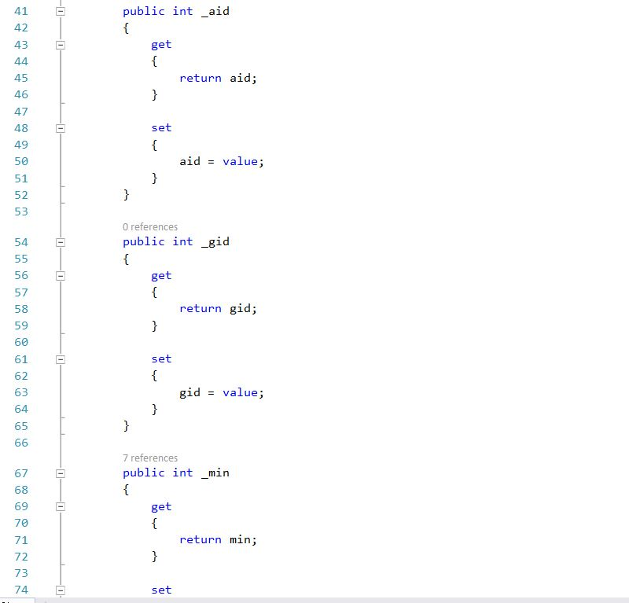

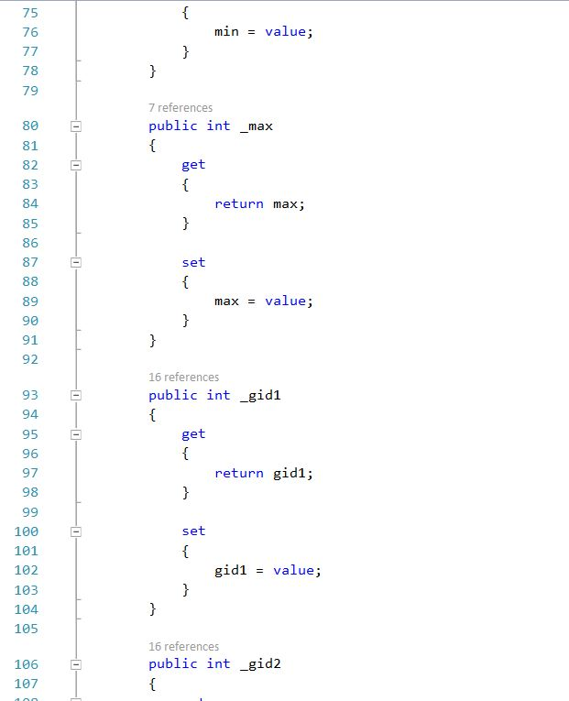

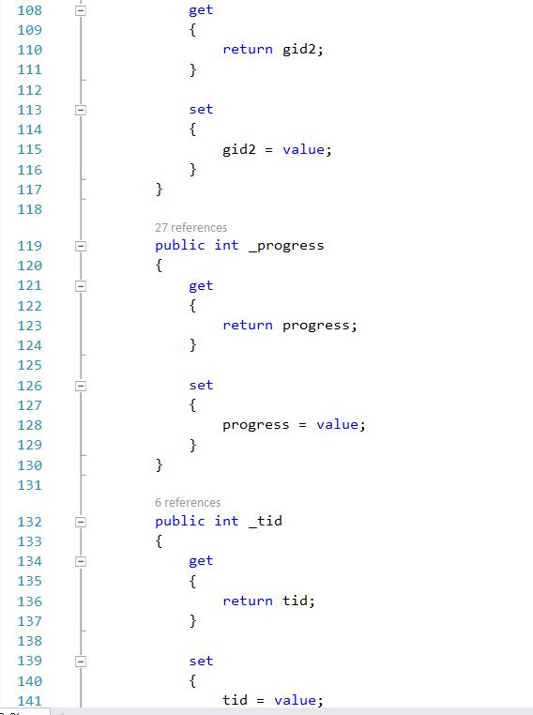

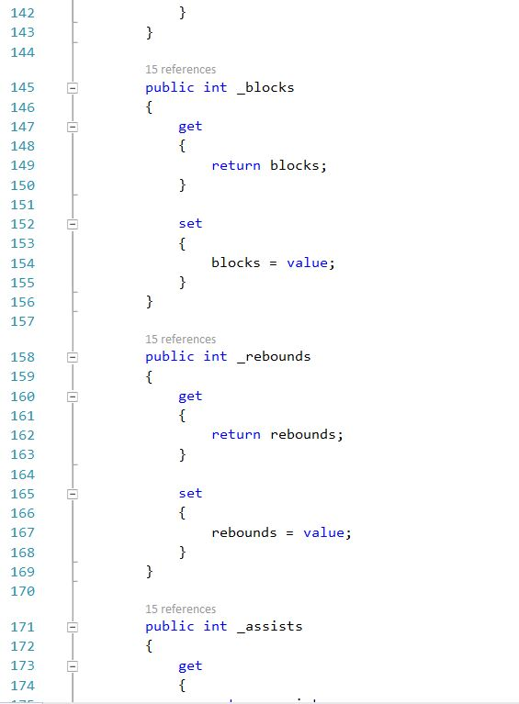

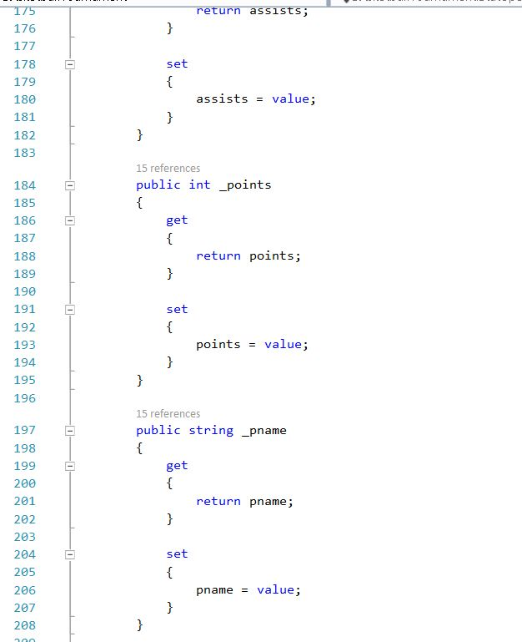

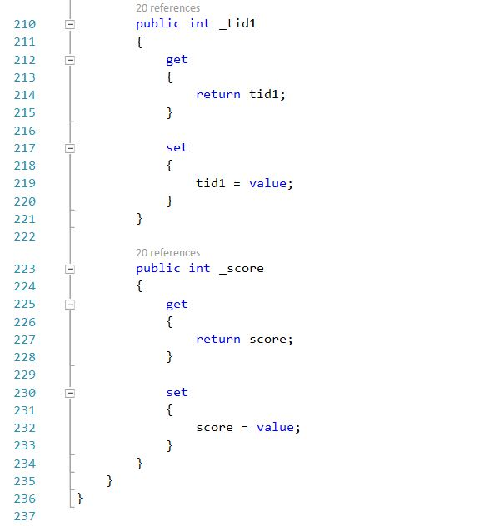

Figure: Model of Stat Update

**UI**

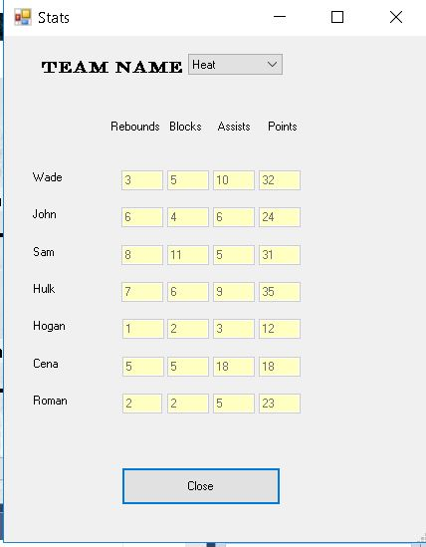

Figure: UI of View Stats

**Code**

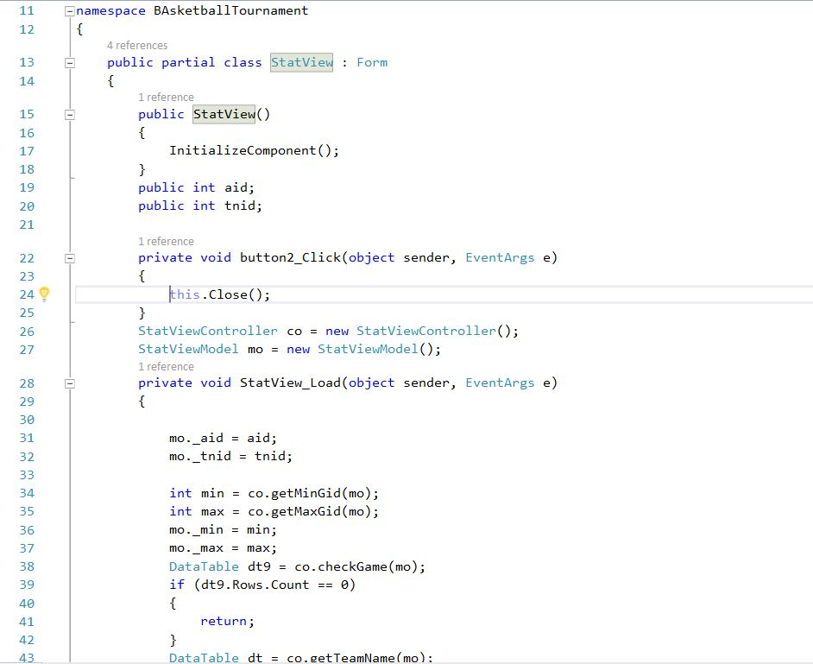

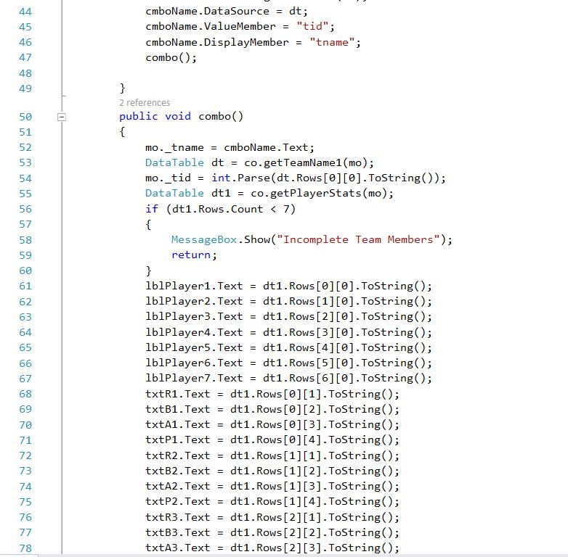

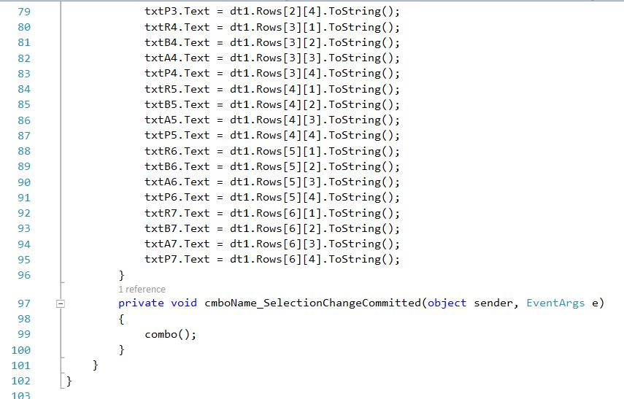

Figure: View of View Stats

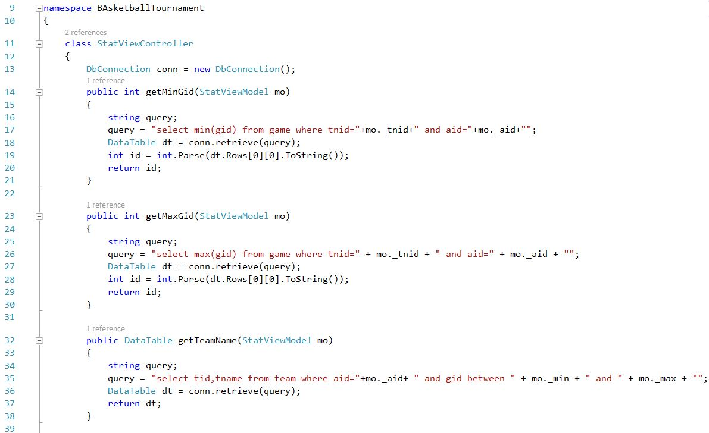

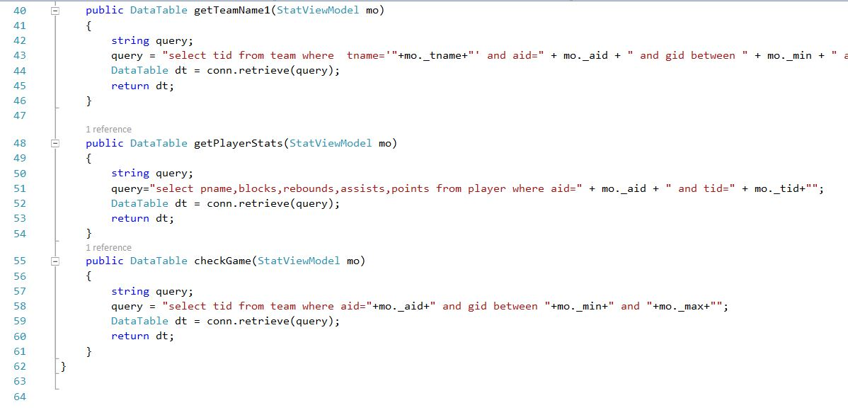

Figure: Controller of View Stats

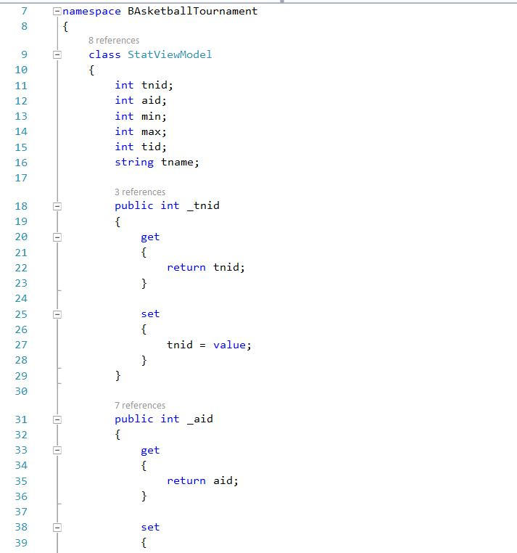

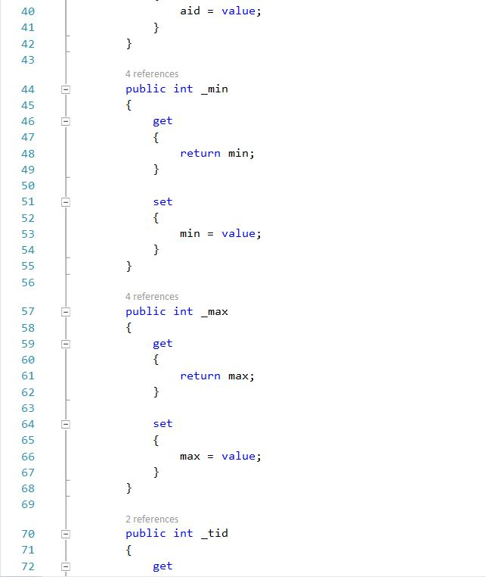

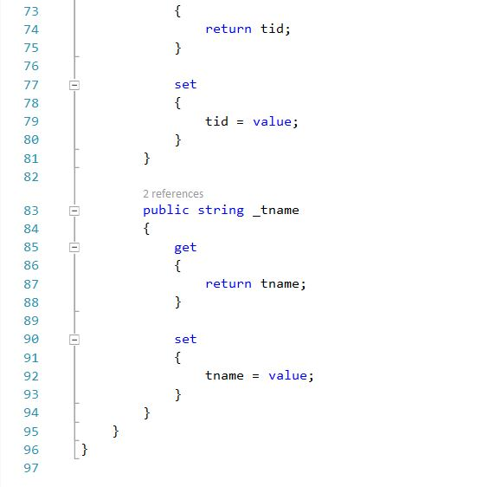

Figure: Model of View Stats

5 Testing

Introduction

Testing is the process in a project which is done to check whether the project or software can run well and correct in different situations. Testing helps to improve the software or project quality and helps to maintain reputation within customers.

Importance

Testing is very important as it helps to find out the error or problems in a software that we are unaware of. This can prevent problems while software unveiling or dealing with customers. Due to this, we are able to maintain reputation and trust within customers helping in the future sales and others. Thus, we can consider our software a legit working one.

Types of Testing

There are different kind of testing. For example: Unit testing, Blackbox Testing (Behavioral Testing), Functional Testing, Integration Testing, Beta Testing, Acceptance Testing etc.,

The Testing that I will be implementing are Unit Testing and BlackBox Testing.

5.1 Unit Testing (With Test Cases)

Unit testing is a software development process in which the smallest testable parts of an application, called units, are individually and independently scrutinized for proper operation. Unit testing can be done manually but is often automated.

Test Name: Admin Login

|  |  |  |  |  |  |
| --- | --- | --- | --- | --- | --- |
| Test ID | Scenario | Input Data | Expected Result | Actual Result | Result |
| 1 | Login | Check Data | Login Successful | The Login was successful | Pass |

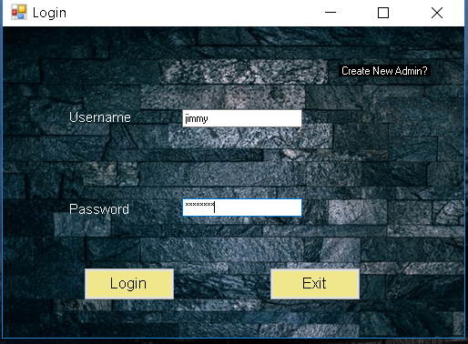

Figure: Admin login

Test Name: Create New Admin

|  |  |  |  |  |  |
| --- | --- | --- | --- | --- | --- |
| Test ID | Scenario | Input Data | Expected Result | Actual Result | Result |
| 2 | Create a new admin | Check data | Admin Created | Admin Created | Pass |

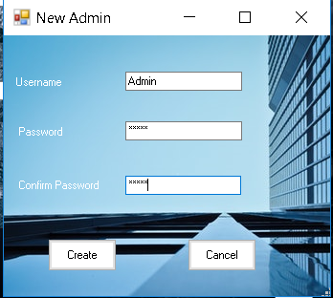

Figure: Creating a New Admin

Test Name: Create a Tournament

|  |  |  |  |  |  |
| --- | --- | --- | --- | --- | --- |
| Test ID | Scenario | Input Data | Expected Result | Actual Result | Result |
| 3 | Create a new tournament | Test user information | A Tournament should be created | A new tournament was successfully created | Pass |

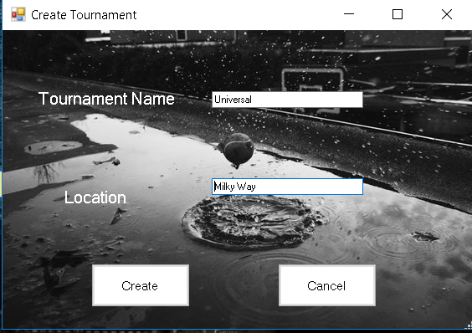

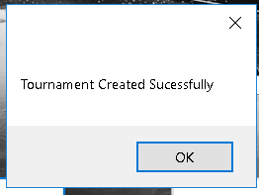

Figure: Creating a Tournament

Test Name: Load Tournament

|  |  |  |  |  |  |
| --- | --- | --- | --- | --- | --- |
| Test ID | Scenario | Input Data | Expected Result | Actual Result | Result |
| 4 | Load an existing tournament | Check selected data | The selected tournament should load successfully | The tournament was loaded | Pass |

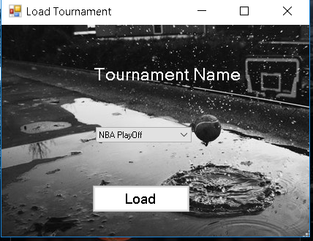

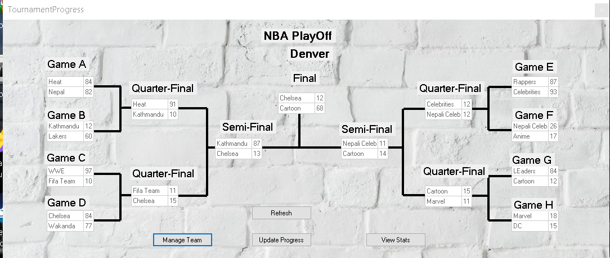

Figure: Loading an Existing Tournament

Test Name: Delete a Team

|  |  |  |  |  |  |
| --- | --- | --- | --- | --- | --- |
| Test ID | Scenario | Input Data | Expected Result | Actual Result | Result |
| 5 | Delete a Team | Check selected data for deletion | The selected tournament should be deleted | The selected team was deleted | Pass |

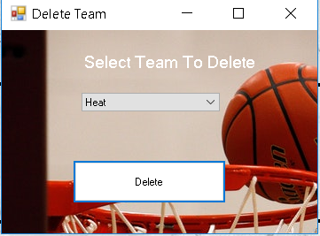

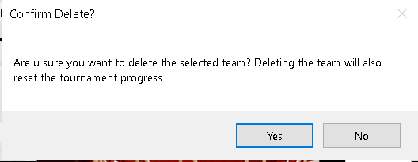

Figure: Deleting a Team

Test Name: Adding a Team

|  |  |  |  |  |  |
| --- | --- | --- | --- | --- | --- |
| Test ID | Scenario | Input Data | Expected Result | Actual Result | Result |
| 6 | Add a New Team | User Detail | A new team should be added | A team was added | Pass |

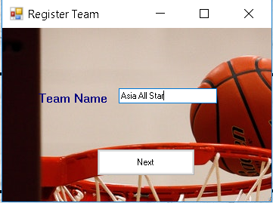

Figure: Adding a Team

Test Name: Adding a Player

|  |  |  |  |  |  |
| --- | --- | --- | --- | --- | --- |
| Test ID | Scenario | Input Data | Expected Result | Actual Result | Result |
| 7 | Add a New Player | User Detail | Players should be added | Players were added | Pass |

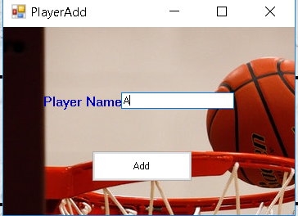

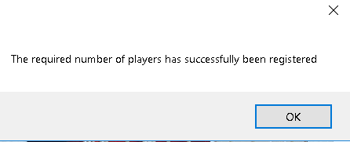

Figure: Adding Players

Test Name: Deleting a Tournament

|  |  |  |  |  |  |
| --- | --- | --- | --- | --- | --- |
| Test ID | Scenario | Input Data | Expected Result | Actual Result | Result |
| 8 | Delete Tournament | Check Selected Tournament | Tournament should be deleted | Selected Tournament was deleted | Pass |

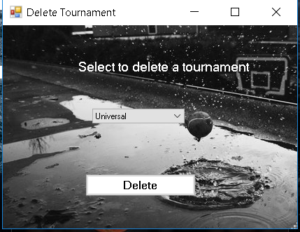

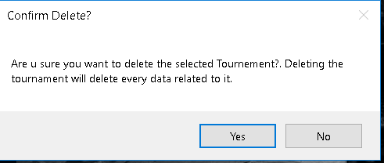

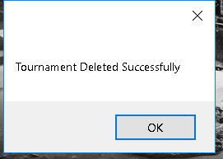

Figure: Deleting a Tournament

Test Name: View Player Stats

|  |  |  |  |  |  |
| --- | --- | --- | --- | --- | --- |
| Test ID | Scenario | Input Data | Expected Result | Actual Result | Result |
| 9 | View Player Stats | Check Selected Team | Stats should be shown | Stats were shown | Pass |

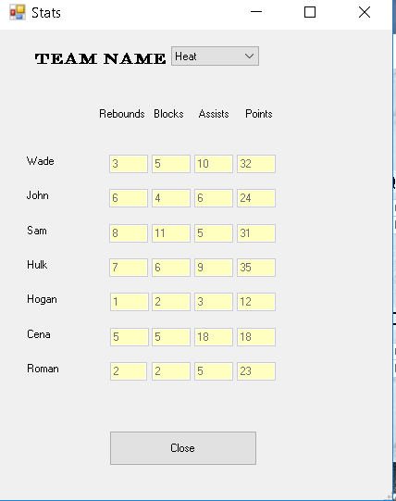

Figure: Player Stats

Test Name: Update Progress

|  |  |  |  |  |  |
| --- | --- | --- | --- | --- | --- |
| Test ID | Scenario | Input Data | Expected Result | Actual Result | Result |
| 10 | Update Data | User Data | Stats should be updated | Game progress was successfully updated | Pass |

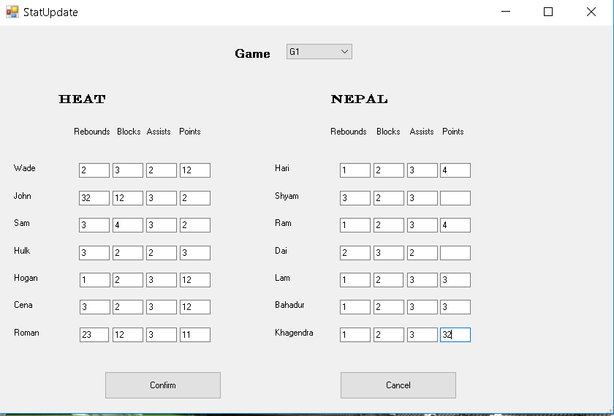

Figure: Updating Tournament Progress or Stat

5.2 Black Box Testing (With Test cases)

Black-box testing is a testing strategy that ignores the internal mechanism of a system or component and focuses solely on outputs generated in response to selected inputs and execution conditions.

Test Name: Admin Login

Pre-Condition: Admin must be created before logging in

|  |  |  |  |  |  |
| --- | --- | --- | --- | --- | --- |
| Test ID | Scenario | Input Data | Expected Result | Actual Result | Result |
| 1 | Login | Username: jimmy  Password:  Password | The Username and Password should match to that of the admin and directed to the dashboard | The Username and password were valid and thus proceeded to the next step. | Pass |



Figure: Admin login

Test Name: Create New Admin

Pre-Condition: None

|  |  |  |  |  |  |
| --- | --- | --- | --- | --- | --- |
| Test ID | Scenario | Input Data | Expected Result | Actual Result | Result |
| 2 | Create a new admin after checking inserted data | Username; Admin  Password:  Admin  Confirmation Password: Password | The username should be available, the two password should match and the a new admin should be created. | The username was available and the passwords were confirmed thus new admin was created | Pass |



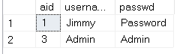

Figure: Creating a New Admin

Test Name: Create a Tournament

Pre-Condition: Need to be logged in as an admin

|  |  |  |  |  |  |
| --- | --- | --- | --- | --- | --- |
| Test ID | Scenario | Input Data | Expected Result | Actual Result | Result |
| 3 | Create a new tournament after checking inserted data | Tournament Name: Universal  Location: Milky Way | The tournament name should be available and should be created thus directed to the dashboard | A new tournament was successfully created and directed to the dashboard | Pass |





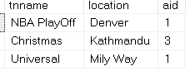

Figure: Creating a Tournament

Test Name: Load Tournament

Pre-Condition: Should be logged in as an admin

|  |  |  |  |  |  |
| --- | --- | --- | --- | --- | --- |
| Test ID | Scenario | Input Data | Expected Result | Actual Result | Result |
| 4 | Load an existing tournament | Tournament Name: NBA PlayOff (From Drop Down List) | The selected tournament should load successfully and should have access to the tournament | The tournament was loaded and access was given to the admin | Pass |





Figure: Loading an Existing Tournament

Test Name: Delete a Team

Pre-Condition: Should Load a tournament and team should be available to delete

|  |  |  |  |  |  |
| --- | --- | --- | --- | --- | --- |
| Test ID | Scenario | Input Data | Expected Result | Actual Result | Result |
| 5 | Deleting a Team without causing any other problems | Select a Team To Delete: Heat (Drop Down List) | The selected tournament should be deleted and the tournament progress reset | The selected team was deleted and the tournament progress was reset | Pass |





Figure: Deleting a Team

Test Name: Adding a Team

Pre-Condition: Tournament should be created and loaded. Team name should be different than others

|  |  |  |  |  |  |
| --- | --- | --- | --- | --- | --- |
| Test ID | Scenario | Input Data | Expected Result | Actual Result | Result |
| 6 | Add a New Team to the current tournament | Team Name: Asia All Star | A new team should be added(Team Name should be available) and proceeded to the next step of adding players | The team name was available and added thus proceeding to the next step | Pass |



Figure: Adding a Team

Test Name: Adding a Player

Pre-Condition: A tournament should be loaded and a team added

|  |  |  |  |  |  |
| --- | --- | --- | --- | --- | --- |
| Test ID | Scenario | Input Data | Expected Result | Actual Result | Result |
| 7 | Add a New Player to the right team without error | Player Name: A | 7 Players should be added to the corresponding team | 7 Players were added to the team | Pass |





Figure: Adding Players

Test Name: Deleting a Tournament

Pre-Condition: Tournament should be available to delete

|  |  |  |  |  |  |
| --- | --- | --- | --- | --- | --- |
| Test ID | Scenario | Input Data | Expected Result | Actual Result | Result |
| 8 | Delete a Tournament to see if it works | Select to delete a tournament: Universal (Drop Down List) | Tournament should be deleted and every of its corresponding data example: Team, Player, Progress etc. | Tournament was deleted including its related data | Pass |







Figure: Deleting a Tournament

Test Name: View Player Stats

Pre-Condition: Team and Team Player should be available

|  |  |  |  |  |  |
| --- | --- | --- | --- | --- | --- |
| Test ID | Scenario | Input Data | Expected Result | Actual Result | Result |
| 9 | View player full stats accurately | Team Name: Heat (Drop Down List) | Stats should be shown with the corresponding player names. | Players stats were shown accurately | Pass |



Figure: Player Stats

Test Name: Update Progress

Pre-Condition: Required numbers of team and players should be added

|  |  |  |  |  |  |
| --- | --- | --- | --- | --- | --- |
| Test ID | Scenario | Input Data | Expected Result | Actual Result | Result |
| 10 | Check if inserted data goes to the right team | Game: G1  Wade:2 3 2 12  Hari: 1 2 3 4 etc. | Stats should be updated accordingly and along with the tournament progress | Game progress was successfully updated along with the tournament progress | Pass |



Figure: Updating Tournament Progress or Stat

6 Other Project Issues

6.1 Risk Management

Risk is the most common thing that needs to be taken in order to gain something. We deal with it in everyday of our life. Risk is a term in accounting and finance used to describe the uncertainty that a future event with a favorable outcome will occur. In other words, risk is the probability that an investment will not perform as expected and the investor will lose the money invested in the project. (https://www.myaccountingcourse.com/accounting-dictionary/risk, n.d.) Therefore, risk is somewhat a very scary thing from a point of view which can lead to either good or bad result. There are few steps which can be taken for improving risk management.

* Identifying the risk
* Analyzing the risk
* Prioritizing the risk
* Treating the risk
* Monitoring the risk
* Identifying the risk

Anticipating possible pitfalls of a project doesn't have to feel like gloom and doom for your organization. Quite the opposite. Identifying risks can be not only a positive experience but also an experience that your whole team can take part in and learn from. (https://www.lucidchart.com/blog/risk-management-process, n.d.)

Identifying the risks helps us to move to next step of improving risk management. Without it, we it’s impossible to move to the next step since we won’t know what kind of risks are we dealing with and how to overcome it.

* Analyzing the risk

Analyzing is the process of making analysis of the risk we identified before the step. This step helps us to make assumption and helps us deal with it later. We estimate the probability and fallout of each risk to decide where to focus first in this step. We analyze the time taken, Cost and quality because they are the factors to be taken into account while taking any sorts of risk.

* Prioritizing the risk

In this step, we identify which risks should be given priority for dealing as they have greater influence than the other risks. It helps us in the future greatly. We do this by ranking each risk on the basis of the likelihood of the risk occurring and its influence on the project. This allows us to focus on the right thing and saves us time and effort. The project itself is not interrupted or delayed in significant ways during this stage.

* Treating the risk

Once the worst risks come to light, dispatch your treatment plan. While you can’t anticipate every risk, the previous steps of your risk management process should have you set up for success. Starting with the highest priority risk first, task your team with either solving or at least mitigating the risk so that it is no longer a threat to the project. (https://www.lucidchart.com/blog/risk-management-process, n.d.) In other words, we simply deal with the risk.

* Monitoring the risk

The final step will be to monitor the risk to ensure that everything is going as it should. Just like in case of cancer, when a person has been treated for it, doctors still monitor the patient and schedule appointments every once in a while to make sure everything is going fine. This helps us to avoid future threats or problems. In this stage, we also monitor, track and review the risks that occur during the time of the project. Risk management can be tricky, but it also can be mastered. We should defend against incoming harm, whether it’s coming from inside or outside.

6.2 Configuration Management

The configuration management system is a tool that serves as a subsystem of the top level project management system. It exists to provide formal and specific guidelines to the project management team in applying administrative and technical direction and supervision to a wide range of processes including the identification and documentation of descriptive characteristics of specific items within a project. These items can include products, services, or other assorted components. The configuration management system, when properly implemented, can also guide the project management team when they attempt to change any of these characteristics, demonstrating the proper way to record and document these changes to best meet requirements for documentation and approvals. Traditionally, the configuration management system is an umbrella system that encompasses many other small essential systems such as the change control system. I have used GitHub to store data and for backups.

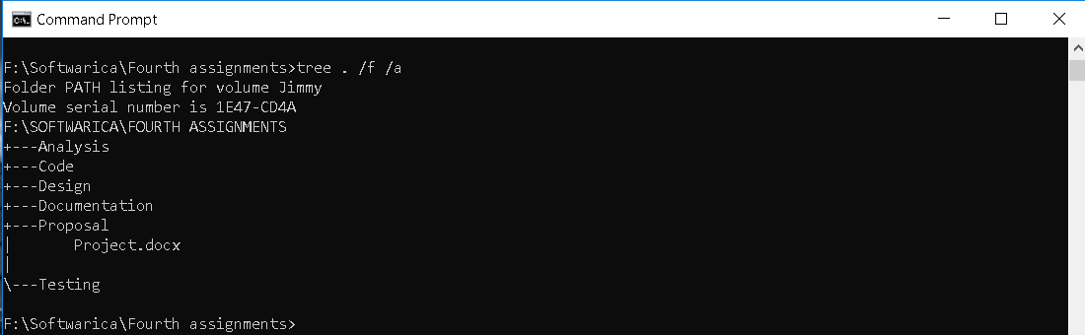

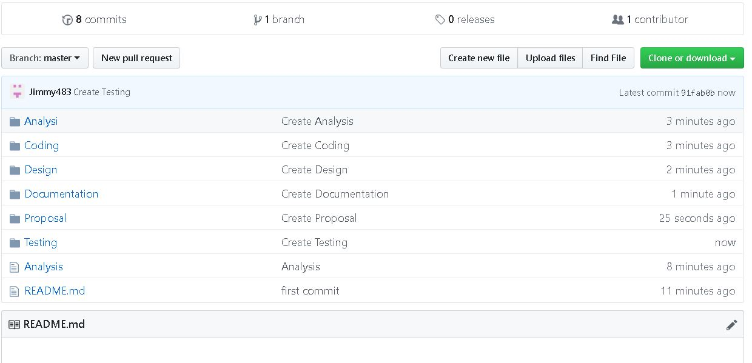

6.3 Scheduling

A Gantt chart, commonly used in project management, is one of the most popular and useful ways of showing activities (tasks or events) displayed against time. (https://www.gantt.com/, n.d.). Gantt chart are developed using programs like Gantt project which I have used to create a Gantt chart. With the help of Gantt chart, I was able to estimate the time required to complete my project.

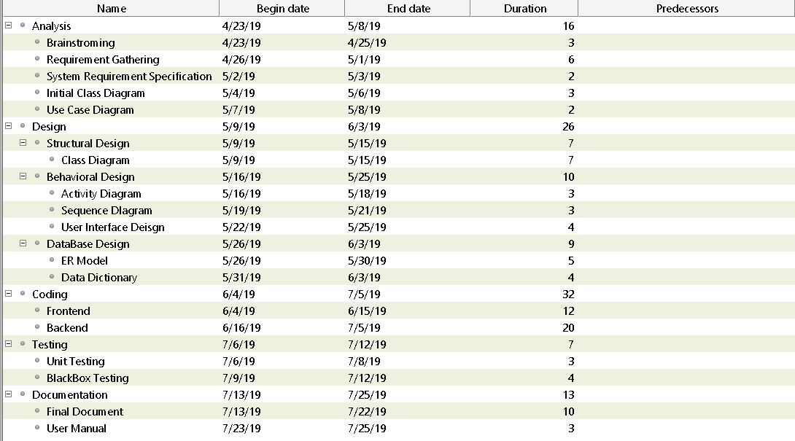

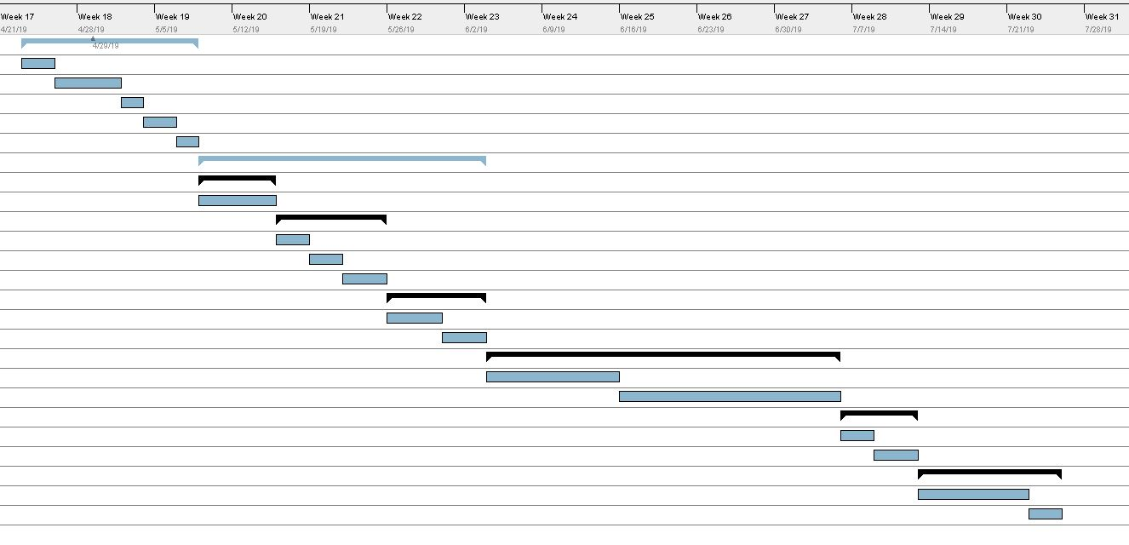

Figure: New Update Gantt Chart

6.4 Future Work

The application that was developed will have numerous additional features in the future to make it more flexible and easy to use. Any Feedbacks will be taken into consideration which can give the idea for new features. If any problems with the application shall exist, it would be fixed quick and clearly.

6.5 User Manual

The application is simple to use and is user friendly. An admin must be created before you can start creating tournaments. You can also load saved tournaments and players. Players can be added by adding a team and following the step. Stats can be viewed from the progress menu.

6.6 Limitations

Although the application is complete, team members that can be registered per team is only 7 and only 16 teams are allowed to participate which is the usual number of teams that participate in a basketball tournament. It is strictly prohibited from updating a match that was already updated as it can cause to reset the progress. Same goes for deleting a team which can reset the tournament progress.

7 Conclusions

The project that I have created is capable of organizing a basketball tournament without problems and remove any confusions regarding the tournament. No team are allowed to register without team members and progress are viewable. Thus, the completion of the project is successful.